**Systematic Database Implementation for Sports Bar**

**Presented by:**

Vinay Reddy Jakka

**PROJECT DESCRIPTION:**

In a world full of busy people, they are even forgetting to relax. That’s where the Sports Bar comes into play, as it unites all the beings to enjoy games. That helps as a refreshment to a routine daily life. It gives off good vibes throughout the place and people celebrate the games with good company on their favorite team winning.

Managing all the employees, customers, menu, profits is quite challenging to do on paper basis. Such as miscalculation of time worked by an employee, price mismatch on menu card (as it needs to be updated regularly), all the transactions of day can be clumsy and huge if it’s just on paper and it will be difficult in finding a transaction where help is needed. This project helps the sports bar to boost their customer service and make sure customers are enjoying themselves. Through this project I will help the managers by avoiding fake timings of employees, it will help the customers to order their food more easily and help with table reservation. It stores the customer details which will later help the managers to be analyzing and improve customer service through purchasing patterns. By solving all these problems, I intend to create a database for organization level rather than specific tasks.

The goal of this project is to help businesses reduce paperwork and make everything online with a database. This database helps store employee details, menu card (food and beverages), serving tables data. This way correct order can be served on an appropriate table with high accuracy. As it also contains daily transactions, will further help businesses understand their profits.

**OBJECTIVES:**

* Storing employee details for clock in and clock out details can help the owners to avoid faking.
* Allowing customers to order online, which will later help in managing the customers during busy times.
* Dine -in table reservation in the bar during good sports (like UFC fight, NFL)
* One of the main objectives is to keep the customers happy and satisfied. And also keeping the correct accounts of all orders and transactions allows business owners to understand clearly about revenue and profits. This will give a generous amount of data to analyze and upgrade the business on the basis of it.

**SCOPE:**

* To help enhance customer service.
* To increase accuracy and quickness when serving orders to all the tables.
* To collect employee clock in and clock out timings and use them for decision-making when proposing hike or promotion.
* To collect customer purchase patterns on food and drinks and analyze them. Which helps with placing orders from beverage companies.
* To create a hassle-free environment by allowing customers to reserve tables in advance.

**PROJECT REQUIREMENTS:**

**Operating system:** Windows

**Database:** Microsoft SQL Server Management Studio (SSMS)

**Applications:** Microsoft word

**DATABASE REQUIREMENTS:**

1. Menu (food and beverages)
2. Furniture (various kinds of tables)
3. Order summary
4. Employees (chefs, bartenders, servers, managers)
5. Restaurant owners
6. Electronics (television and their position)
7. Customer information table
8. Employees work schedule

**USER REQUIREMENTS:**

* Customers will be able to search for all the available reservations. Customers can also find their own reservation time and table.
* The system can generate a list of employees working on that particular day. Details of employees include employee name, employee id, employee type, server id if applicable.
* Owners can find the payment details in the database. This helps owners aggregate profits, business expenses, salaries of employees.
* Owners can take reviews from customers, which helps them understand the changes that should be implemented moving forward.
* Also, the feedback on servers from customers will help owners get an idea on the employee like quickness, correctness, customer treatment.

**BUSINESS RULES:**

The sports bar has two parts, one is a restaurant, and another is a bar where bartenders serve customers.

1. **Tables :**

* Restaurant has tables
* Each table has its own capacity e.g.: 2 persons, 4 persons, 6 persons table etc.
* Each table has its unique id

1. **Chairs :**

* Chairs can be placed in front of bars which are called bar chairs.
* Each chair has its own id

1. **Bar Menu :**

* Whole bar has unique bar menu
* Bar menu has a list of ids, alcohol/drink names, type and price
* Each type of drink has unique alcohol id

1. **Food Menu :**

* Whole bar has unique food menu
* Food menu contains list of food items, id and price
* Each item has unique food id

1. **Restaurant :**

* Restaurant can be managed by multiple owners
* Restaurant has tables
* Restaurant has its food menu
* Servers serve the restaurant

1. **Bar:**

* Owners can manage bar
* Bartenders serve the bar
* Bar pack cleans the bar
* Bar has chairs
* Bar has bar menu for drinks

1. **Customers :**

* Customers can sit either at bar or at tables
* If customers sit at bar they can be served by bartender and if they sit at table, employees can serve them
* Customers can access both food menu as well as bar menu
* Customers can access their invoice from toast
* Food runners serve the food to customers

1. **Server :**

* Servers serve the customers
* Servers stay in the restaurant to serve the customers who sit at the restaurant
* Each server can access the toast with their own password to serve the tables
* Servers are type of employees in bar

1. **Food Runner :**

* Food runners receive the orders from the kitchen and serve it to respective customers
* Food runners are type of employees in bar

1. **Chef :**

* Chefs are type of employees in bar
* Chef works in kitchen

1. **Bartender :**

* Bartender server the bar
* Bartenders can access toast with their own password to serve the customers who sit at the bar.
* Bartenders are type of employees in bar

1. **Employee :**

* Each employee has unique employee id
* Each employee must check in and check out
* Employee can be chef, bartender, bar pack, server
* Owners manage employees

1. **Check in:**

* The check-in table contains the employees’ check-in and check-out time on a specific date.

1. **Tv :**

* TV has unique ID based on their position
* Owners manage TVs

1. **Owners :**

* Owners manage the restaurant and bar
* Owners also manage the employees
* Owners also manage the tv

1. **Kitchen :**

* Chefs can manage kitchen
* Kitchen prepares the food items list received from the toast

1. **Toast :**

* Toast generates the invoice for customers
* Toast will send the food list to kitchen and alcohol list to bar
* Toast can be accessed by servers and bartender to enter customers details by using their unique login and passwords

**Entity Relationship Diagram:** Fig : 1 First phase with Many to M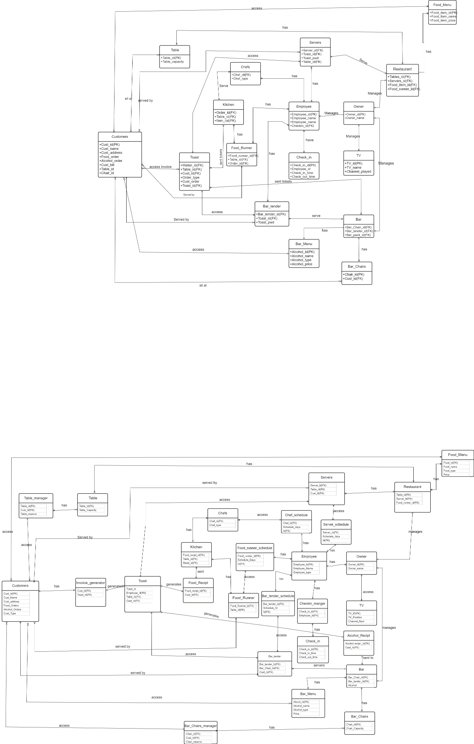

**Ref(**[**https://drive.google.com/file/d/1A1aw-THInGYeyEaHtQTH9S1g0vyoyVVa/view?usp=sharing**](https://drive.google.com/file/d/1A1aw-THInGYeyEaHtQTH9S1g0vyoyVVa/view?usp=sharing) **)**

**Data Dictionary:**

Data dictionary can be accessed through the following link which is shown in google sheets

<https://docs.google.com/spreadsheets/d/1AtoQ3uN1Wf-8Ef_2vr_GLVN_HbE4pBmTA7srbFfyTBU/edit?usp=sharing>

**Entity Generation and Data Entry:**

1. **Queries and operations for database creation:**

**Explanation:**

* Created database **sports_bar** using query “create DATABASE db_name”

**Query:**

* Create DATABASE sports_bar;

**Result:**

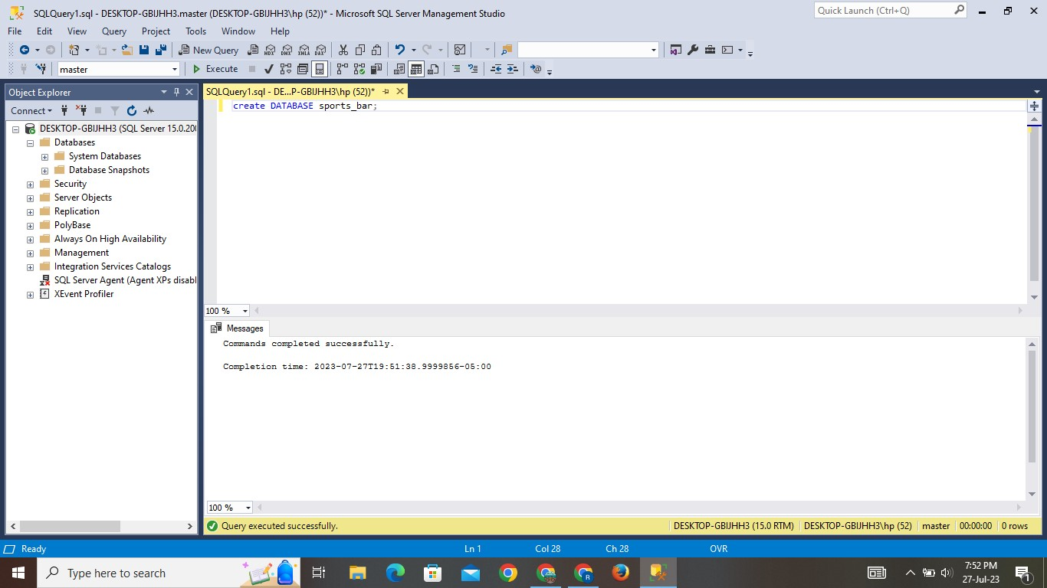

1. **Queries and operations for Tables:**

* The tables are created under the sports_bar database.
* The table is created using “**create TABLE table_name**”
* After the table is created successfully, used “**INSERT INTO table_name (column1, column2, column3…)”**
* Then used “**SELECT * FROM table_name**” to display the inserted values in the table.
* The above-mentioned steps are common at all tables.

1. **Food Menu Table:**

**Explanation:**

* The table is created with the name Food_Menu. This table gives us information about food id, food name, food type and price.
* Values are inserted into the table. And using SELECT statement can check the inserted values.

**Query:**

CREATE TABLE Food_Menu (food id INT PRIMARY KEY,

food name VARCHAR (10),

food type VARCHAR (10),

price INT);

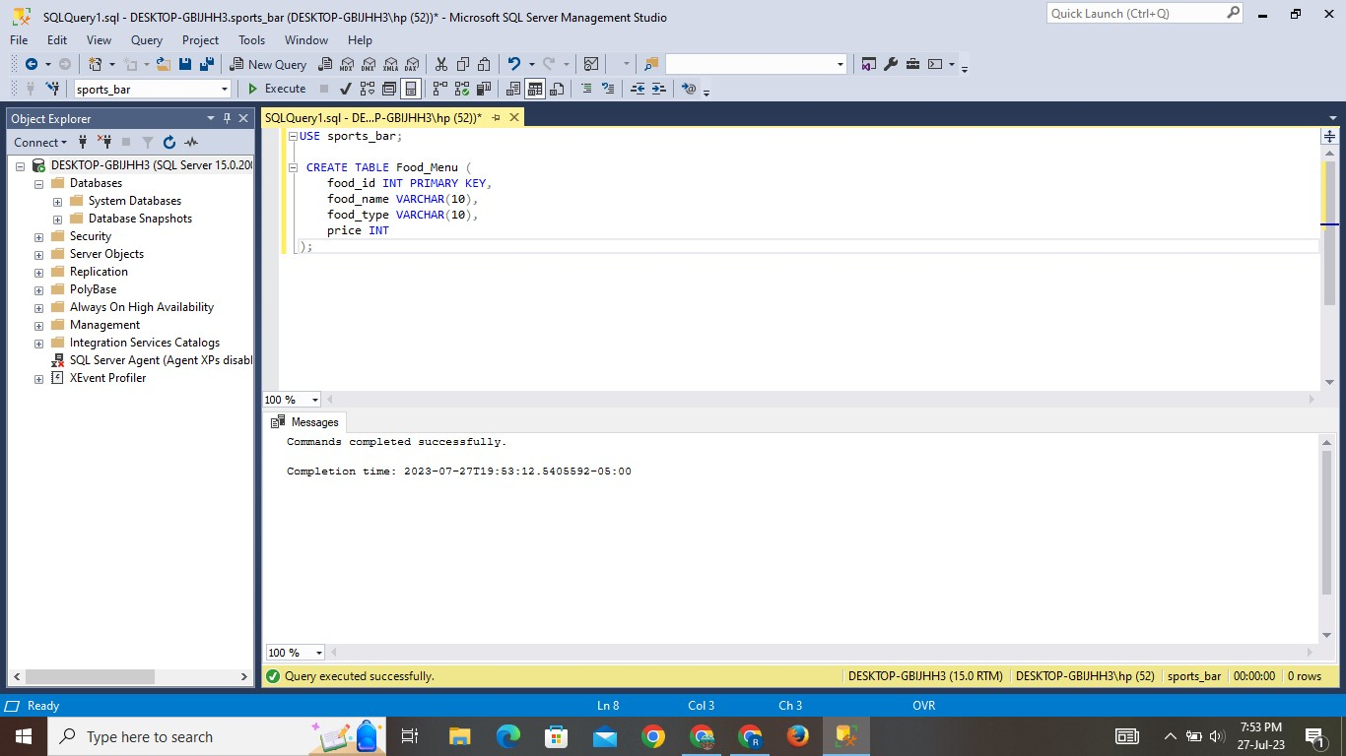

**INSERT STATEMENT:**

INSERT INTO Food_Menu VALUE (1, Pizza, Main_Course, 12);

INSERT INTO Food_Menu VALUE(2, Salad, Appetizer, 6);

INSERT INTO Food_Menu VALUE(3, Burger, Main_Course, 8);

INSERT INTO Food_Menu VALUE(4, Fries, Side Dish, 4);

INSERT INTO Food_Menu VALUE(5, Pasta, Main_Course, 10);

INSERT INTO Food_Menu VALUE(6, Wine, Beverage, 15);

INSERT INTO Food_Menu VALUE(7, Sushi, Main_Course, 14);

INSERT INTO Food_Menu VALUE(8 ,Steak, Main_Course, 20);

INSERT INTO Food_Menu VALUE(9 ,Mashed Potatoes, Side Dish, 5);

INSERT INTO Food_Menu VALUE(10, Fish Tacos, Main_Course, 9);

INSERT INTO Food_Menu VALUE(11, Tequila, Beverage, 7);

INSERT INTO Food_Menu VALUE(12, Chicken Wings, Appetizer, 8);

INSERT INTO Food_Menu VALUE(13, Nachos, Appetizer, 7);

INSERT INTO Food_Menu VALUE(14, Vegetable Stir Fry, Main_Course, 11);

INSERT INTO Food_Menu VALUE(15, Red Wine, Beverage , 12);

INSERT INTO Food_Menu VALUE(16, Lasagna, Main_Course, 13);

INSERT INTO Food_Menu VALUE(17, White Wine, Beverage, 14);

INSERT INTO Food_Menu VALUE(18, Hot Dog, Main_Course, 6);

INSERT INTO Food_Menu VALUE(19, Shrimp Scampi, Main_Course, 16);

INSERT INTO Food_Menu VALUE(20, BBQ Ribs, Main_Course, 18);

INSERT INTO Food_Menu VALUE(21, Coleslaw, Side, Dish, 4);

INSERT INTO Food_Menu VALUE(22, Vegetarian Pizza, Main_Course, 11);

INSERT INTO Food_Menu VALUE(23, Chicken Alfredo, Main_Course, 12);

INSERT INTO Food_Menu VALUE(24, Margarita, Beverage , 8);

INSERT INTO Food_Menu VALUE(25, Grilled Cheese Sandwich, Main_Course, 7);

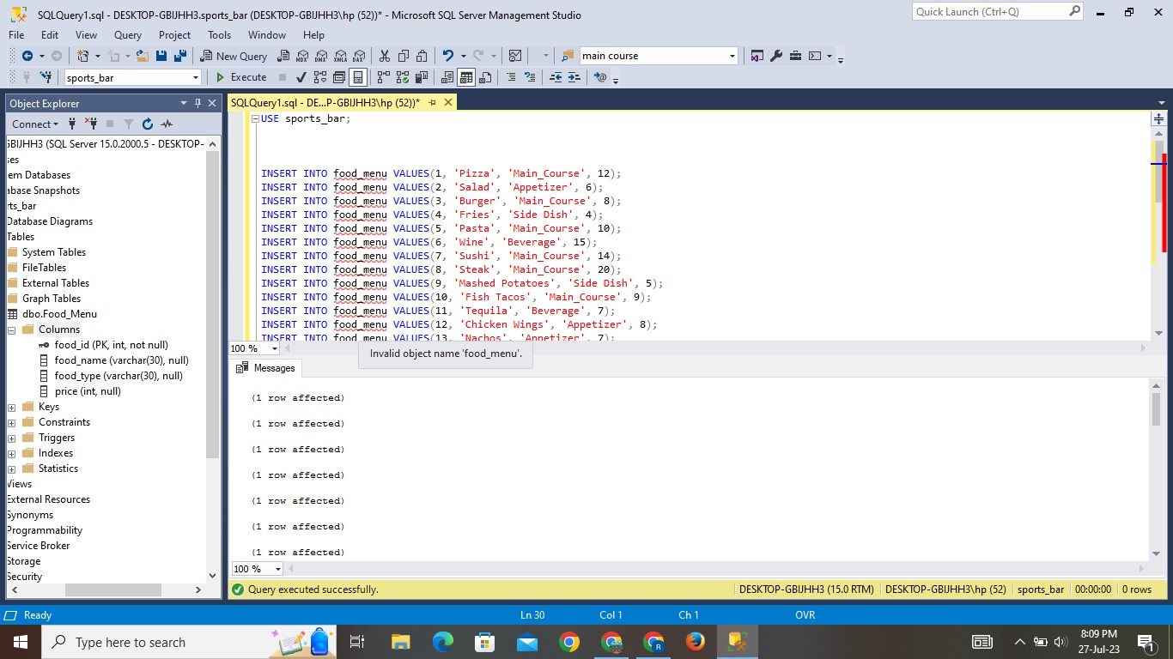

**Result:**

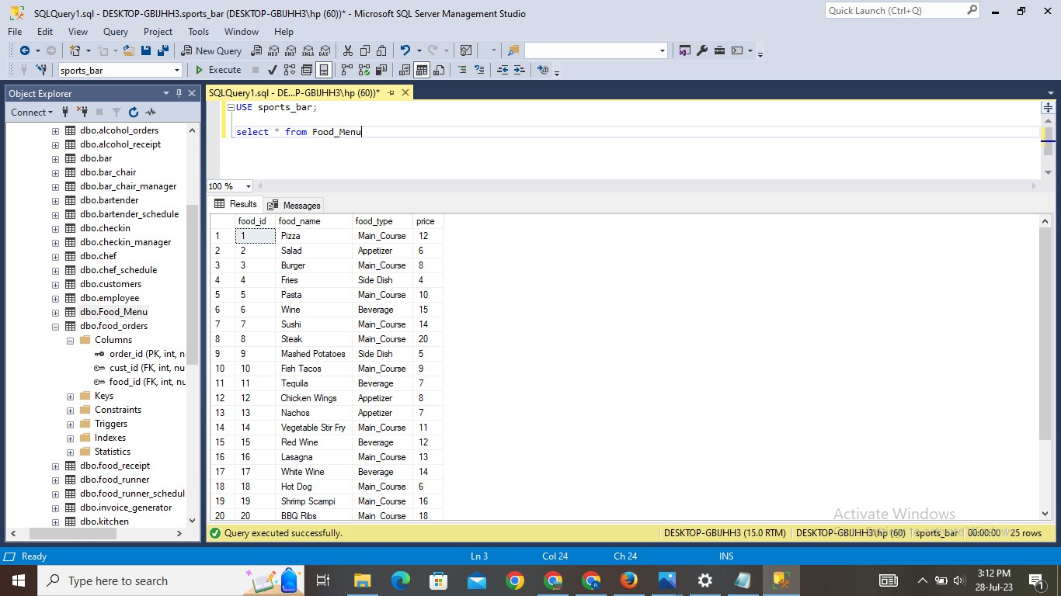

1. **Alcohol Menu Table:**

**Explanation:**

* The table is created with the name alcohol_menu. This table gives us information about alcohol id, alcohol name, alcohol type and price.
* Values are inserted into the table. And using SELECT statement can check the inserted values.

**Query:**

CREATE TABLE alcohol_menu ( alcohol_id   INT   PRIMARY KEY,

alcohol_name  VARCHAR(30),

Alcohol_type VARCHAR(30),

price INT);

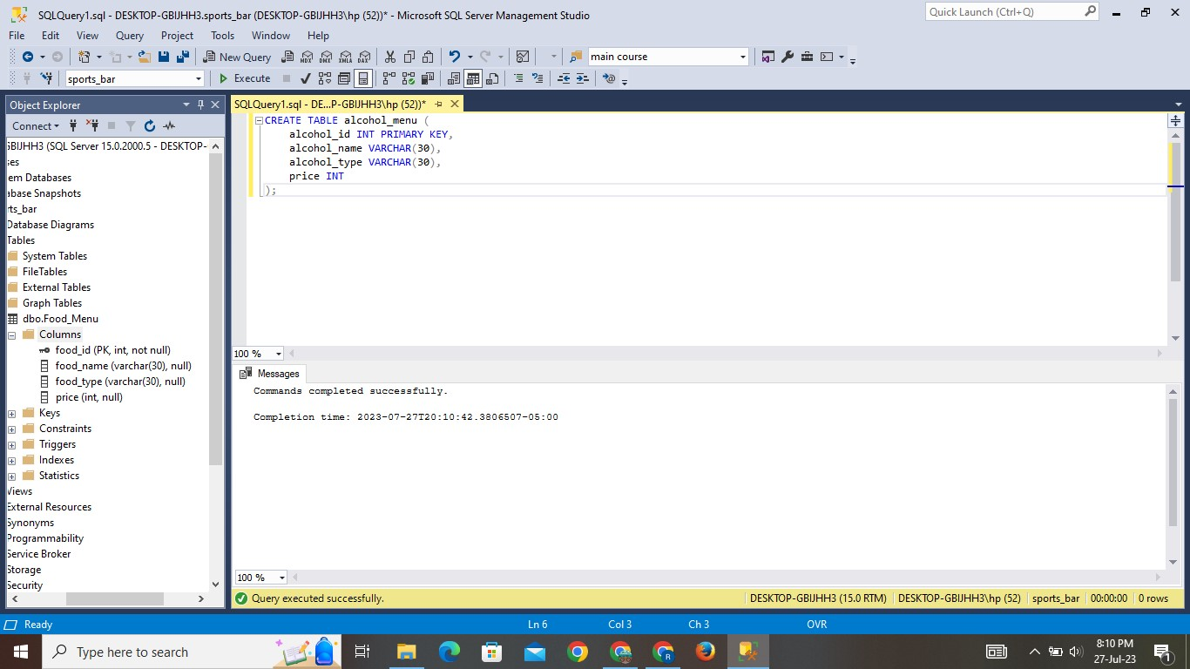

**INSERT STATEMENT:**

INSERT INTO alcohol_menu (alcohol_id, alcohol_name, alcohol_type, price) values

(1, 'Beer', 'Beer', 5),

(2, 'Wine', 'Wine', 10),

(3, 'Whiskey', 'Whiskey', 15),

(4, 'Tequila', 'Tequila', 12),

(5, 'Vodka', 'Vodka', 8),

(6, 'Rum', 'Rum', 9),

(7, 'Gin', 'Gin', 11),

(8, 'Champagne', 'Champagne', 20),

(9, 'Margarita', 'Cocktail', 14),

(10, 'Sake', 'Sake', 16),

(11, 'Prosecco', 'Sparkling Wine', 18),

(12, 'Mojito', 'Cocktail', 7),

(13, 'Martini', 'Cocktail', 12),

(14, 'Cider', 'Beer', 6),

(15, 'Bourbon', 'Whiskey', 11),

(16, 'Scotch', 'Whiskey', 20),

(17, 'Gin and Tonic', 'Cocktail', 9),

(18, 'Mojito', 'Cocktail', 8),

(19, 'Sangria', 'Wine', 13),

(20, 'Daiquiri', 'Cocktail', 10),

(21, 'Bloody Mary', 'Cocktail', 7),

(22, 'Piña Colada', 'Cocktail', 11),

(23, 'Manhattan', 'Cocktail', 15),

(24, 'White Russian', 'Cocktail', 12),

(25, 'Cosmopolitan', 'Cocktail', 14)

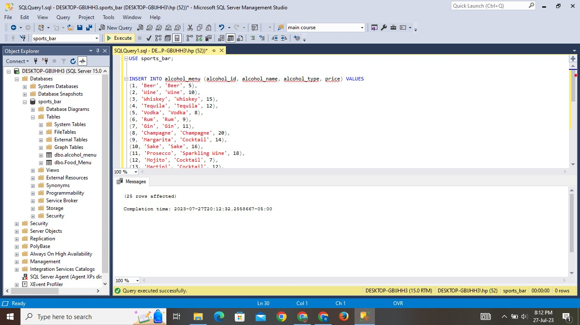

**Result:**

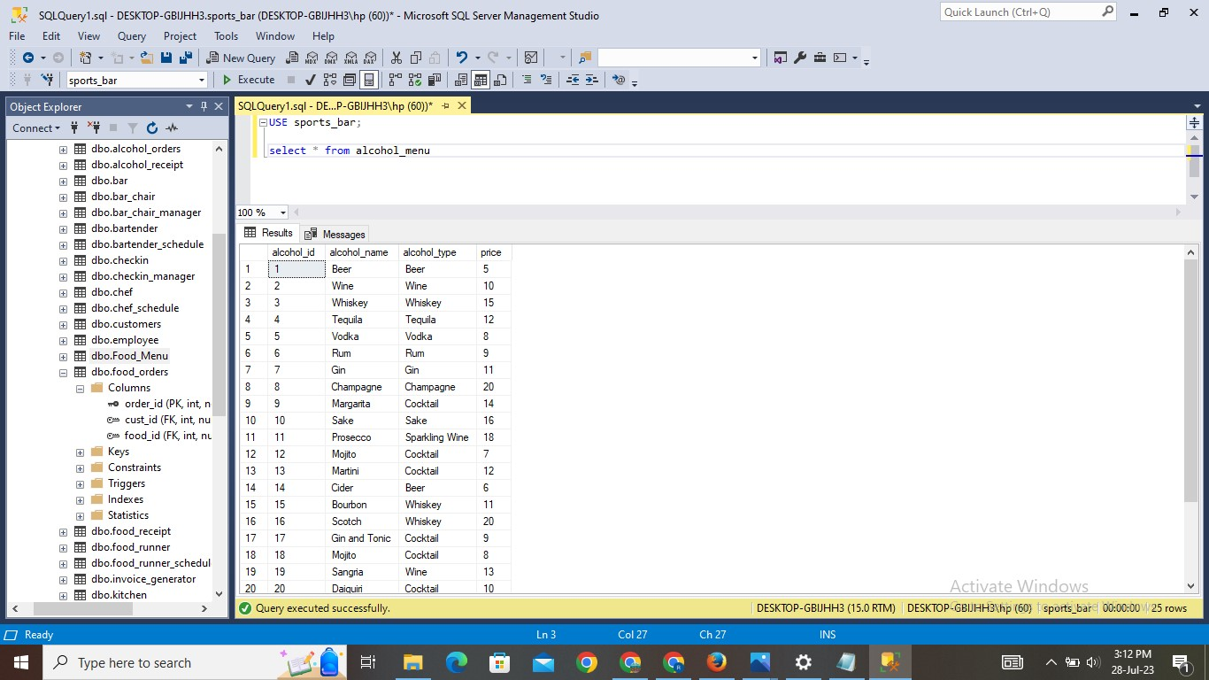

1. **Customers Table:**

**Explanation:**

* The table is created with the name of customers. This table gives us information about customer id, customer name, customer address, customer type.
* Values are inserted into the table. And using SELECT statement can check the inserted values.

**Query:**

CREATE TABLE customers ( Cust_id INT PRIMARY KEY,

Cust_name VARCHAR(30),

Cust_add VARCHAR(100),

Cust_type VARCHAR(10));

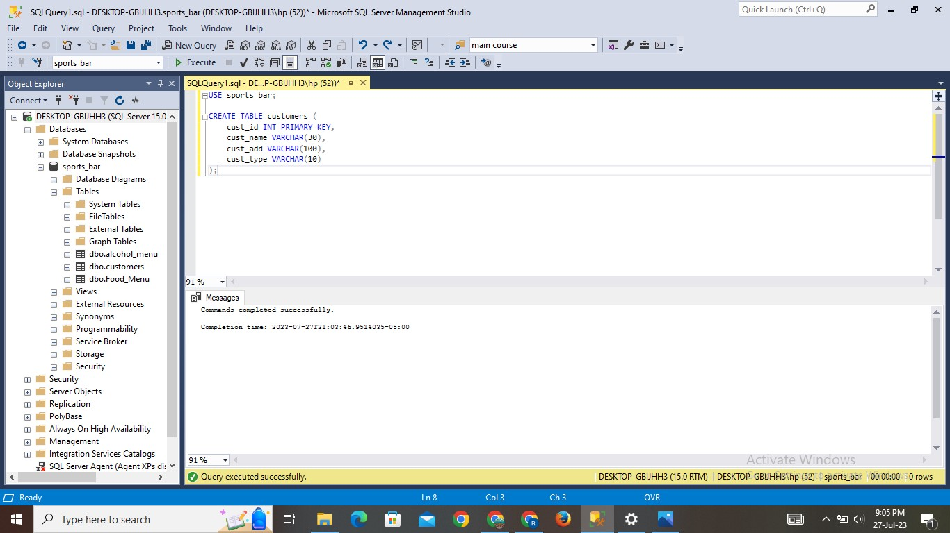

**INSERT STATEMENT:**

INSERT INTO customers (cust_id, cust_name, cust_add, cust_type) values

(1, 'John Doe', '123 Main Street', 'dine_in'),

(2, 'Jane Smith', '456 Elm Avenue', 'dine_in'),

 (3, 'Michael Johnson', '789 Oak Road', 'dine_in'),

(4, 'Emily Lee', '101 Pine Lane', 'online'),

(5, 'William Brown', '222 Maple Drive', 'dine_in'),

(6, 'Olivia Wilson', '333 Cedar Court', 'online'),

 (7, 'James Taylor', '444 Birch Street', 'dine_in'),

 (8, 'Sophia Martinez', '555 Willow Avenue', 'dine_in'),

 (9, 'Benjamin Anderson', '666 Pine Lane', 'online'),

 (10, 'Isabella Hernandez', '777 Oak Road', 'dine_in'),

(11, 'Mason Lopez', '888 Elm Avenue', 'dine_in'),

(12, 'Emma Garcia', '999 Maple Drive', 'online'),

(13, 'Alexander Martinez', '111 Cedar Court', 'dine_in'),

 (14, 'Ava Robinson', '222 Birch Street', 'dine_in'),

(15, 'Ethan Gonzalez', '333 Willow Avenue', 'dine_in'),

(16, 'Oliver Perez', '444 Pine Lane', 'online'),

(17, 'Charlotte Adams', '555 Oak Road', 'dine_in'),

(18, 'Amelia Scott', '666 Elm Avenue', 'dine_in'),

 (19, 'Lucas Mitchell', '777 Maple Drive', 'dine_in'),

(20, 'Mia Baker', '888 Cedar Court', 'online'),

(21, 'Aiden Green', '999 Birch Street', 'dine_in'), (

22, 'Harper Hall', '111 Willow Avenue', 'dine_in'),

 (23, 'Evelyn Adams', '222 Pine Lane', 'dine_in'),

 (24, 'Abigail Campbell', '333 Oak Road', 'online'),

(25, 'Elijah Allen', '444 Elm Avenue', 'dine_in'),

(26, 'John Johnson', '123 Elm Street, City U', 'Dine-in'),

(27, 'Emily Davis', '456 Cedar Avenue, City V', 'Online'),

 (28, 'Michael Wilson', '789 Pine Lane, City W', 'Dine-in'),

(29, 'Jessica Anderson', '101 Birch Road, City X', 'Online'),

(30, 'Daniel Lee', '555 Willow Drive, City Y', 'Dine-in'),

(31, 'Michelle Marz', '777 Oak Court, City Z', 'Online'),

(32, 'Andrew Clark', '888 Elm Street, City AA', 'Dine-in'),

(33, 'Laura Turner', '999 Pine Avenue, City BB', 'Online'),

(34, 'Matthew Perez', '111 Cedar Lane, City CC', 'Dine-in'),

 (35, 'Jennifer Davis', '222 Birch Road, City DD', 'Online'),

 (36, 'Christopher Wilson', '333 Willow Drive, City EE', 'Dine-in'),

(37, 'Elizabeth Adams', '444 Oak Street, City FF', 'Online'),

(38, 'Robert Smith', '555 Elm Court, City GG', 'Dine-in'),

 (39, 'Sarah Brown', '666 Pine Avenue, City HH', 'Online'),

(40, 'David Taylor', '777 Cedar Lane, City II', 'Dine-in')

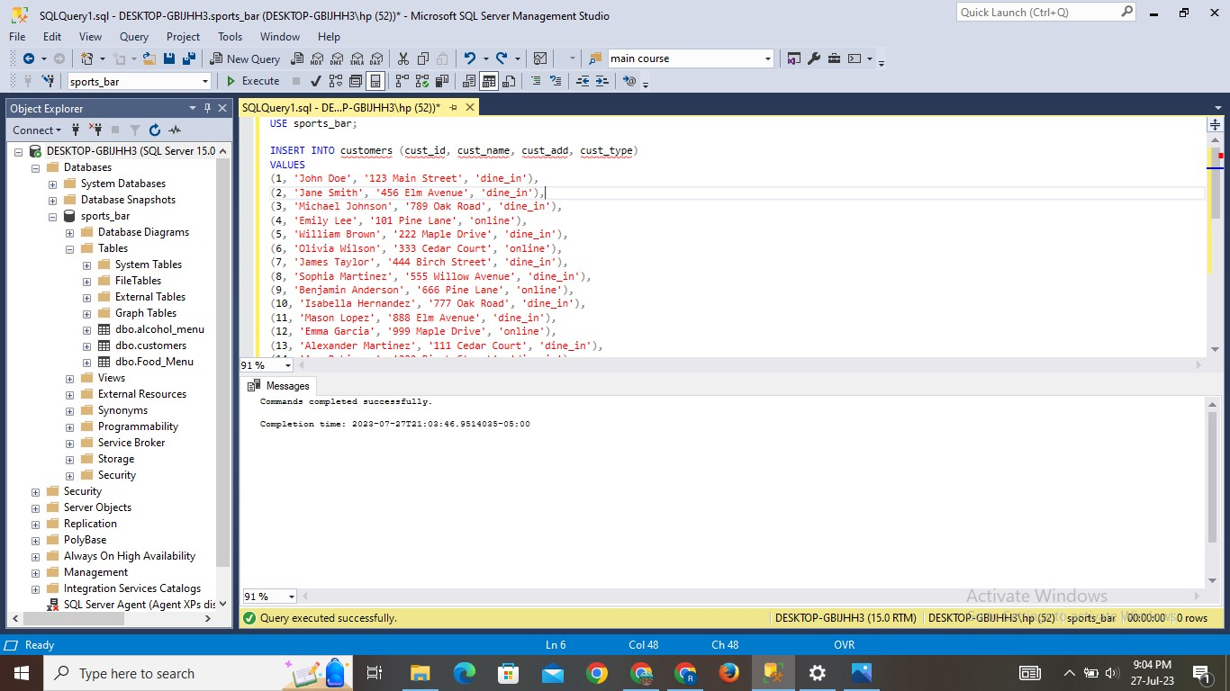

**Result:**

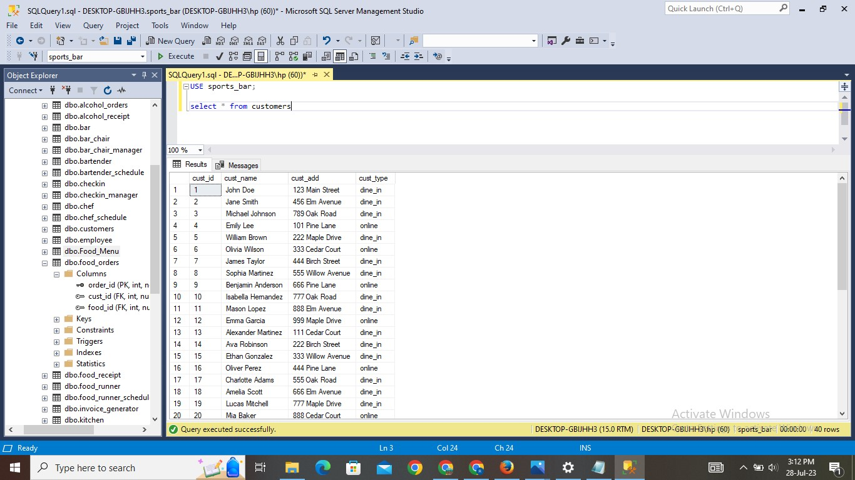

1. **Food Orders Table:**

**Explanation:**

* The table is created with the name of food_orders. This table gives us information about order id, customer id and food id.
* Values are inserted into the table. And using SELECT statement can check the inserted values.

**Query:**

CREATE TABLE food_order(Order_id INT PRIMARY KEY,

Cust_id INT,

Food_id INT,

FOREIGN KEY(cust_id) REFERENCES customers(cust_id),

FOREIGN KEY(food_id) REFERENCES food_menu(food_id));

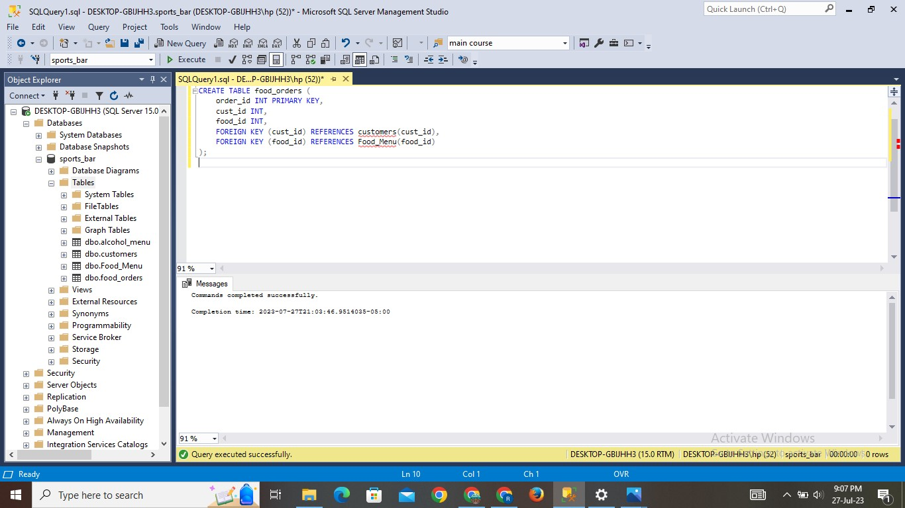

**INSERT STATEMENT:**

INSERT INTO food_orders(order_id, cust_id, food_id) values

(1, 1, 1),

(2, 1, 2),

(3, 1, 6),

(4, 2, 3),

(5, 2, 4),

(6, 3, 5),

(7, 3, 10),

(8, 4, 7),

(9, 5, 8),

(10, 5, 9),

(11, 5, 13),

(12, 6, 10),

(13, 6, 14),

(14, 7, 12),

(15, 7, 15),

(16, 8, 14),

(17, 8, 19),

(18, 9, 16),

(19, 9, 22),

(20, 10, 17),

(21, 10, 23),

(22, 11, 18),

(23, 12, 19),

(24, 12, 21),

(25, 13, 20),

(26, 25, 1),

(27, 25, 2),

(28, 26, 3),

(29, 26, 4),

(30, 27, 5),

(31, 27, 10),

(32, 28, 7),

(33, 28, 8),

(34, 29, 9),

(35, 29, 13),

(36, 30, 10),

(37, 30, 14),

(38, 31, 12),

(39, 31, 15),

(40, 32, 14),

(41, 32, 19),

(42, 33, 16),

(43, 33, 22),

(44, 34, 17),

(45, 34, 23),

(46, 35, 18),

(47, 36, 19),

(48, 36, 21),

(49, 37, 20)

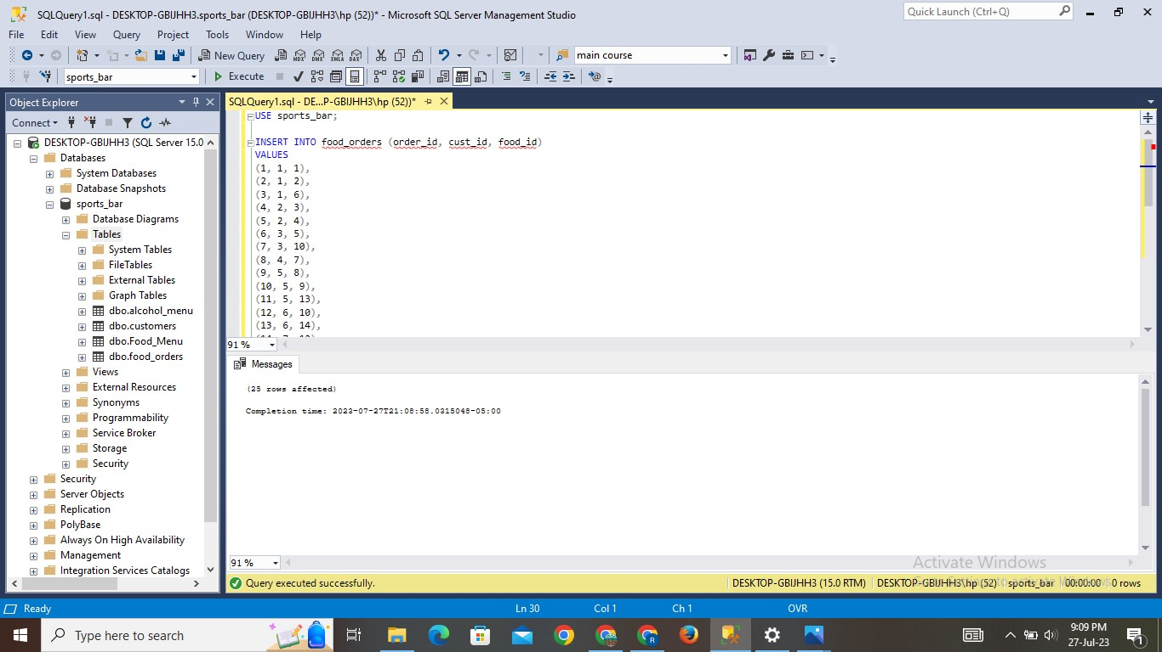

**Result:**

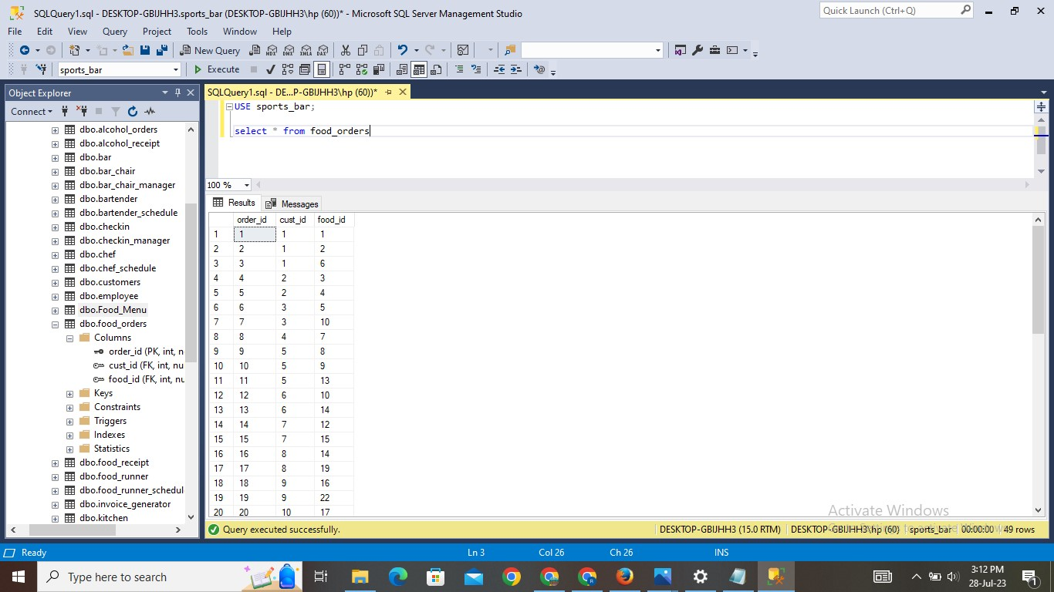

1. **Alcohol Orders Table:**

**Explanation:**

* The table is created with the name of alcohol orders. This table gives us information about order id, customer id, and alcohol id.
* Values are inserted into the table. And using SELECT statement can check the inserted values.

**Query:**

CREATE TABLE alcohol_order( Order_id INT PRIMARY KEY,

Cust_id INT,

alcohol_id INT,

FOREIGN KEY(cust_id) REFERENCES customers(cust_id),

FOREIGN KEY(alcohol_id) REFERENCES food_menu(alcohol_id));

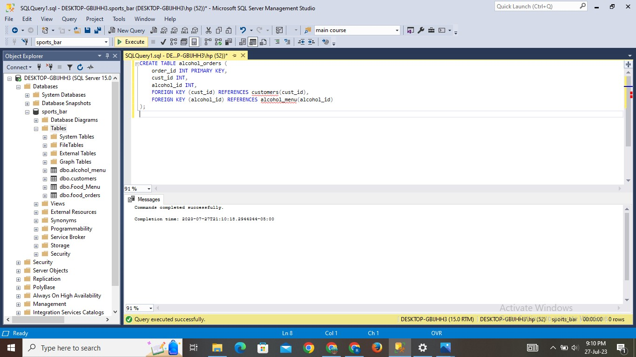

**INSERT STATEMENT:**

INSERT INTO alcohol_orders(order_id, cust_id, alcohol_id) values

    (1, 1, 2),

    (2, 1, 5),

    (3, 2, 1),

    (4, 3, 2),

    (5, 3, 1),

    (6, 4, 6),

    (7, 5, 2),

    (8, 5, 9),

    (9, 6, 11),

    (10, 7, 2),

    (11, 8, 11),

    (12, 9, 3),

    (13, 9, 5),

    (14, 10, 1),

    (15, 11, 8),

    (16, 12, 12),

    (17, 13, 2),

    (18, 14, 6),

    (19, 15, 3),

    (20, 16, 8),

    (21, 16, 12),

    (22, 17, 2),

    (23, 18, 7),

    (24, 18, 14),

    (25, 19, 12),

    (26, 25, 1),

    (27, 25, 2),

    (28, 26, 3),

    (29, 26, 4),

    (30, 27, 5),

    (31, 27, 10),

    (32, 28, 7),

    (33, 28, 8),

    (34, 29, 9),

    (35, 29, 13),

    (36, 30, 10),

    (37, 30, 14),

    (38, 31, 12),

    (39, 31, 15),

    (40, 32, 14),

    (41, 32, 19),

    (42, 33, 16),

    (43, 33, 22),

    (44, 34, 17),

    (45, 34, 23),

    (46, 35, 18),

    (47, 36, 19),

    (48, 36, 21),

    (49, 37, 20)

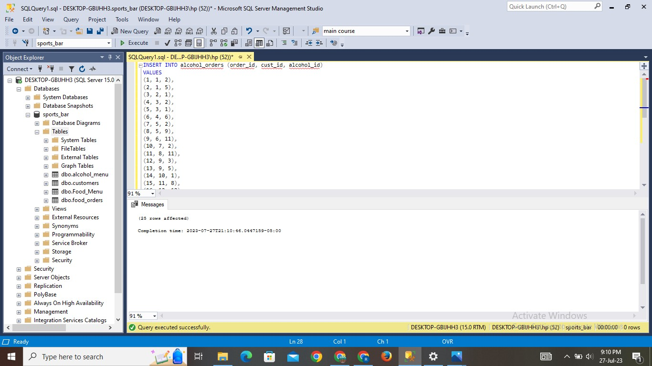

**Result:**

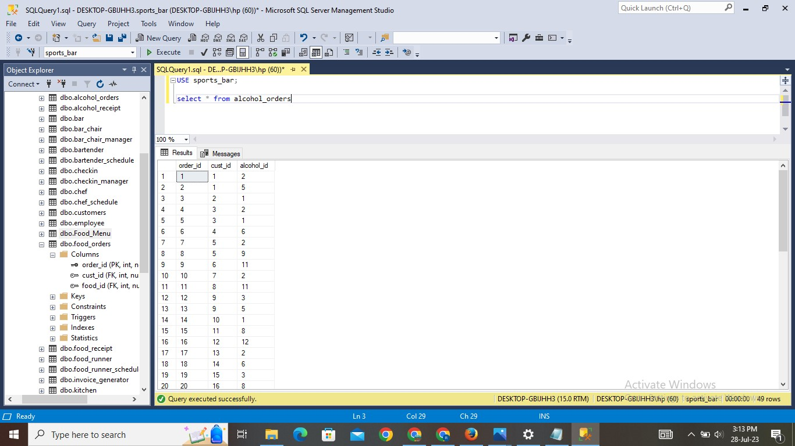

1. **Employee Table:**

**Explanation:**

* The table is created with the name of the employee. This table gives us information about employee id, employee name, employee type.
* Values are inserted into the table. And using SELECT statement can check the inserted values.

**Query:**

Create table employee(Employee_id int primary key

Employee_name varchar(30),

Employee_type varchar(20))

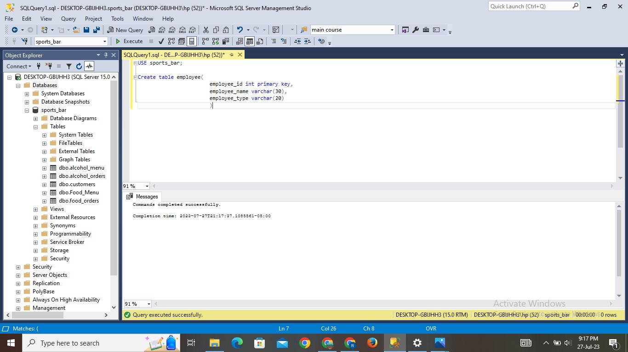

**INSERT STATEMENT:**

INSERT INTO employee(employee_id, employee_name, employee_type) VALUES

    (1, 'John Smith', 'barpack'),

    (2, 'Emily Johnson', 'bartender'),

    (3, 'Michael Williams', 'server'),

    (4, 'Sarah Brown', 'food runner'),

    (5, 'David Jones', 'chef'),

    (6, 'Jennifer Davis', 'bartender'),

    (7, 'Robert Miller', 'server'),

    (8, 'Linda Wilson', 'chef'),

    (9, 'William Taylor', 'server'),

    (10, 'Karen Anderson', 'bartender'),

    (11, 'Richard Martinez', 'food runner'),

    (12, 'Nancy Lee', 'chef'),

    (13, 'Charles Clark', 'server'),

    (14, 'Margaret Hall', 'barpack'),

    (15, 'Matthew Lewis', 'server'),

    (16, 'Susan Scott', 'bartender'),

    (17, 'Daniel Green', 'food runner'),

    (18, 'Donna Adams', 'chef'),

    (19, 'Paul Hill', 'server'),

    (20, 'Carolyn Carter', 'barpack'),

    (21, 'George Turner', 'server'),

    (22, 'Betty Perez', 'chef'),

    (23, 'Kenneth Mitchell', 'bartender'),

    (24, 'Angela Rivera', 'food runner'),

    (25, 'Steven Evans', 'server')

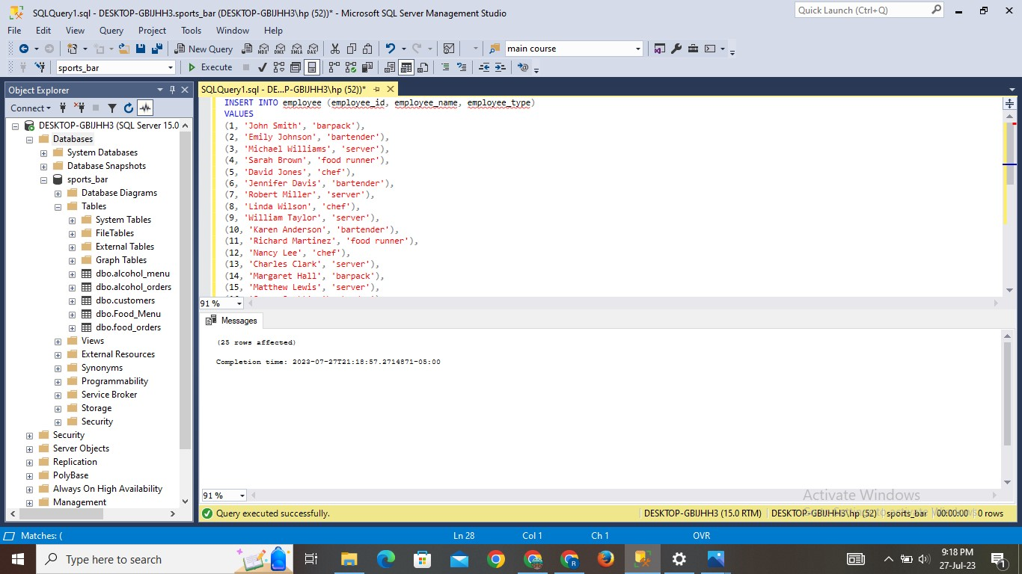

**Result:**

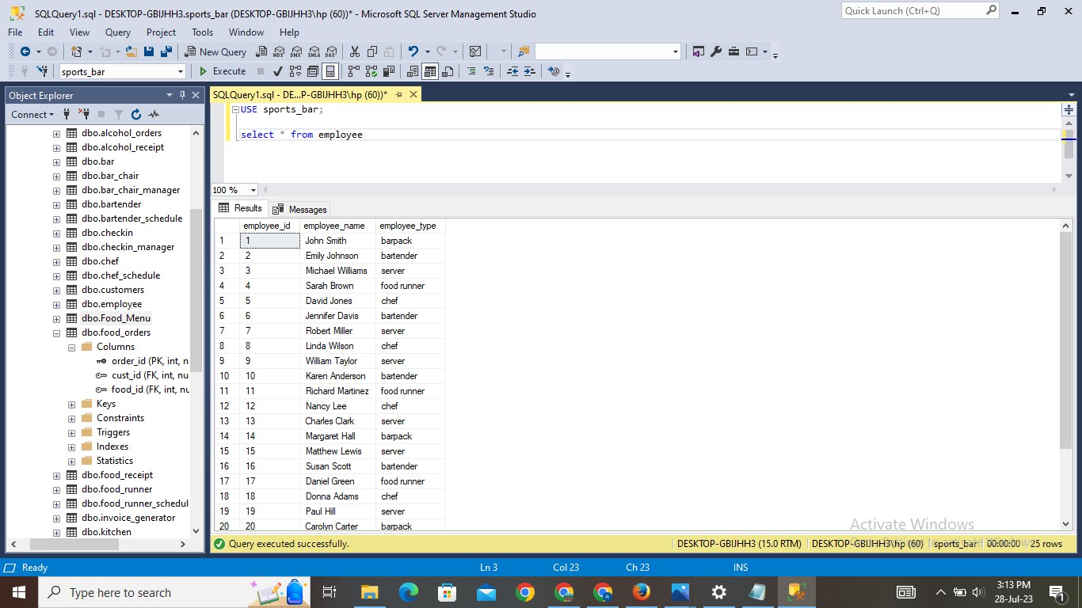

1. **Owner Table:**

**Explanation:**

* The table is created with the name of the owner. This table gives us information about owner id, owner name.
* Values are inserted into the table. And using SELECT statement can check the inserted values.

**Query:**

Create table owner (owner-id int primary key,

Owner_name varchar(30))

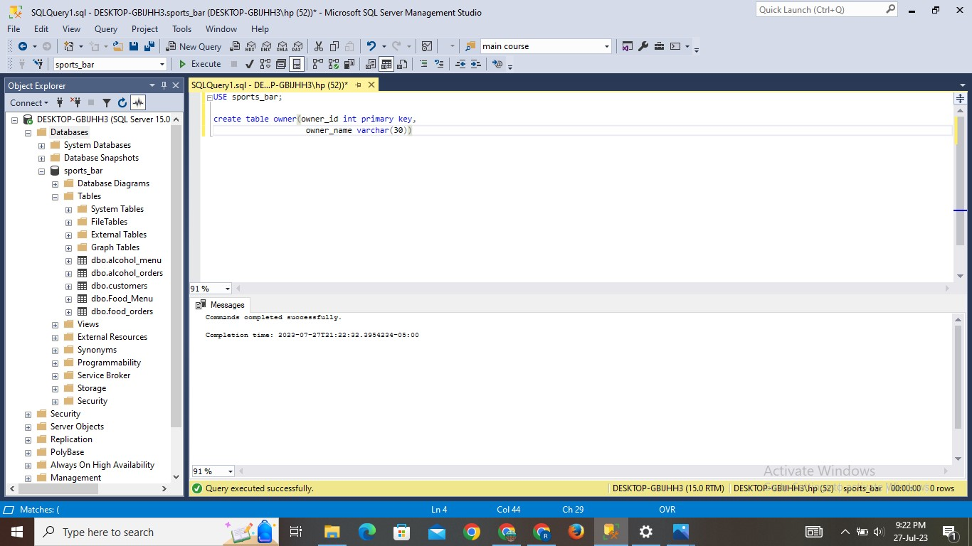

**INSERT STATEMENT:**

INSERT INTO owner(owner_id, owner_name) VALUES

    (1, 'John Smith'),

    (2, 'Emily Johnson')

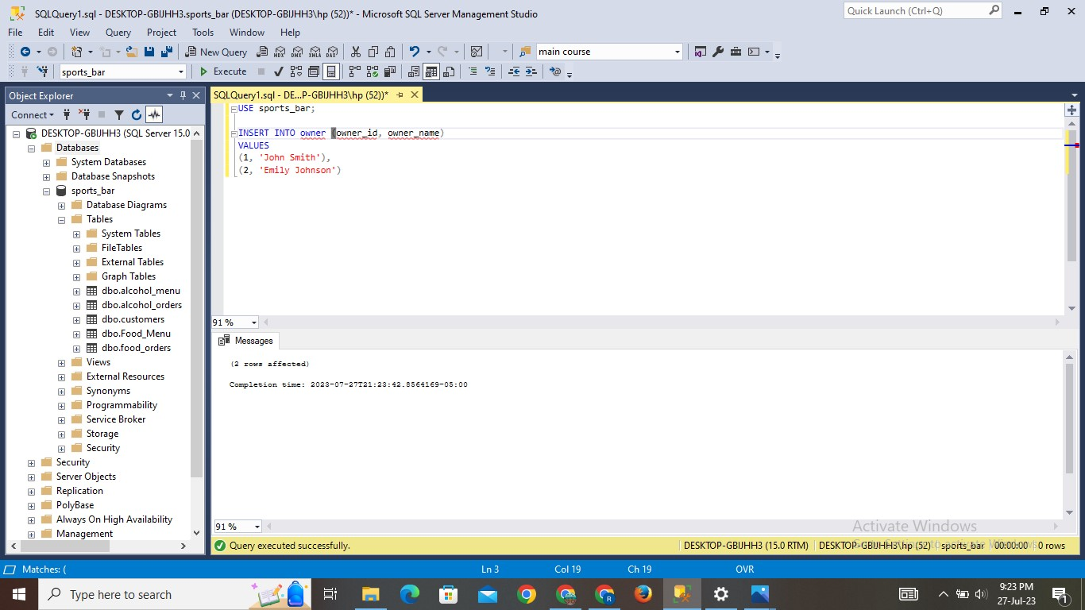

**Result:**

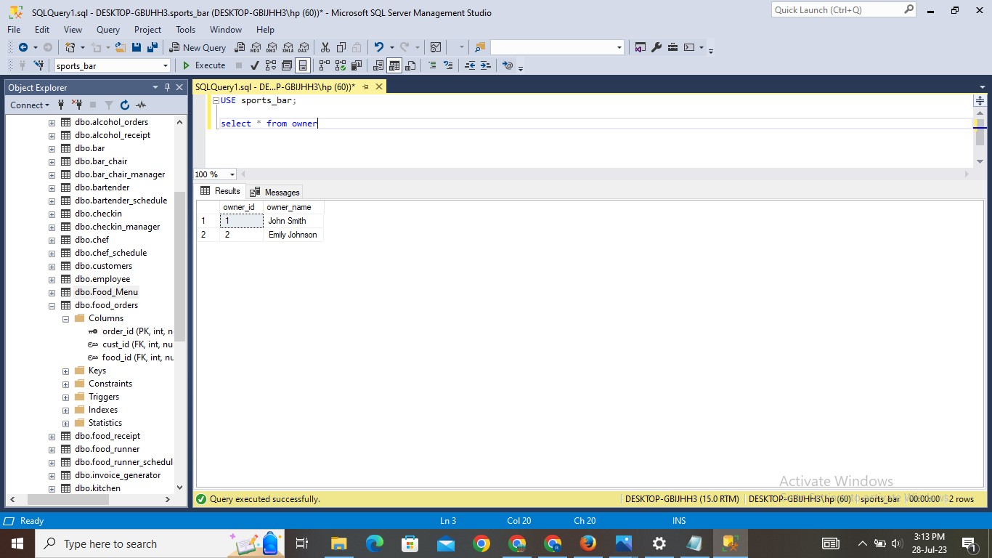

1. **Tables R Table:**

**Explanation:**

* The table is created with the name of tables_r. This table gives us information about table id and table capacity i.e., 2, 4 or 6.
* Values are inserted into the table. And using SELECT statement can check the inserted values.

**Query:**

Create table tables_r (table_id int primary key,

Table_capacity int)

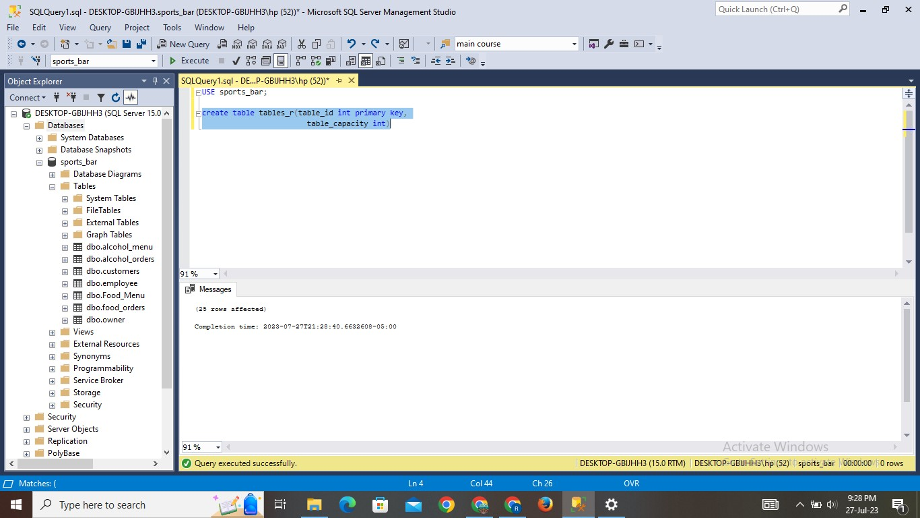

**INSERT STATEMENT:**

INSERT INTO tables_r(table_id, table_capacity) VALUES

    (1, 2),

    (2, 4),

    (3, 6),

    (4, 4),

    (5, 2),

    (6, 6),

    (7, 4),

    (8, 2),

    (9, 8),

    (10, 4),

    (11, 2),

    (12, 6),

    (13, 4),

    (14, 2),

    (15, 6),

    (16, 4),

    (17, 2),

    (18, 4),

    (19, 6),

    (20, 2),

    (21, 8),

    (22, 4),

    (23, 2),

    (24, 6),

    (25, 4)

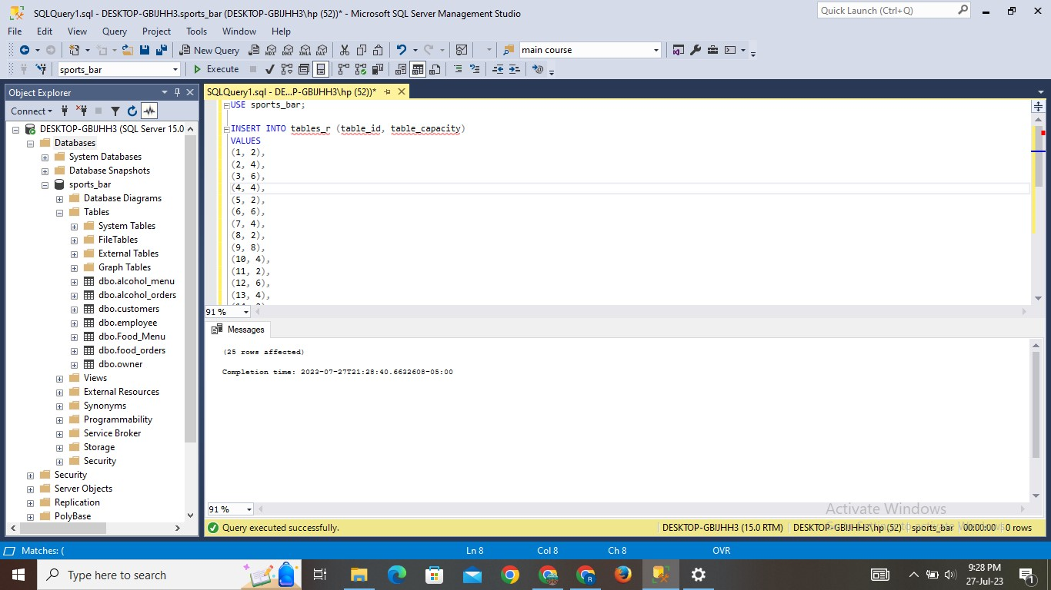

**Result:**

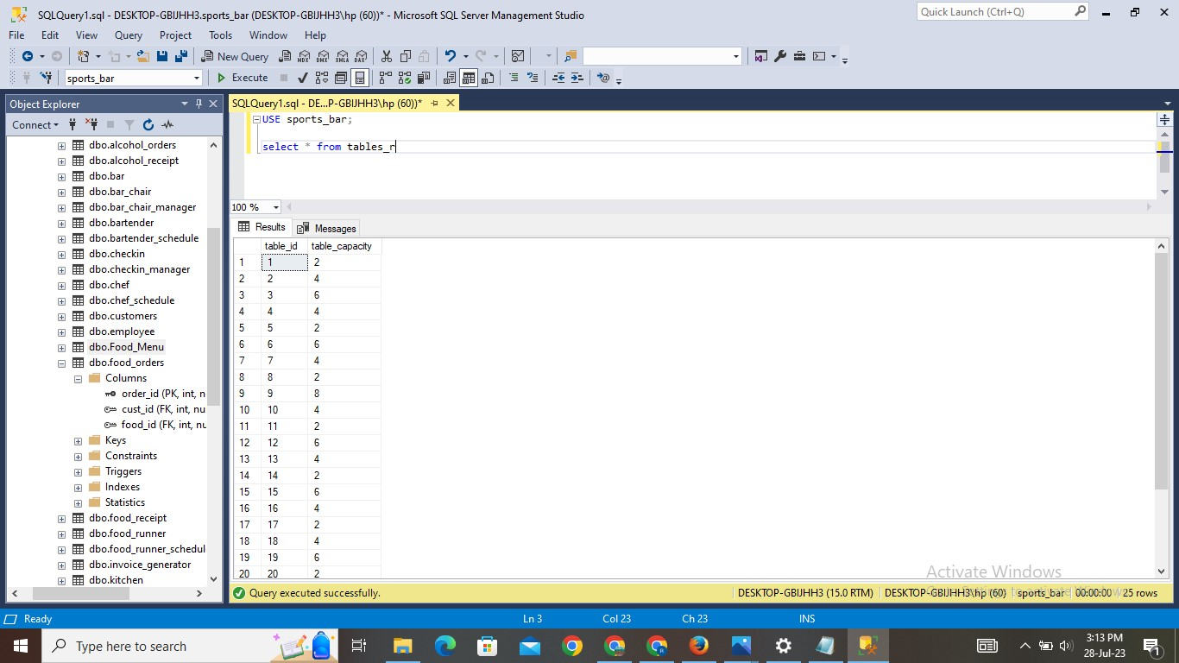

1. **Tables Manager Table:**

**Explanation:**

* The table is created with the name of tables_manager. This table gives us information about table id, customer id and gives the status of reservation for that particular table.
* Values are inserted into the table. And using SELECT statement can check the inserted values.

**Query:**

Create table tables_manager(table_id int,

Cust_id int, reserver varchar(3),

Foreign key(table_id) references tables_r(table_id), Foreign key(cust_id) references customers(cust_id))

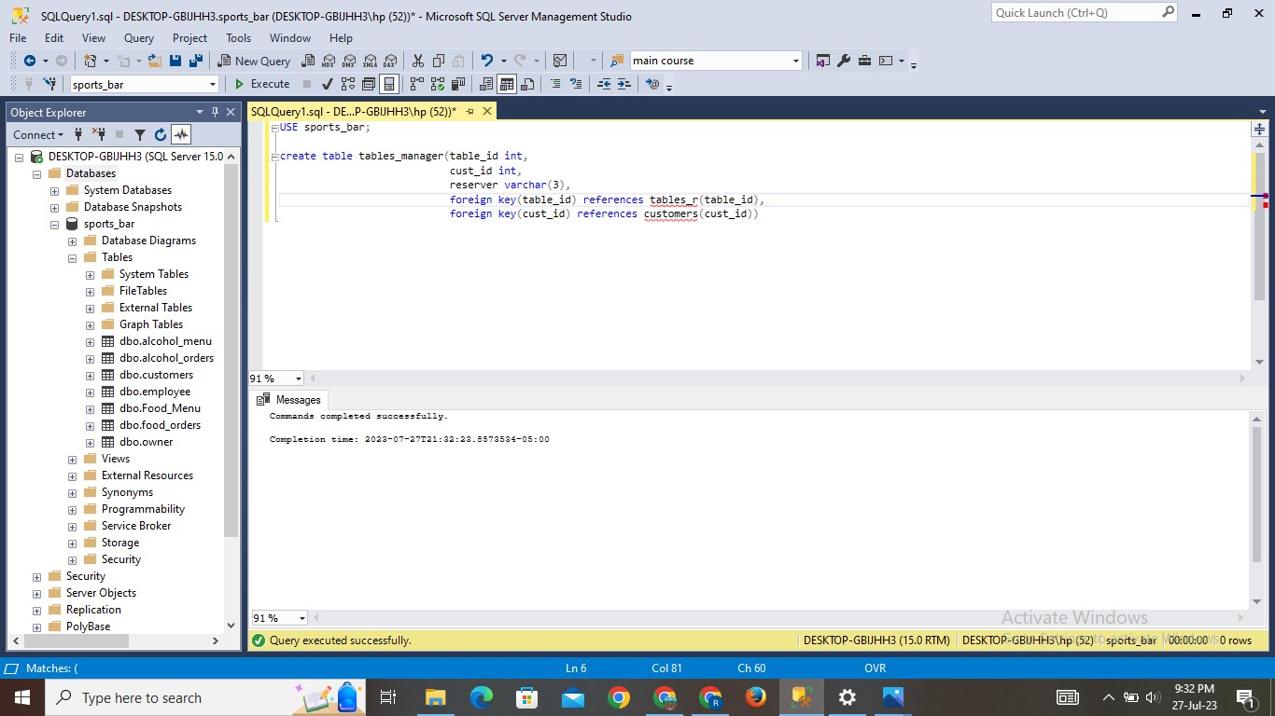

**INSERT STATEMENT:**

INSERT INTO tables_manager (table_id, cust_id, reserver) VALUES

    (1, 1, 'Yes'),

    (2, 3, 'No'),

    (3, 5, 'Yes'),

    (4, 7, 'Yes'),

    (5, 9, 'No'),

    (6, 11, 'No'),

    (7, 13, 'Yes'),

    (8, 15, 'No'),

    (9, 17, 'Yes'),

    (10, 19, 'No'),

    (11, 21, 'No'),

    (12, 23, 'Yes'),

    (13, 25, 'Yes'),

    (14, None, 'No'),

    (15, None, 'Yes'),

    (16, None, 'No'),

    (17, None, 'No'),

    (18, None, 'No'),

    (19, None, 'Yes'),

    (20, None, 'Yes'),

    (21, None, 'No'),

    (22, None, 'Yes'),

    (23, None, 'No'),

    (24, None, 'No'),

    (25, None, 'Yes')

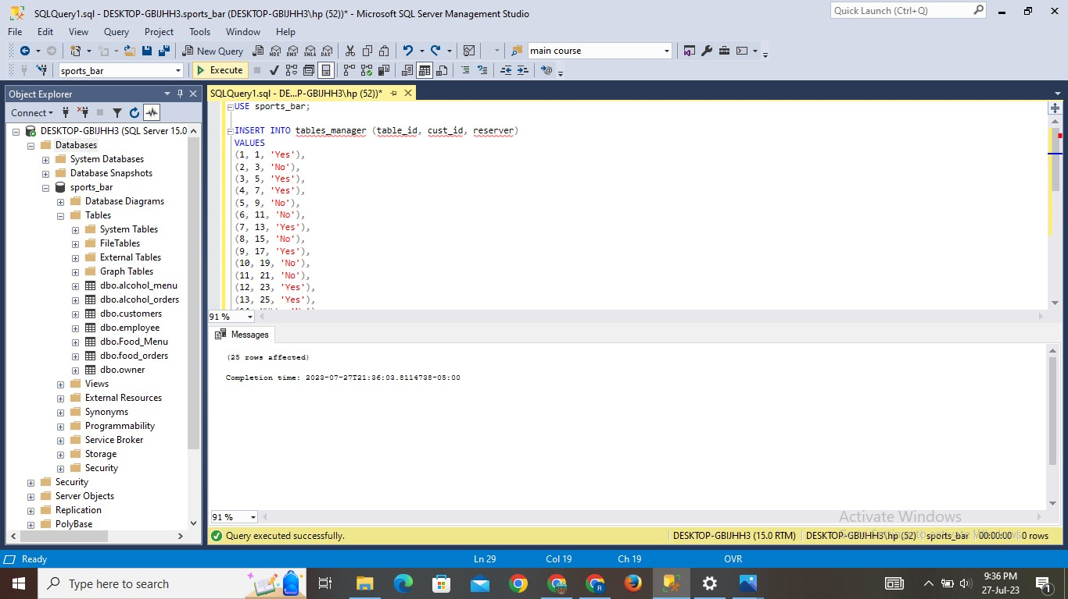

**Result:**

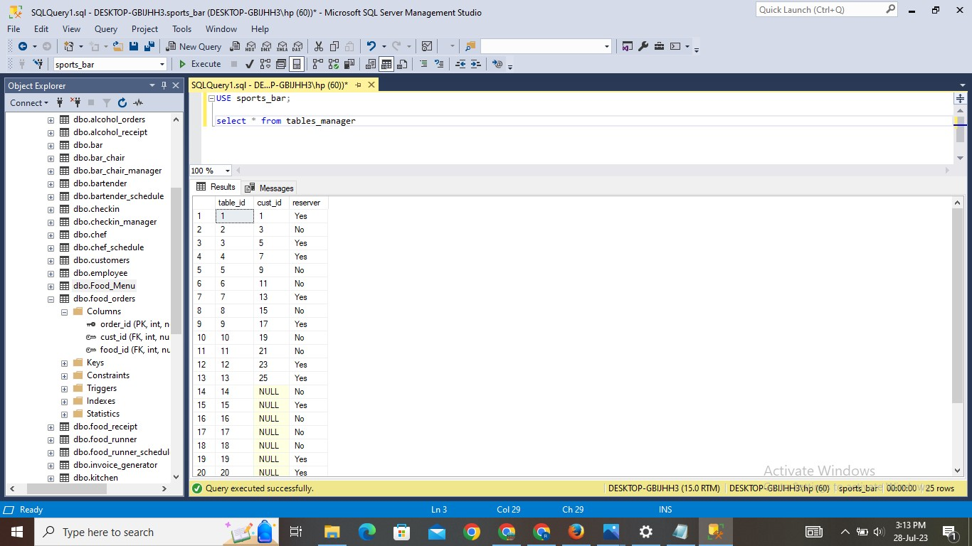

1. **Server Schedule Table:**

**Explanation:**

* The table is created with the name of servers_schedule. This table gives us information about server id and employee id.
* Values are inserted into the table. And using SELECT statement can check the inserted values.

**Query:**

Create table servers_schedule( server_id int primary key,

Employee_id int,

Foreign key (employee_id) references employee(employee_id))

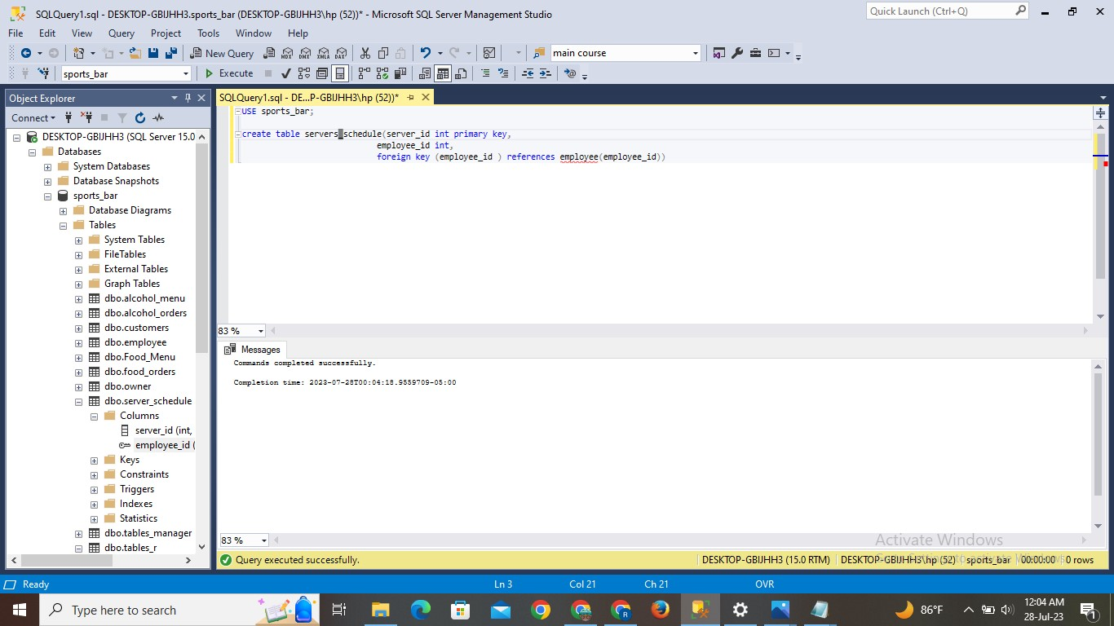

**INSERT STATEMENT:**

Insert into servers_schedule values

    (1, 3),

    (2, 7),

    (3, 9),

    (4, 13),

    (5, 15),

    (6, 19),

    (7, 21),

    (8, 25)

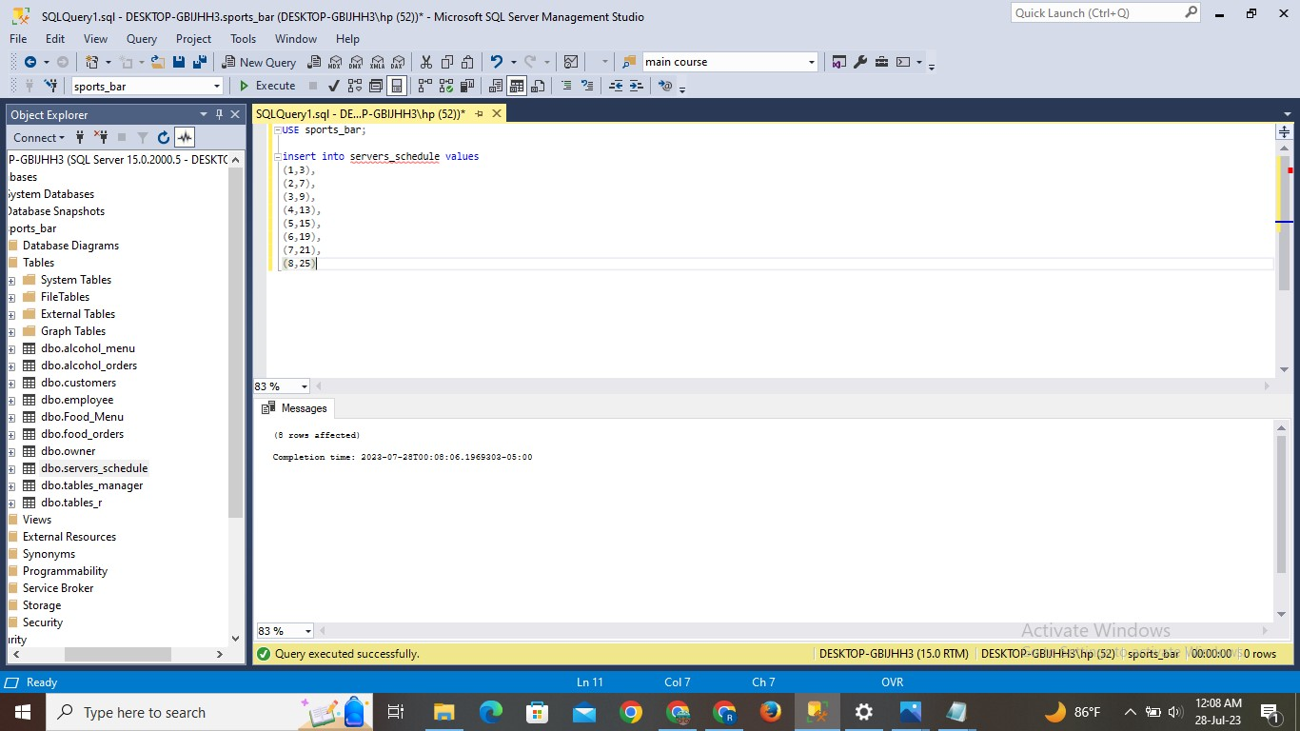

**Result:**

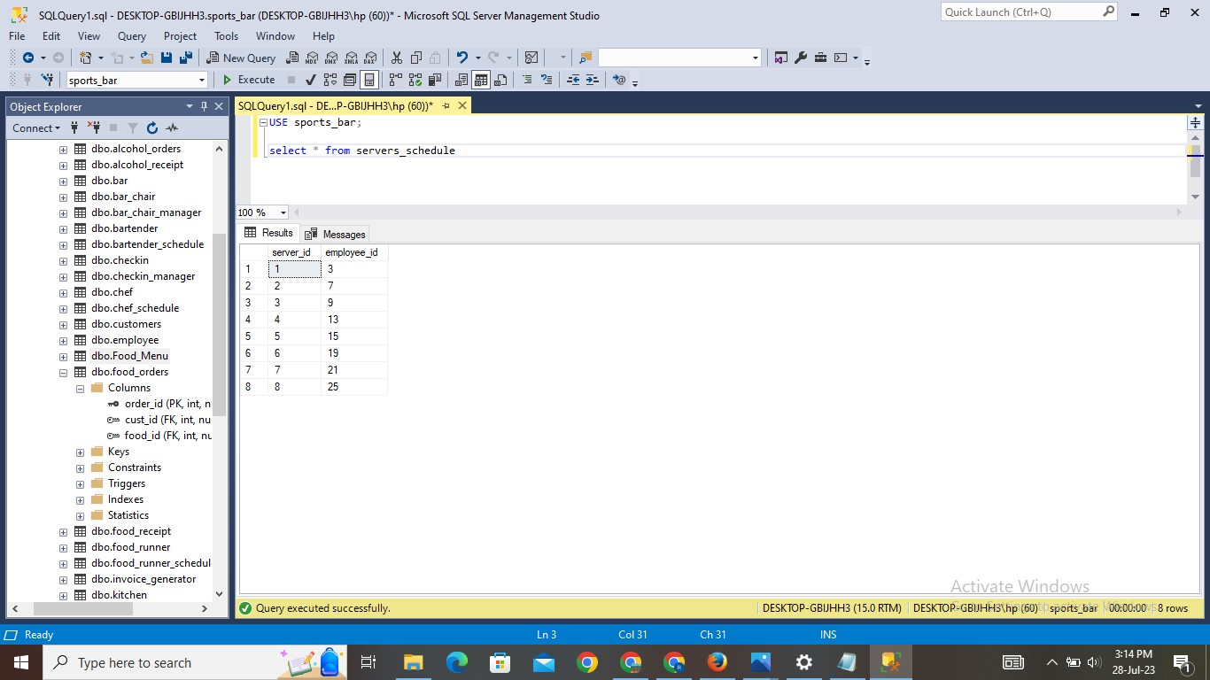

1. **Server S Table:**

**Explanation:**

* The table is created with the name of server_s. This table gives us information about server id, table id and customer id.
* Values are inserted into the table. And using SELECT statement can check the inserted values.

**Query:**

Create table server_s(server_id int,

Table_id int,

Cust_id int,

Foreign key(server_id) references servers_schedule(server_id),

Foreign key(table_id) references tables_r(table_id),

Foreign key(cust_id) references customers(cust_id))

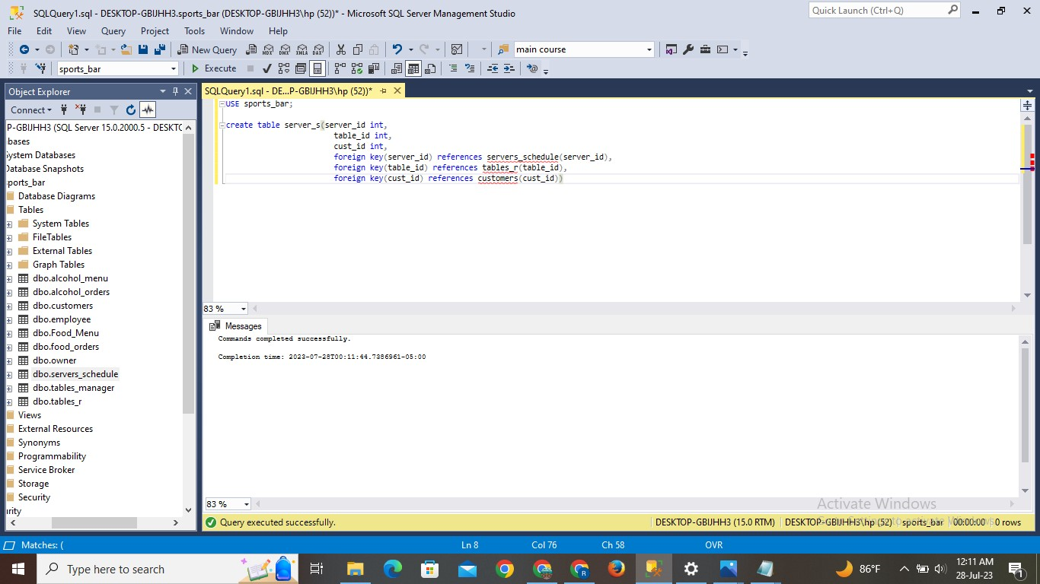

**INSERT STATEMENT:**

Insert into server_s values

(1, 1, 1),

    (5, 2, 3),

    (3, 3, 5),

    (6, 4, 7),

    (7, 5, 9),

    (2, 6, 11),

    (8, 7, 13),

    (4, 8, 15),

    (3, 9, 17),

    (1, 10, 19),

    (2, 11, 21),

    (7, 12, 23),

    (5, 13, 25)

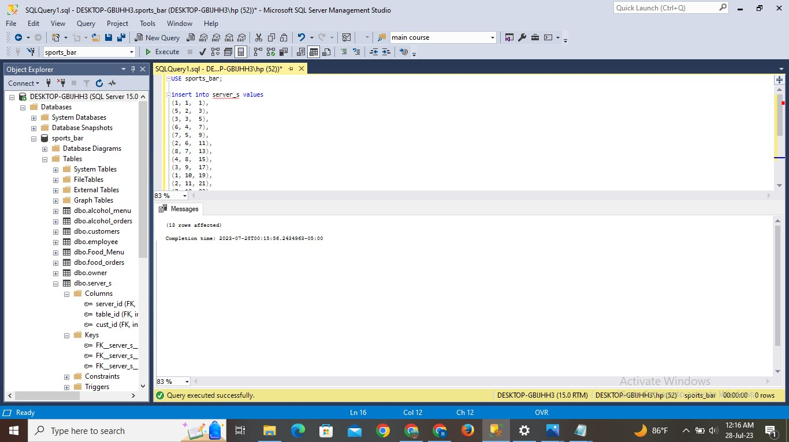

**Result:**

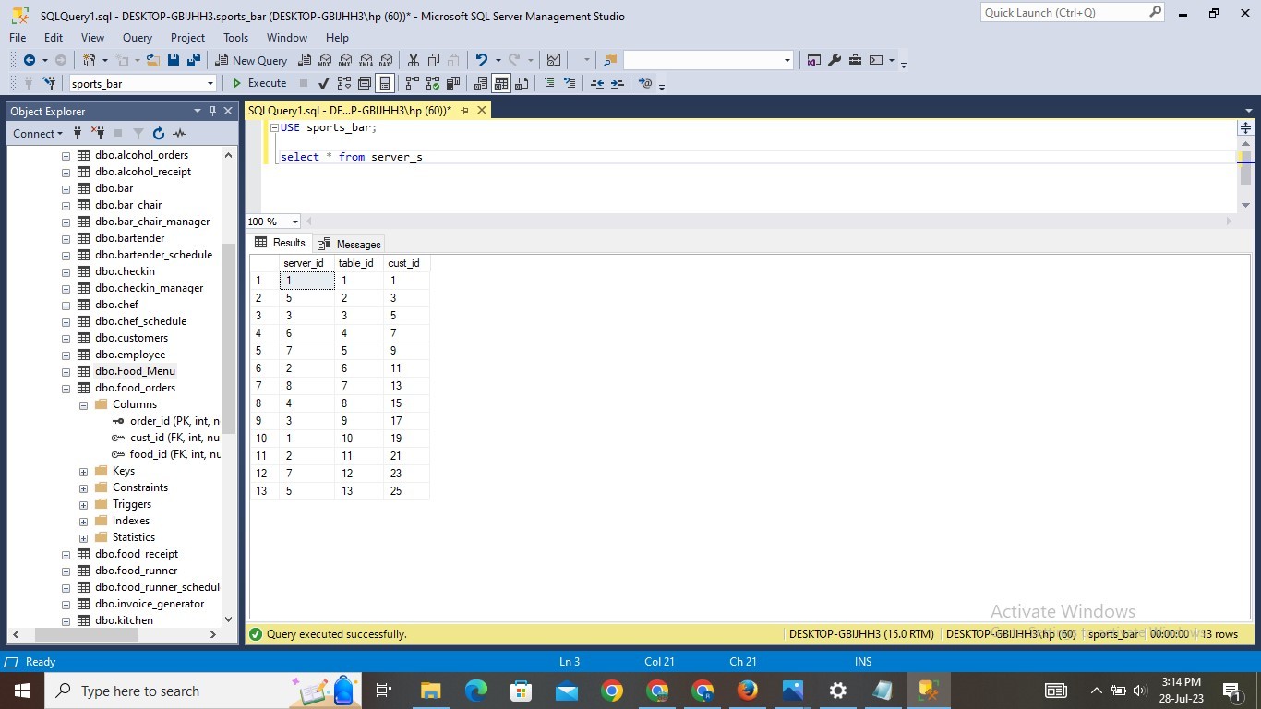

1. **Chef Schedule Table:**

**Explanation:**

* The table is created with the name of chef_schedule. This table gives us information about chef id and employee id.
* Values are inserted into the table. And using SELECT statement can check the inserted values.

**Query:**

Create table chef_schedule(chef_id int primary key,

Employee_id int,

Foreign key(employee_id) references employee(employee_id))

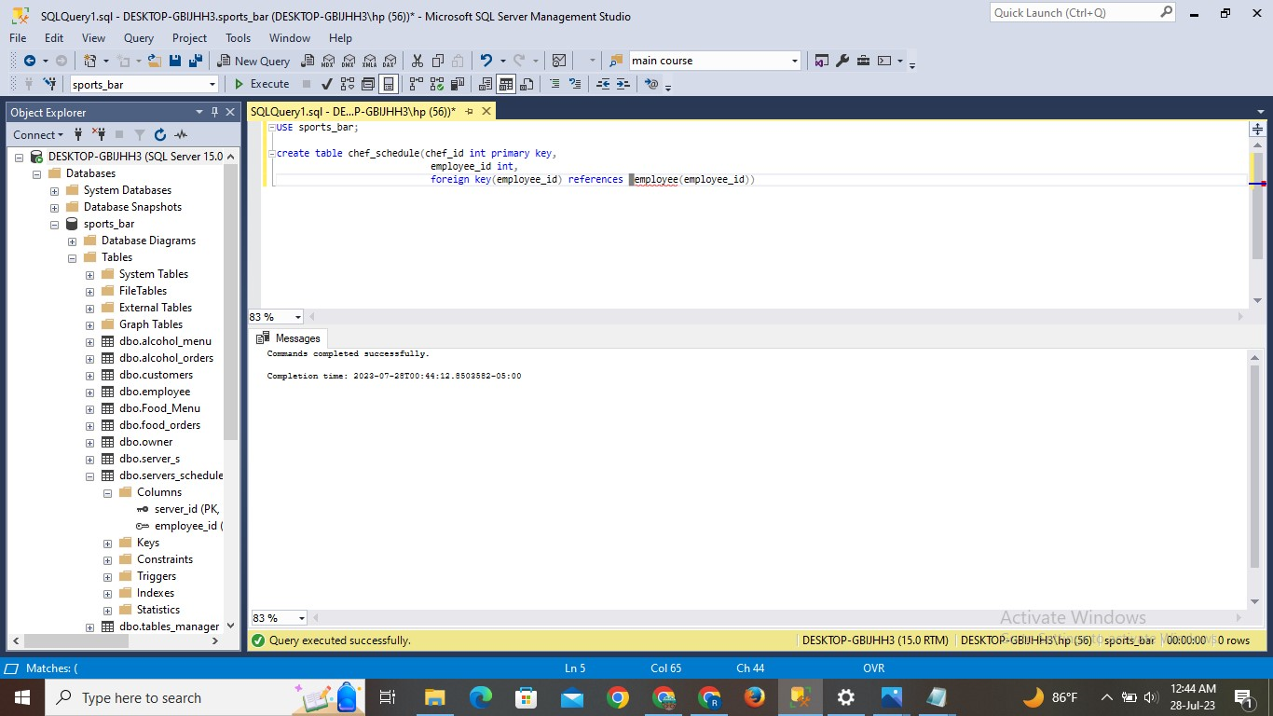

**INSERT STATEMENT:**

Insert into chef_schedule values

    (1, 5),

    (2, 8),

    (3, 12),

    (4, 18),

    (5, 22)

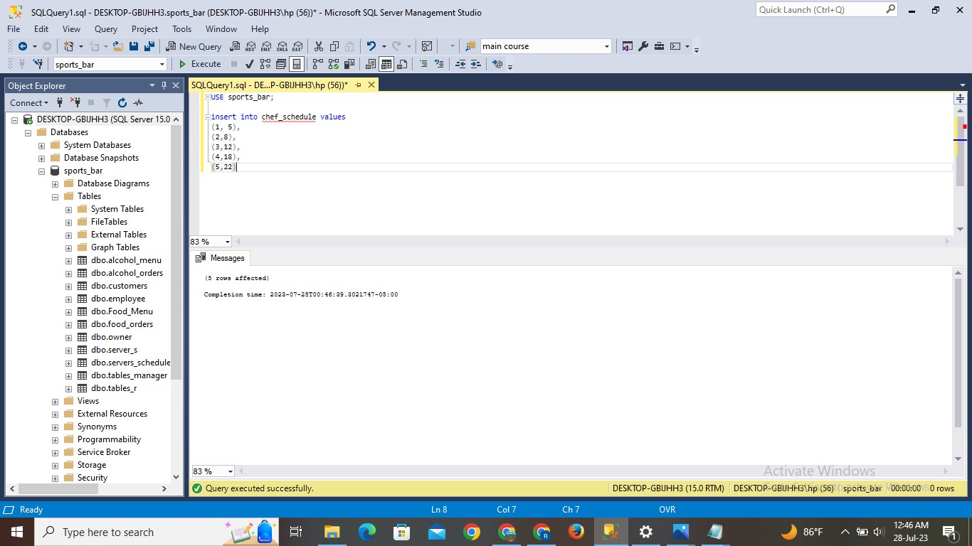

**Result:**

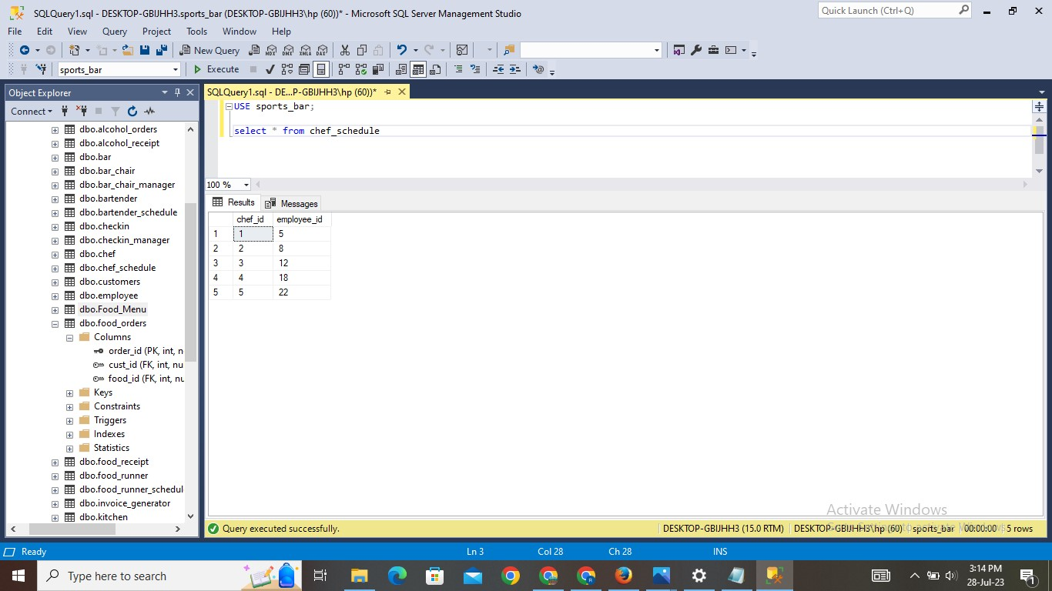

1. **Chef Table:**

**Explanation:**

* The table is created with the name of chef. This table gives us information about chef id and chef type like junior or senior.
* Values are inserted into the table. And using SELECT statement can check the inserted values.

**Query:**

Create table chef(chef_id int,

Chef_type varchar(10),

Foreign key(chef_id) references chef_schedule(chef_id))

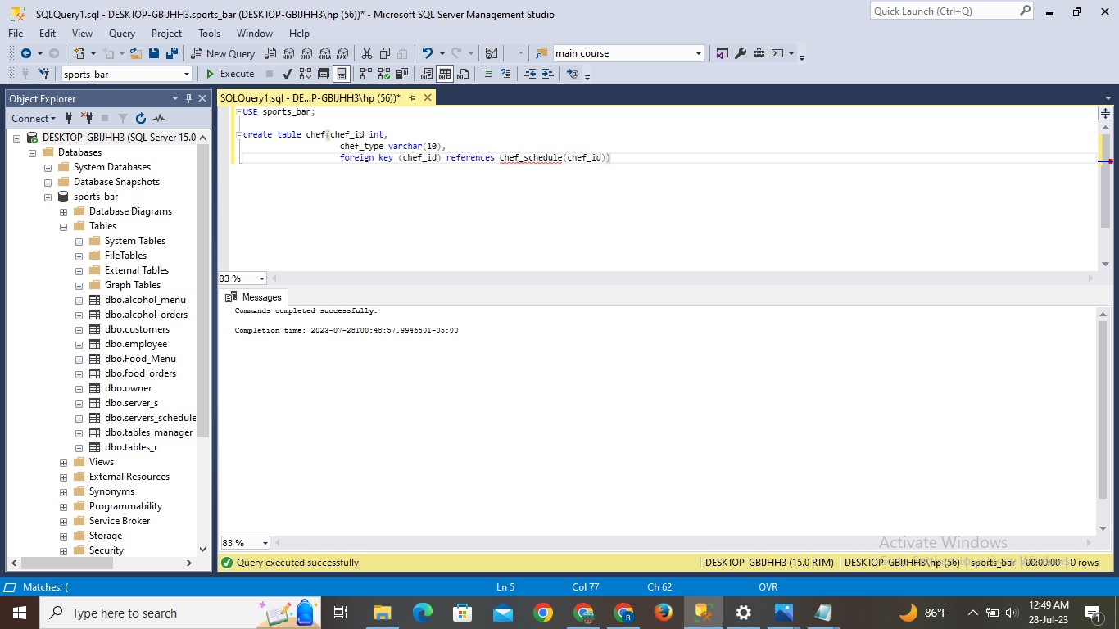

**INSERT STATEMENT:**

Insert into chef values

    (1, 'junior'),

    (2, 'senior'),

    (3, 'executive'),

    (4, 'commi'),

    (5, 'junior')

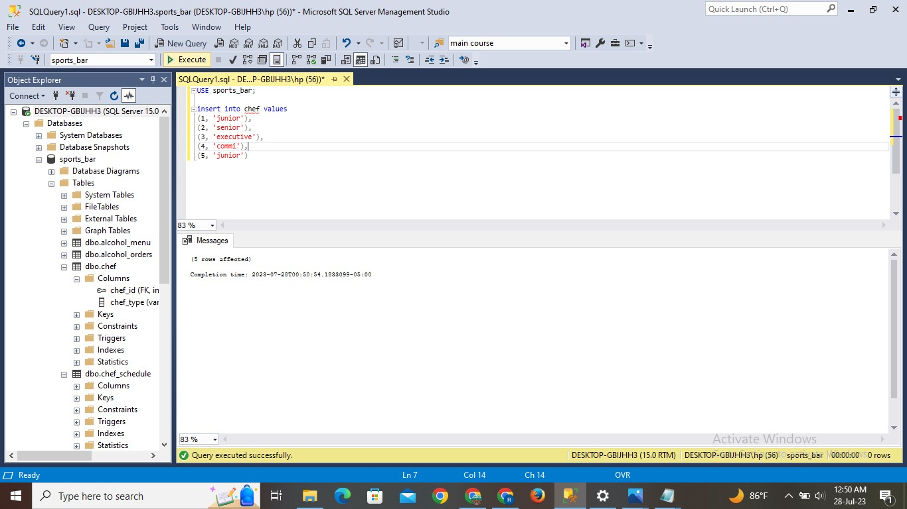

**Result:**

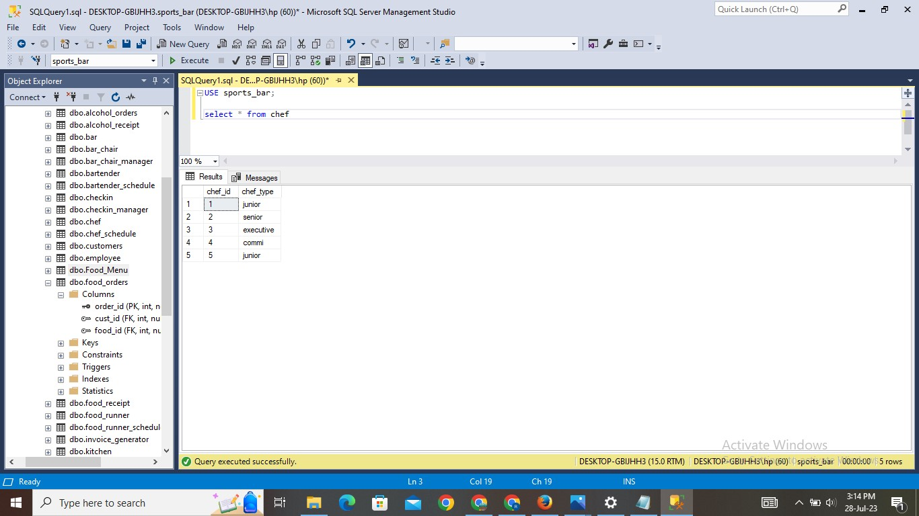

1. **Bar Chair Table:**

**Explanation:**

* The table is created with the name of bar_chair. This table gives us information about chair id and chair capacity.
* Values are inserted into the table. And using SELECT statement can check the inserted values.

**Query:**

Create table bar_chair(chair_id int primary key,

Chair_capacity int)

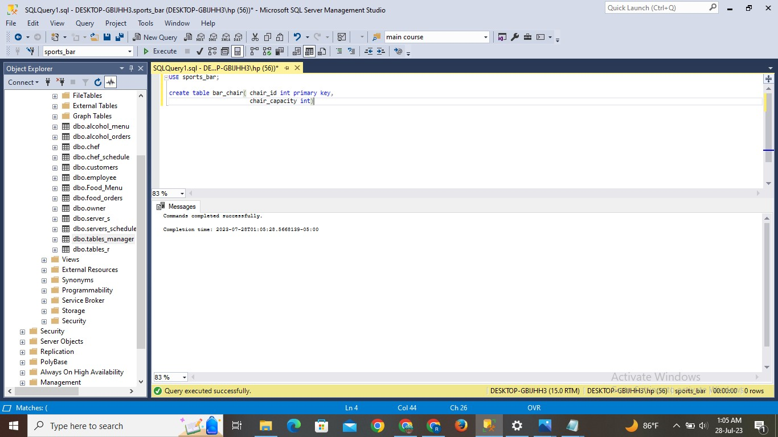

**INSERT STATEMENT:**

INSERT INTO bar_chair(chair_id, chair_capacity) VALUES

    (1, 2),

    (2, 2),

    (3, 1),

    (4, 3),

    (5, 1),

    (6, 2),

    (7, 3),

    (8, 2),

    (9, 1),

    (10, 3),

    (11, 1),

    (12, 2),

    (13, 2),

    (14, 1),

    (15, 3),

    (16, 1),

    (17, 2),

    (18, 2),

    (19, 3),

    (20, 1),

    (21, 2),

    (22, 2),

    (23, 1),

    (24, 3),

    (25, 1)

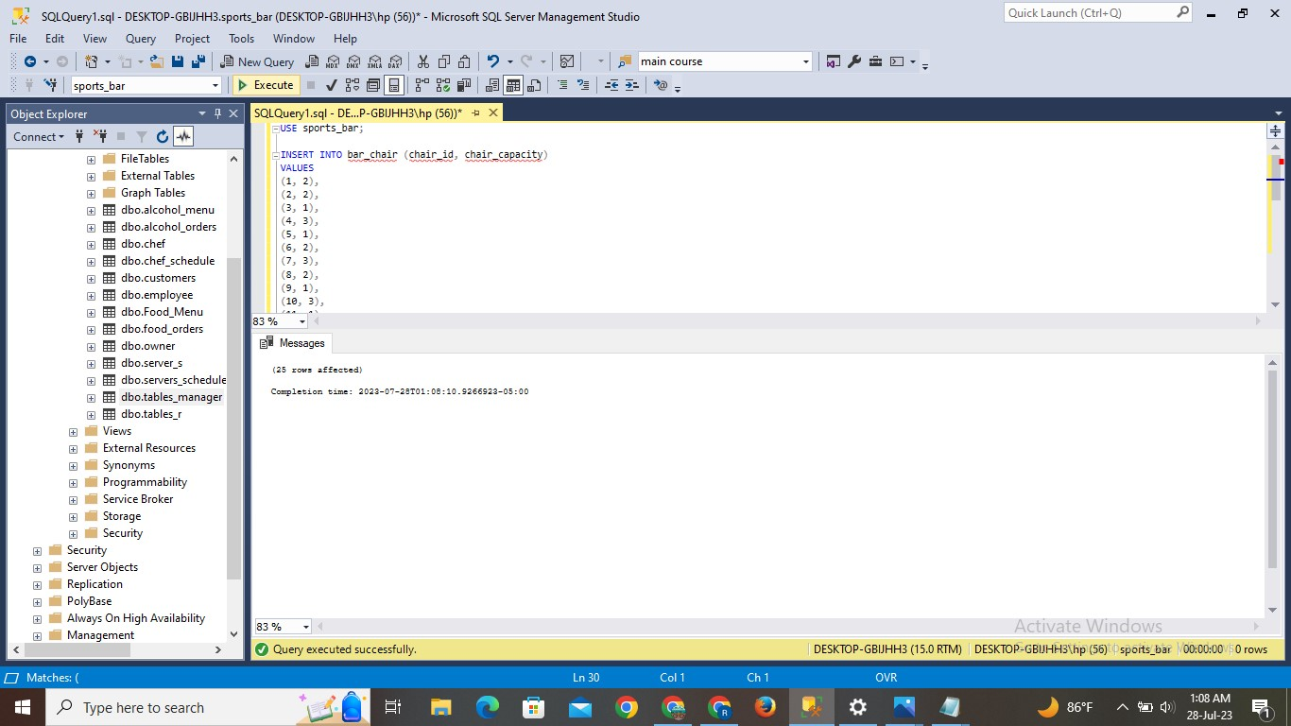

**Result:**

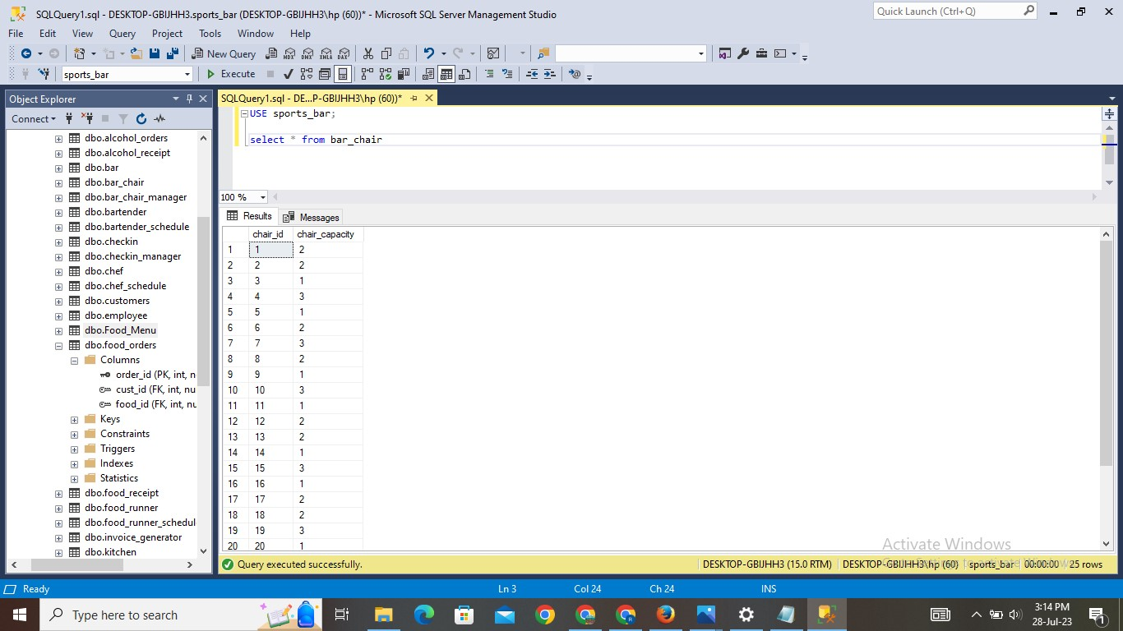

1. **Bar Chair Manager Table:**

**Explanation:**

* The table is created with the name of bar_chair_manager. This table gives us information about chair id, customer id and chair reservation status.
* Values are inserted into the table. And using SELECT statement can check the inserted values.

**Query:**

Create table bar_chair_manager( chair_id int,

Cust_id int,

Chair_reserve varchar(3),

   Foreign key (chair_id) references bar_chair(chair_id),

Foreign key(cust_id) references customers(cust_id))

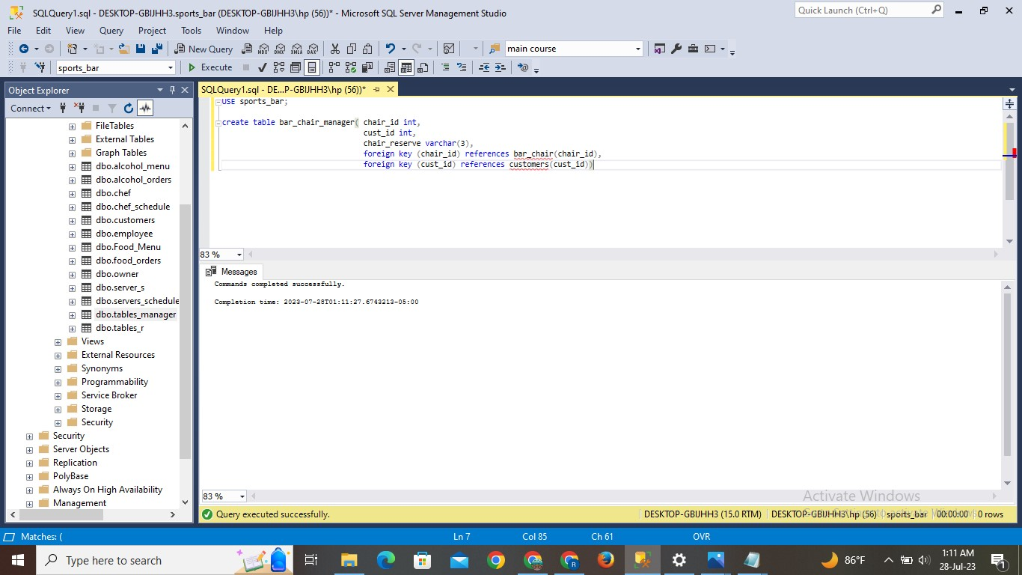

**INSERT STATEMENT:**

INSERT INTO bar_chair_manager(chair_id, cust_id, chair_reserve) VALUES

    (1, 26, 'Yes'),

    (2, 27, 'No'),

    (3, 28, 'Yes'),

    (4, 29, 'No'),

    (5, 30, 'Yes'),

    (6, 31, 'Yes'),

    (7, 32, 'No'),

    (8, 33, 'Yes'),

    (9, 34, 'No'),

    (10, 35, 'Yes'),

    (11, 36, 'No'),

    (12, 37, 'No'),

    (13, 38, 'Yes'),

    (14, 39, 'No'),

    (15, 40, 'Yes'),

    (16, 26, 'Yes'),

    (17, 27, 'No'),

    (18, 28, 'Yes'),

    (19, 29, 'No'),

    (20, 30, 'Yes'),

    (21, 31, 'Yes'),

    (22, 32, 'No'),

    (23, 33, 'Yes'),

    (24, 34, 'No'),

    (25, 35, 'Yes')

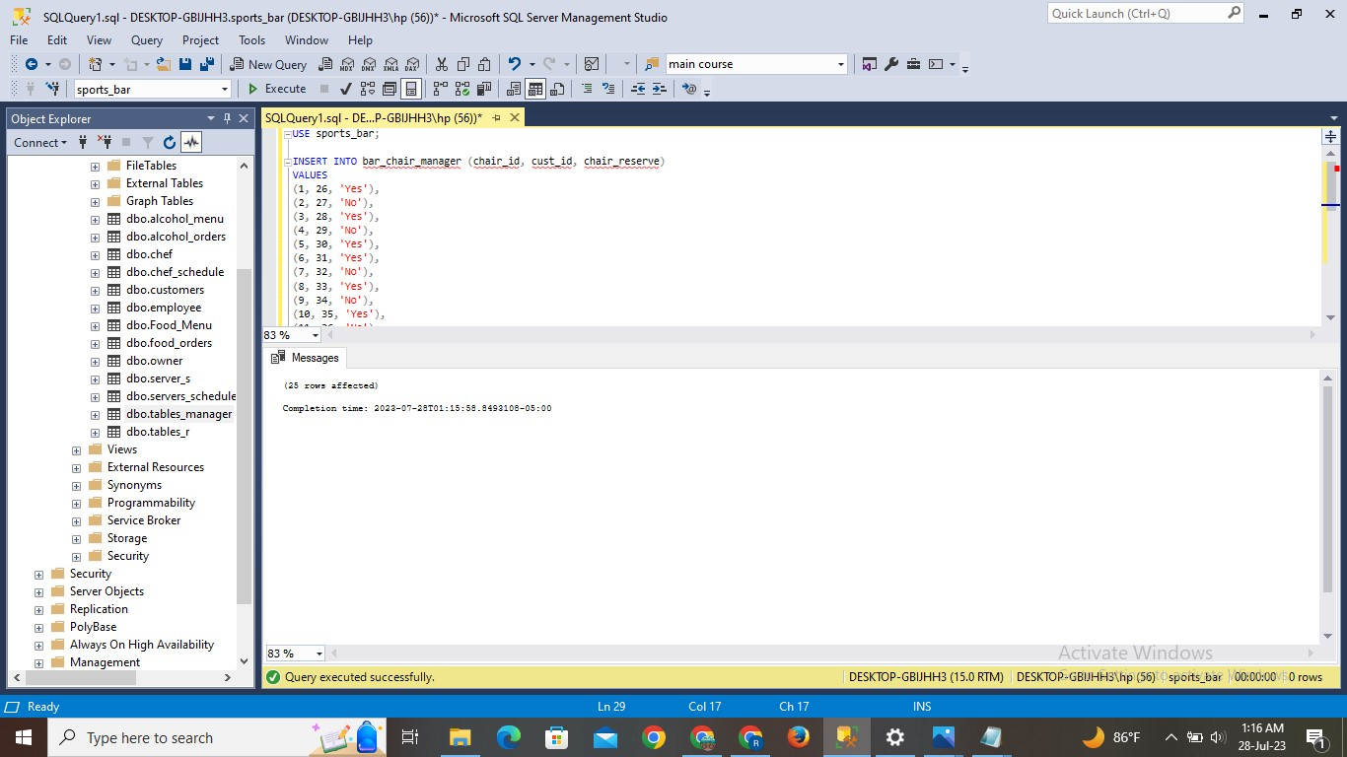

**Result:**

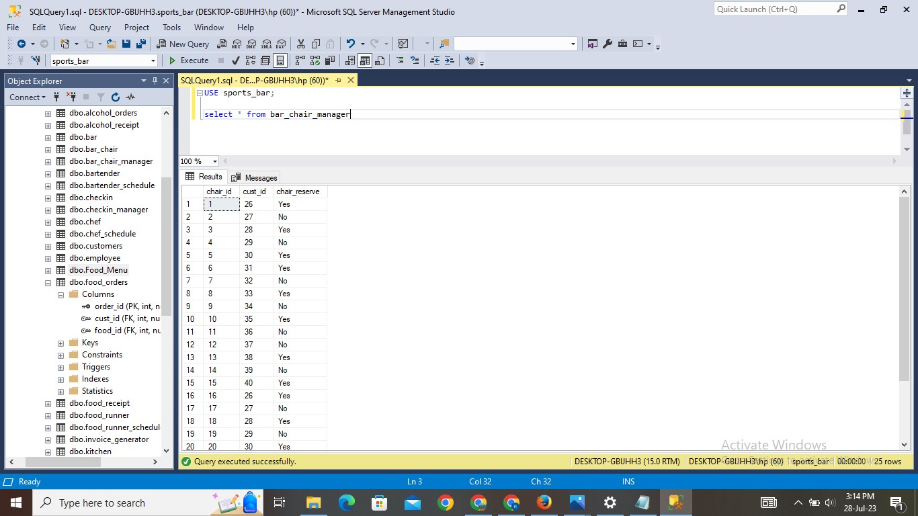

1. **Bartender Schedule Table:**

**Explanation:**

* The table is created with the name of bartender_schedule. This table gives us information about bartender id and employee id.
* Values are inserted into the table. And using SELECT statement can check the inserted values.

**Query:**

Create table bartender_schedule (bartender_id int primary key,

Employee_id int,

Foreign key(employee_id) references employee(employee_id))

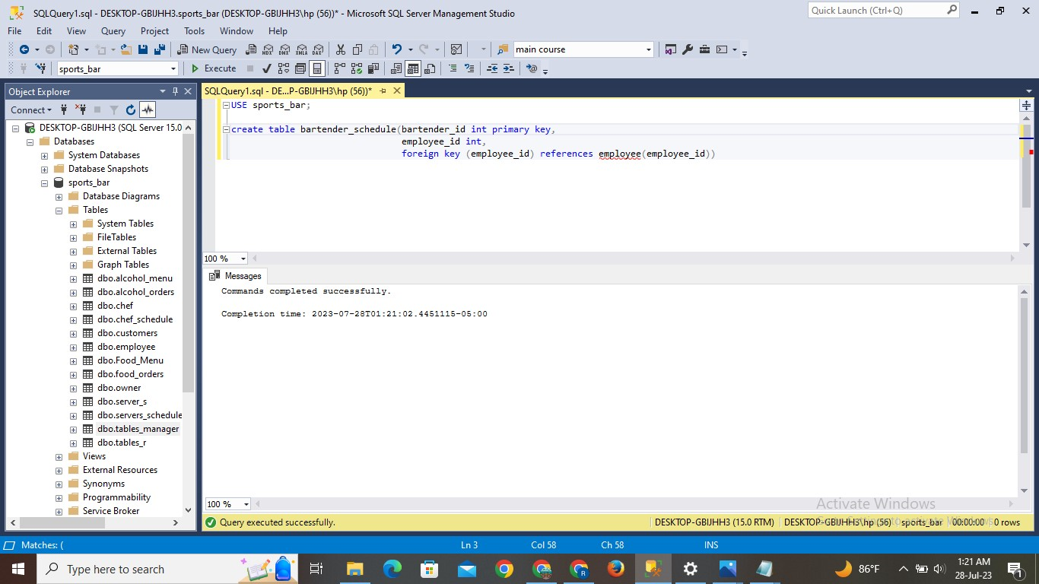

**INSERT STATEMENT:**

Insert into bartender_schedule values

    (1, 2),

    (2, 6),

    (3, 10),

    (4, 16),

    (5, 23)

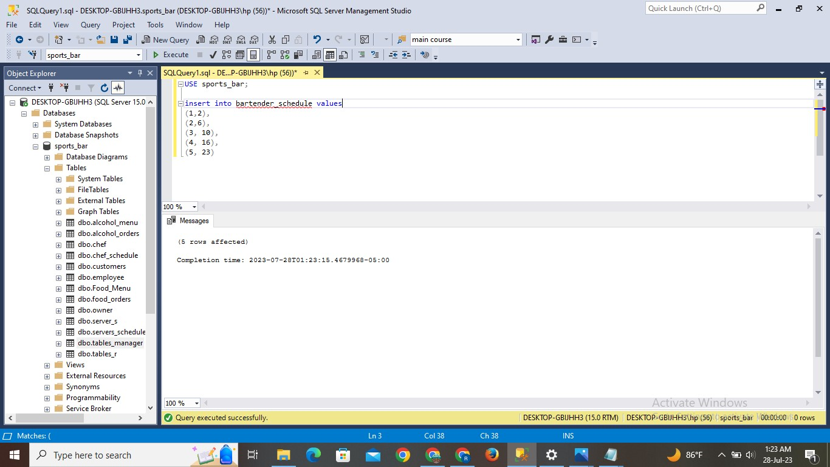

**Result:**

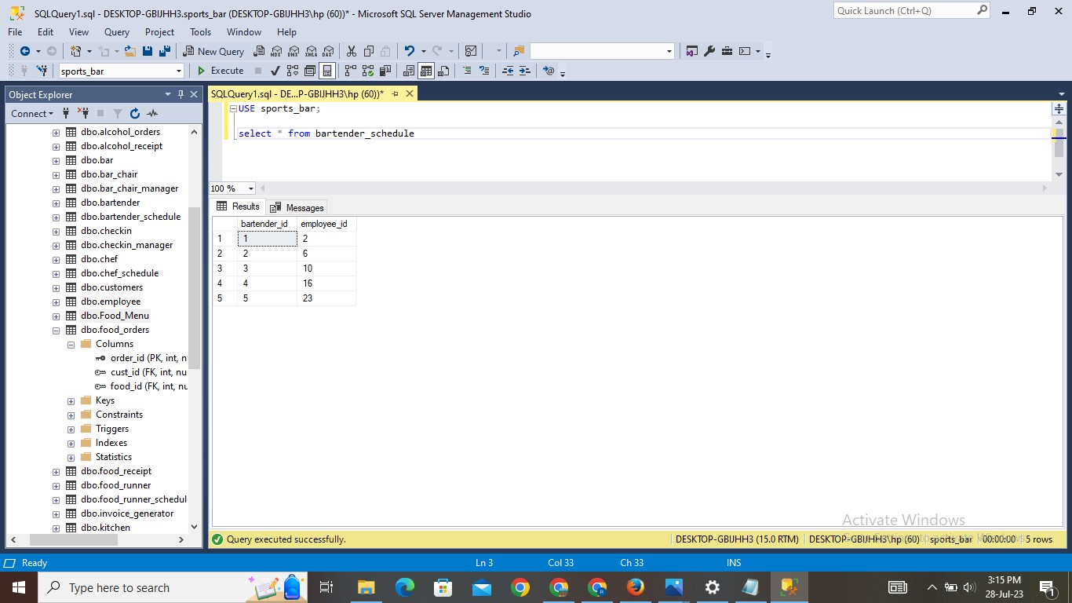

1. **Bartender Table:**

**Explanation:**

* The table is created with the name of bartender_schedule. This table gives us information about bartender id chair id and customer id.
* Values are inserted into the table. And using SELECT statement can check the inserted values.

**Query:**

Create table bartender(bar_id int,

Chair_id int,

Cust_id int,

Foreign key(bar_id) references bartender_schedule(bartender_id),

Foreign key(chair_id) references bar_chair(chair_id)

Foreign key(cust_id) references customers(cust_id))

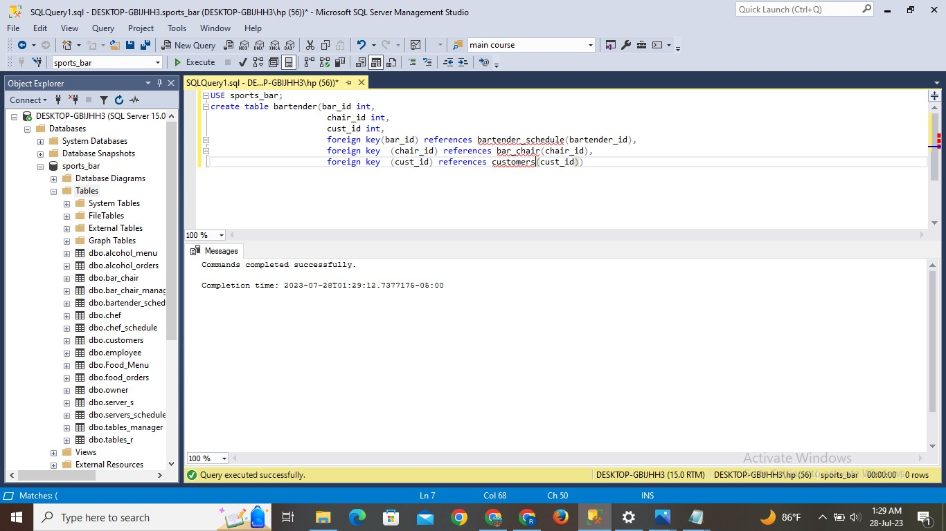

**INSERT STATEMENT:**

Insert into bartender values

    (1, 1, 26),

    (4, 2, 27),

    (2, 3, 28),

    (3, 4, 29),

    (3, 5, 30),

    (2, 6, 31),

    (3, 7, 32),

    (2, 8, 33),

    (2, 9, 34),

    (4, 10, 35),

    (1, 11, 36),

    (2, 12, 37),

    (2, 13, 38),

    (1, 14, 39),

    (4, 15, 40),

    (2, 16, 26),

    (1, 17, 27),

    (5, 18, 28),

    (4, 19, 29),

    (5, 20, 30),

    (2, 21, 31),

    (2, 22, 32),

    (2, 23, 33),

    (2, 24, 34),

    (2, 25, 35)

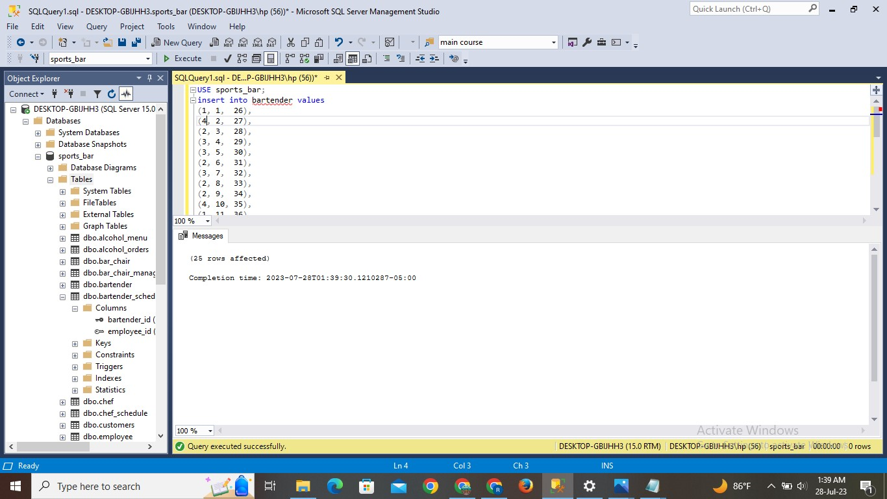

**Result:**

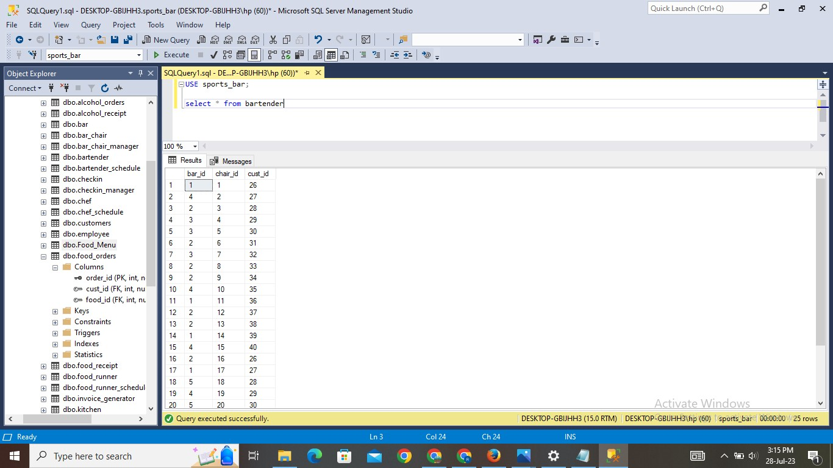

1. **Bar Table:**

**Explanation:**

* The table is created with the name of bar. This table gives us information about bartender id and chair id.
* Values are inserted into the table. And using SELECT statement can check the inserted values.

**Query:**

Create table bar(chair_id int,

Bartender_id int,

Foreign key(chair_id) references bar_chair(chair_id),

foreign key (bartender_id) references bartender_schedule(bartender_id))

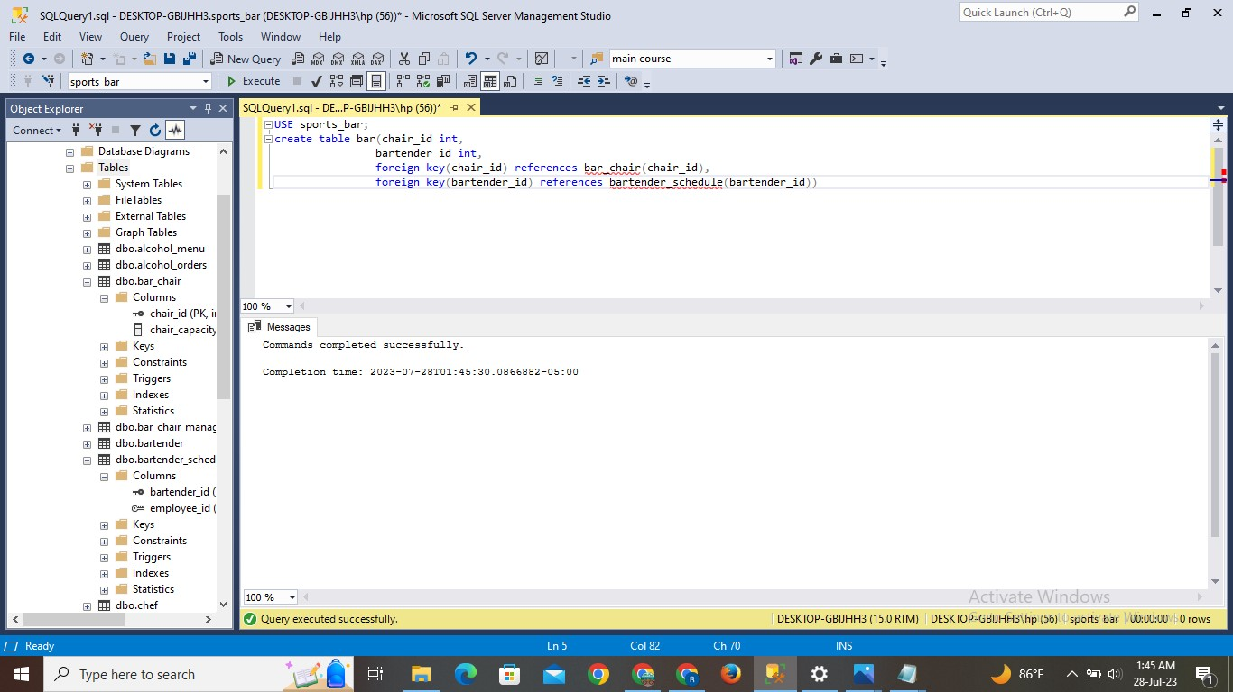

**INSERT STATEMENT:**

Insert into bar values

    (1, 1),

    (2, 4),

    (3, 2),

    (4, 3),

    (5, 3),

    (6, 2),

    (7, 3),

    (8, 2),

    (9, 2),

    (10, 4),

    (11, 1),

    (12, 2),

    (13, 2),

    (14, 1),

    (15, 4),

    (16, 2),

    (17, 1),

    (18, 5),

    (19, 4),

    (20, 5),

    (21, 2),

    (22, 2),

    (23, 2),

    (24, 2),

    (25, 2)

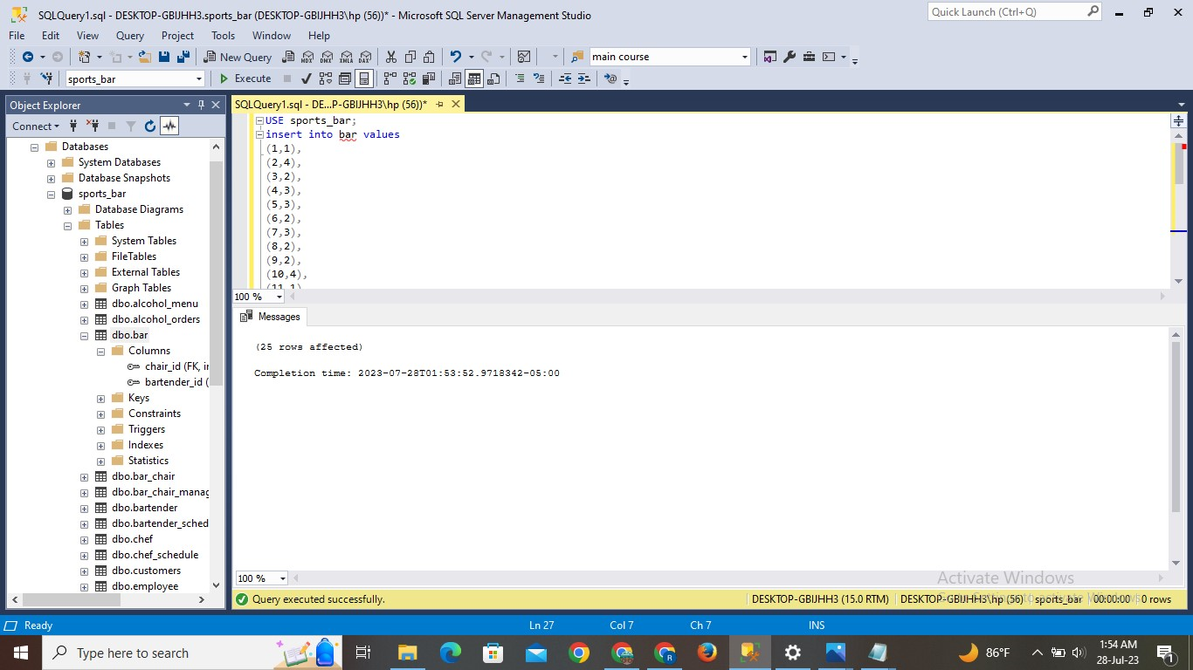

**Result:**

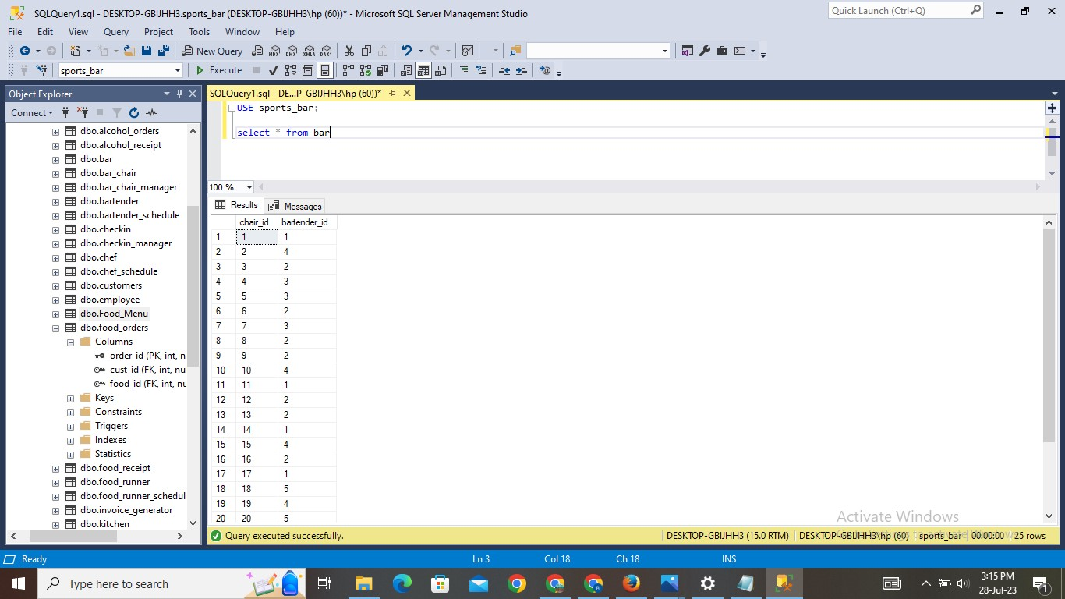

1. **Restaurant Table:**

**Explanation:**

* The table is created with the name of restaurant. This table gives us information about table id and server id.
* Values are inserted into the table. And using SELECT statement can check the inserted values.

**Query:**

Create table restaurant(table_id int,

Server_id int,

Foreign key(table_id) references tables_t(table_id)

Foreign key(server_id) references servers_schedule(server_id))

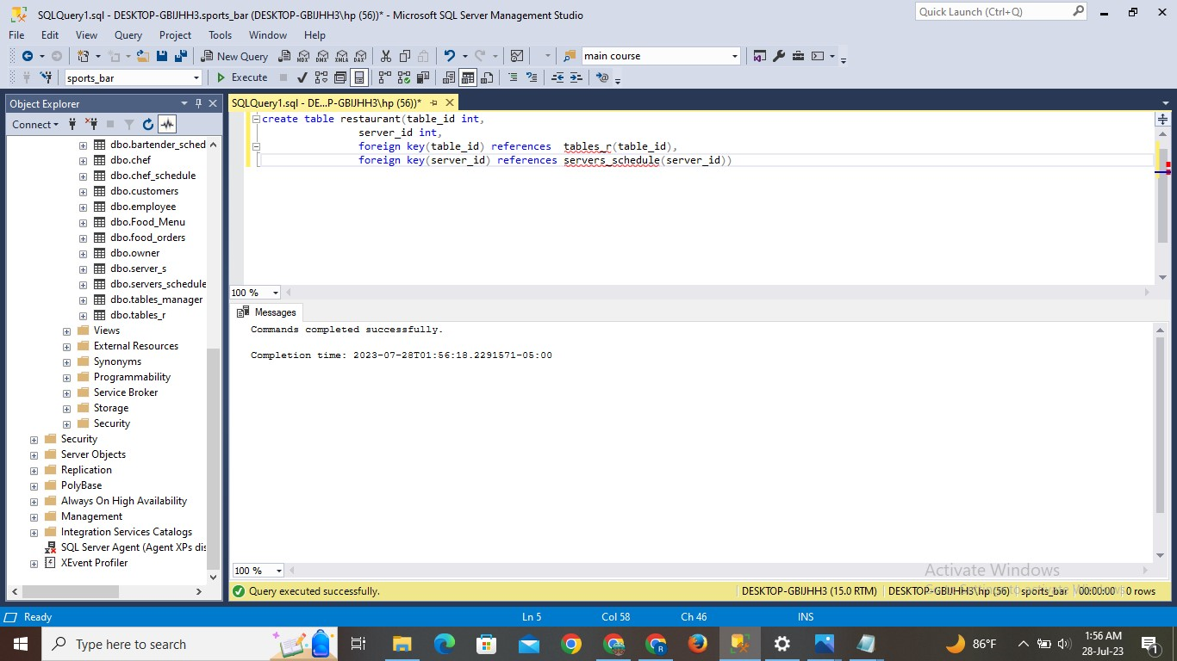

**INSERT STATEMENT:**

Insert into restaurant values

    (1, 1),

    (2, 5),

    (3, 3),

    (4, 6),

    (5, 7),

    (6, 2),

    (7, 8),

    (8, 4),

    (9, 3),

    (10, 1),

    (11, 2),

    (12, 7),

    (13, 5)

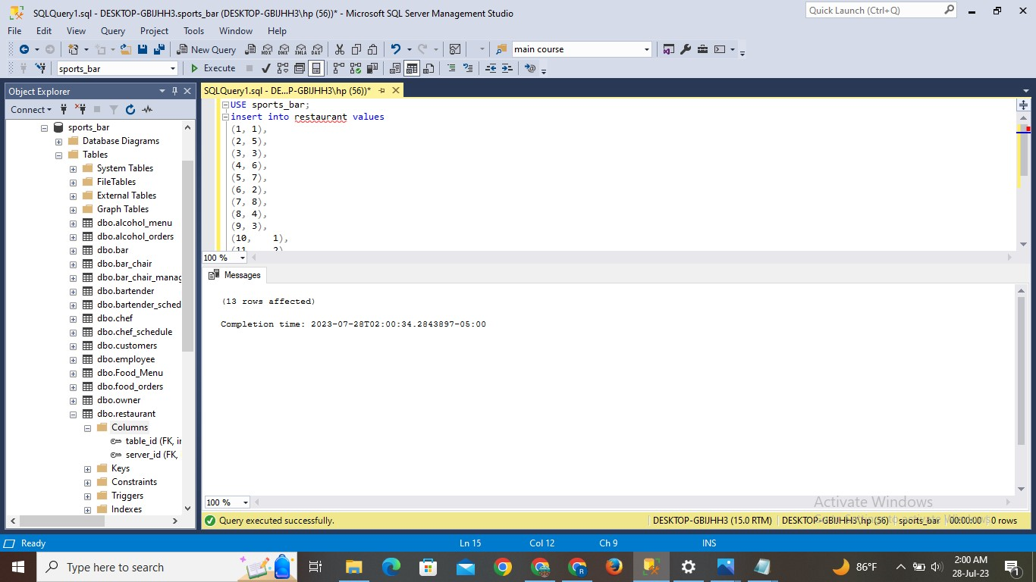

**Result:**

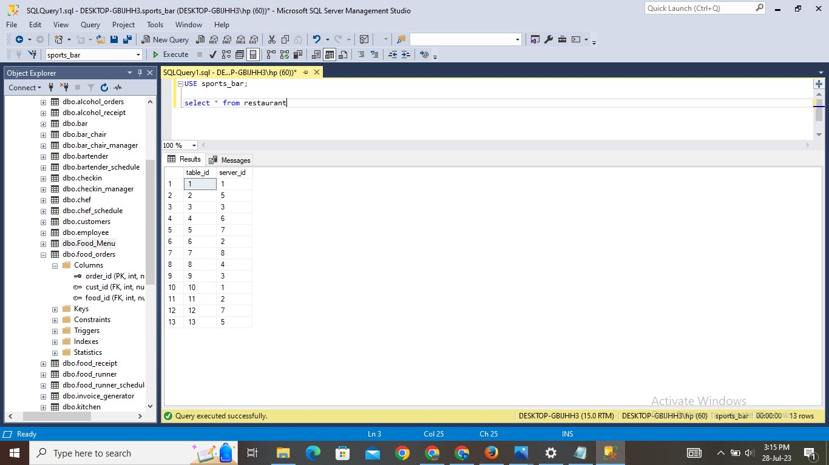

1. **Food Runner Schedule Table:**

**Explanation:**

* The table is created with the name of food_runner_schedule. This table gives us information about food runner id and employee id.
* Values are inserted into the table. And using SELECT statement can check the inserted values.

**Query:**

Create table food_runner_schedule(food_runner_id int primary key,

Employee_id int,

Foreign key(employee_id) references employee(employee_id))

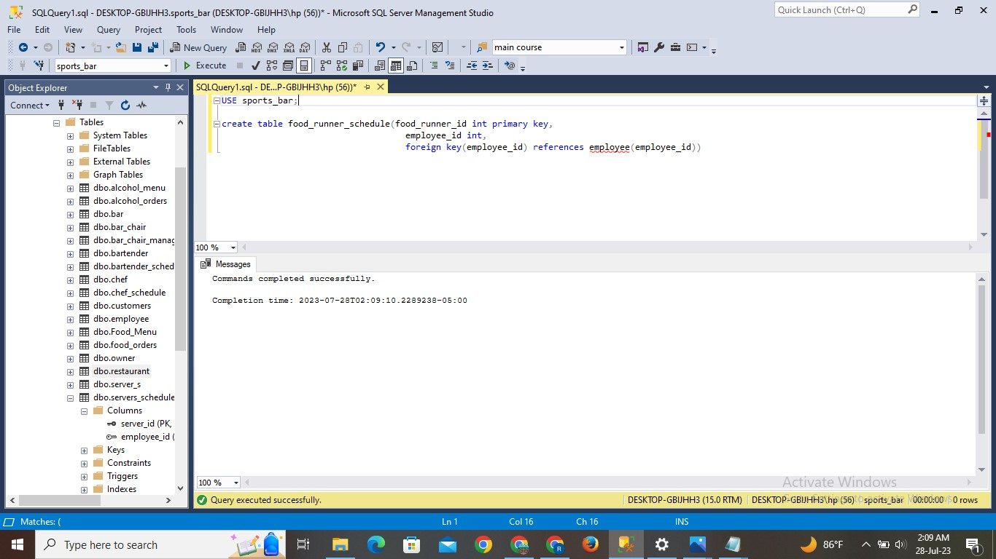

**INSERT STATEMENT:**

Insert into foor_runner_schedule values

(1,4),

(2,11),

(3,17),

(4,24)

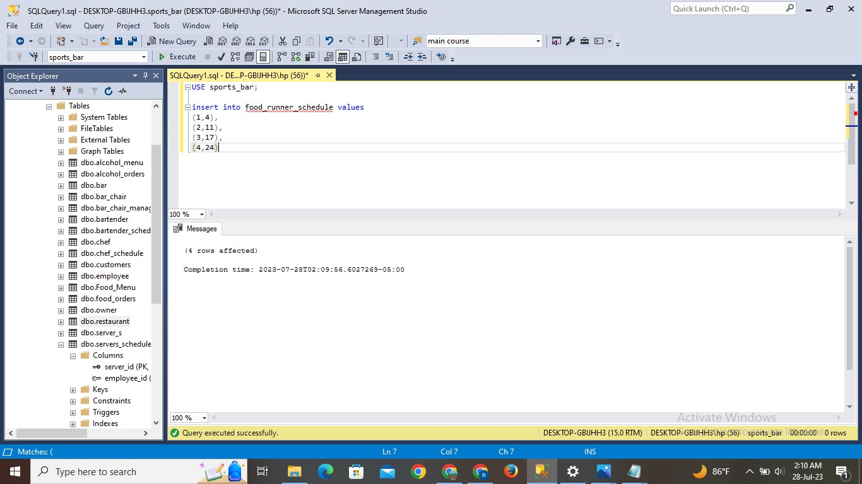

**Result:**

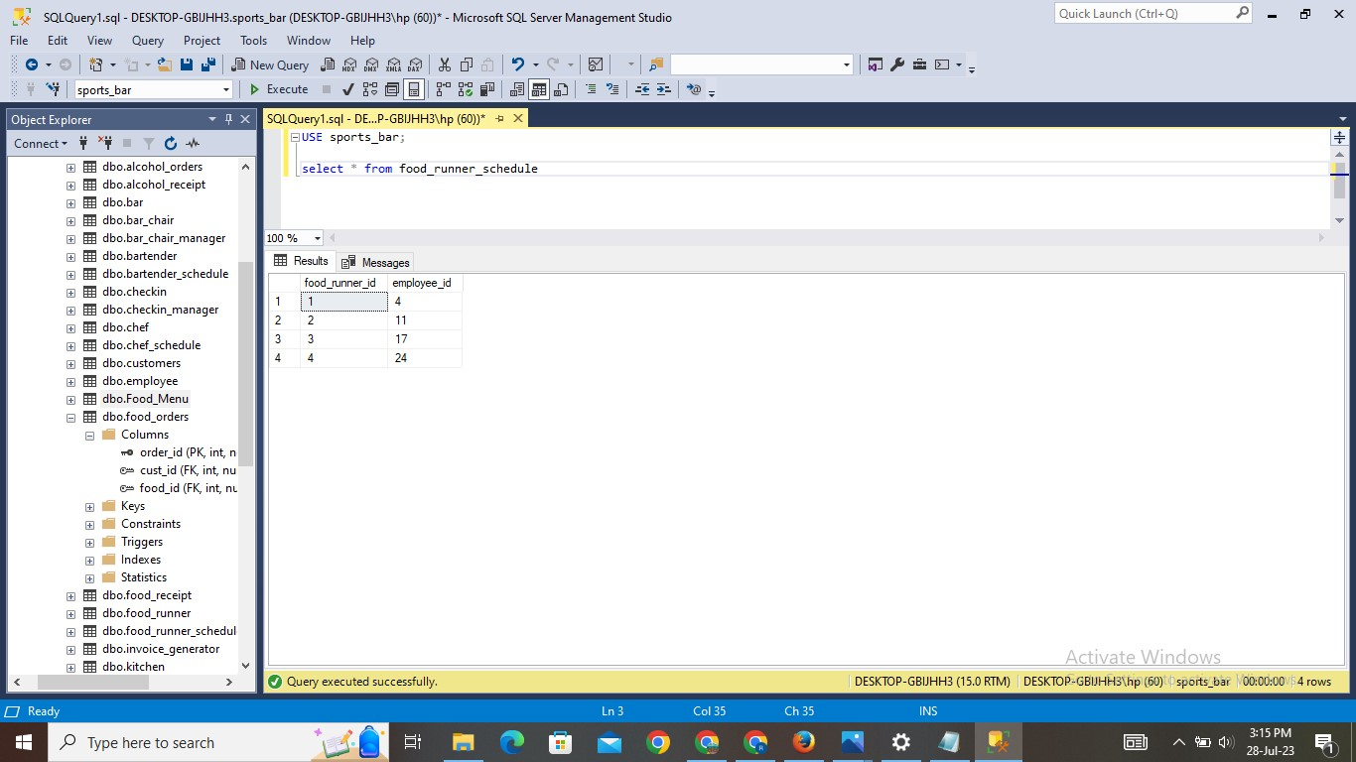

1. **Toast Table:**

**Explanation:**

* The table is created with the name of toast. This table gives us information about toast id, employee id and table_id.
* Values are inserted into the table. And using SELECT statement can check the inserted values.

**Query:**

Create table toast(toast_id int,

Employee_id int,

Table_id int,

Foreign key(employee_id) references employee(employee_id),

Foreign key(table_id) references tables_r(table_id))

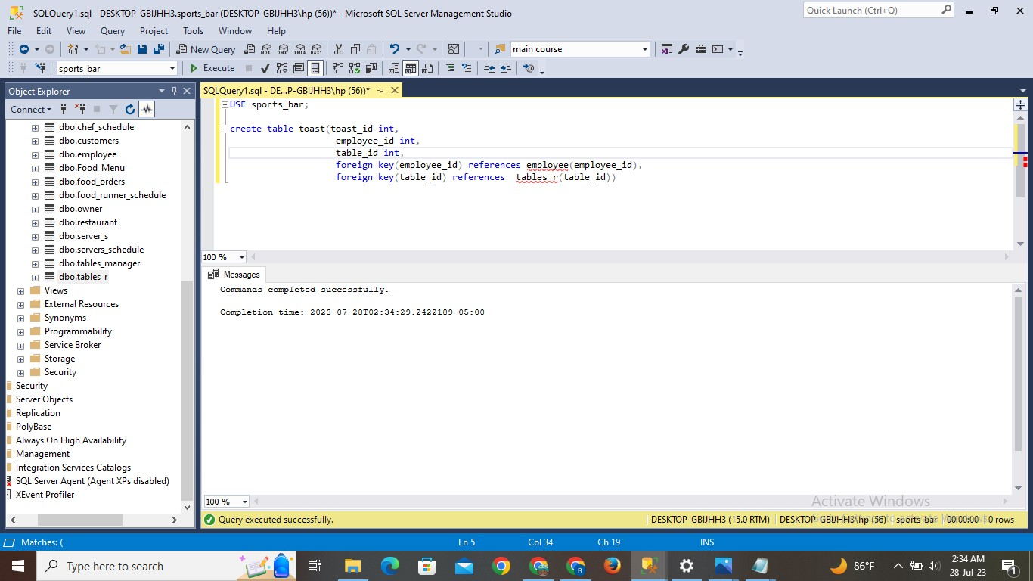

**INSERT STATEMENT:**

Insert into toast values

    (1, 1, 1),

    (1, 5, 2),

    (5, 3, 3),

    (2, 6, 4),

    (1, 7, 5),

    (5, 2, 6),

    (3, 8, 7),

    (3, 4, 8),

    (4, 3, 9),

    (5, 1, 10),

    (2, 2, 11),

    (3, 7, 12),

    (4, 5, 13),

    (2, 2, 12),

    (3, 2, 13),

    (5, 1, 14),

    (2, 4, 15),

    (3, 2, 16),

    (1, 1, 17),

    (3, 5, 18),

    (2, 4, 19),

    (5, 5, 20),

    (4, 2, 21),

    (3, 2, 22),

    (2, 2, 23),

    (1, 2, 24),

    (1, 2, 25)

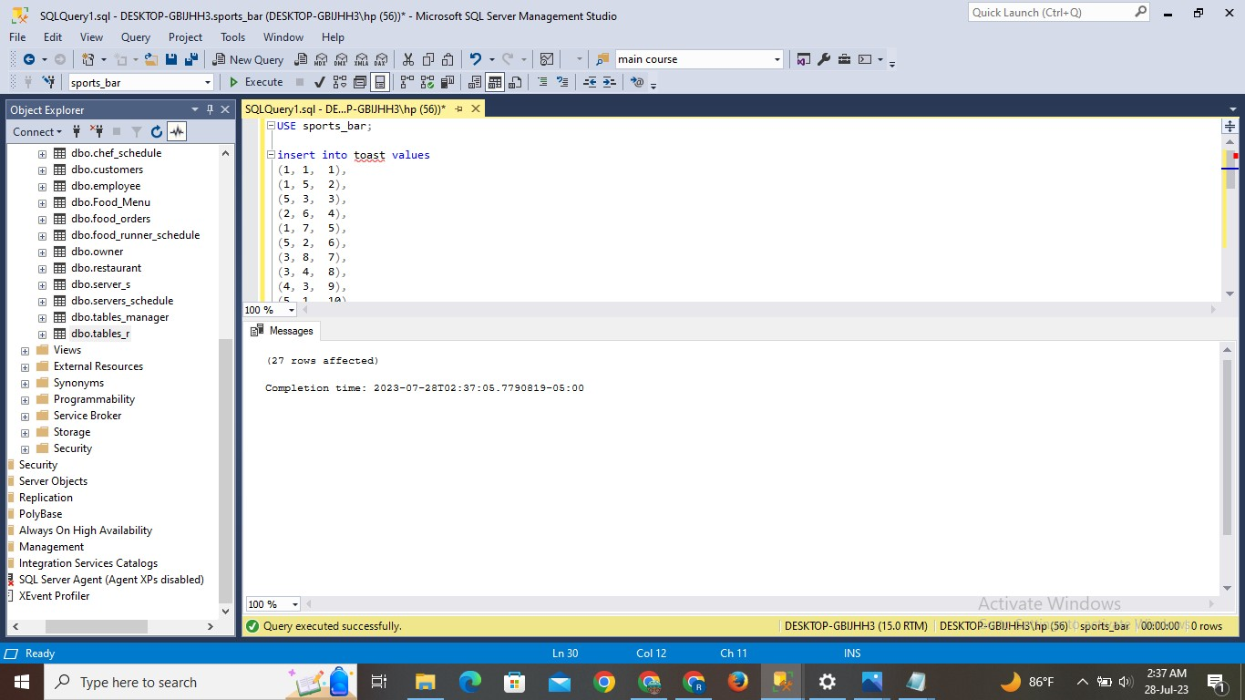

**Result:**

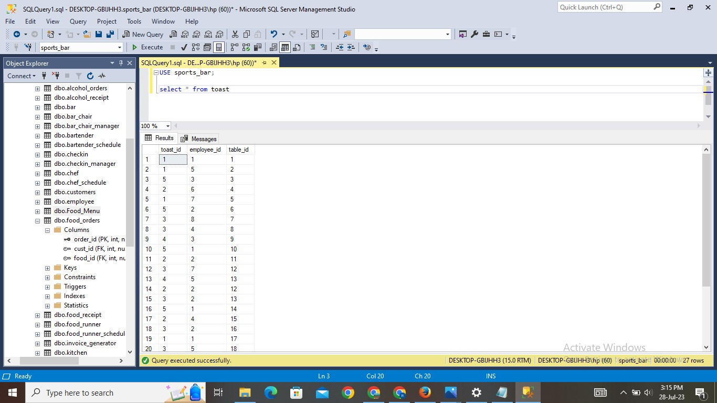

1. **Invoice Generator Table:**

**Explanation:**

* The table is created with the name of invoice_generator. This table gives us information about customer id and toast id.
* Values are inserted into the table. And using SELECT statement can check the inserted values.

**Query:**

Create table invoice_generator(cust_id int,

Toast_id int,

Foreign key(cust_id) references customers(cust_id))

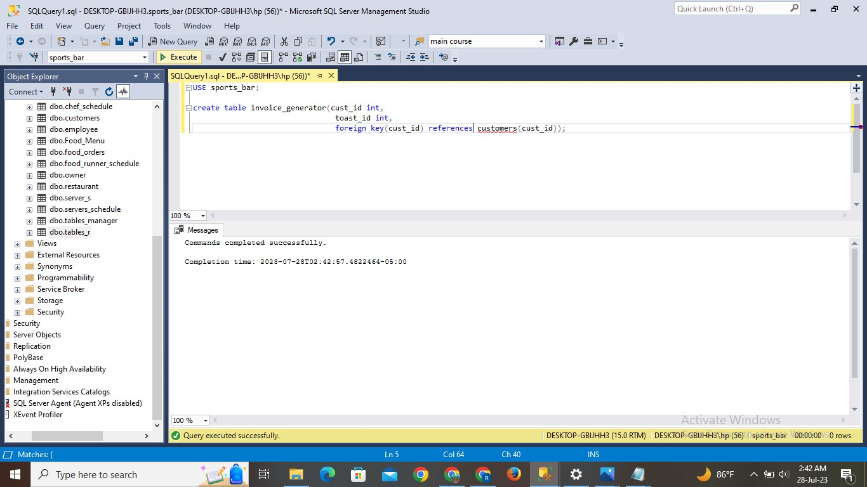

**INSERT STATEMENT:**

Insert into invoice_generator values

    (1, 1),

    (3, 1),

    (5, 5),

    (7, 2),

    (9, 1),

    (11, 5),

    (13, 3),

    (15, 3),

    (17, 4),

    (19, 5),

    (21, 2),

    (23, 3),

    (25, 4),

    (37, 2),

    (38, 3),

    (39, 5),

    (40, 2),

    (26, 3),

    (27, 1),

    (28, 3),

    (29, 2),

    (30, 5),

    (31, 4),

    (32, 3),

    (33, 2),

    (34, 1),

    (35, 1)

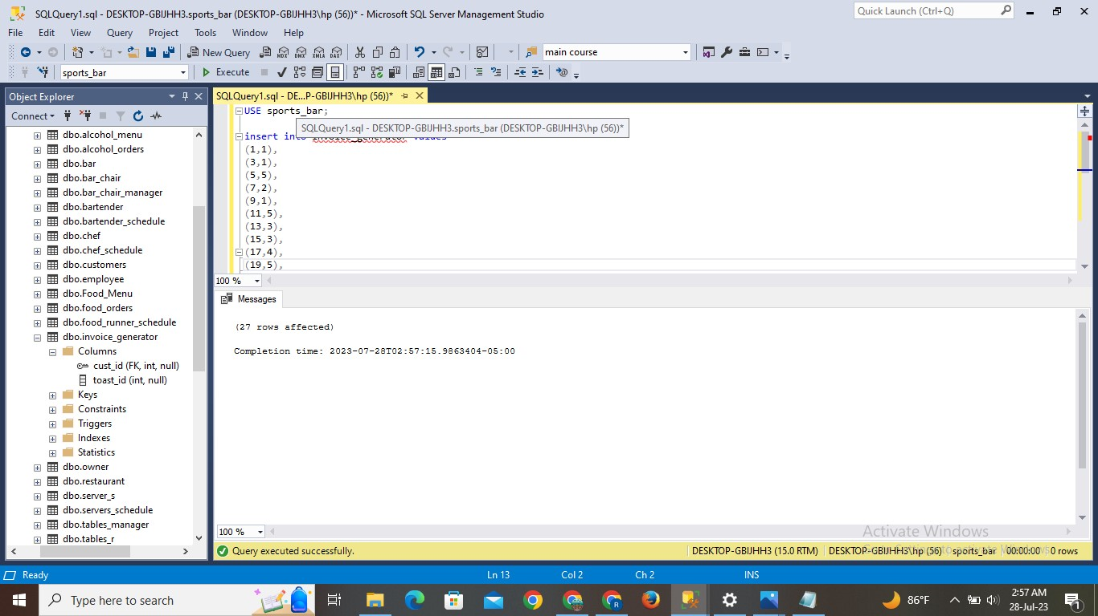

**Result:**

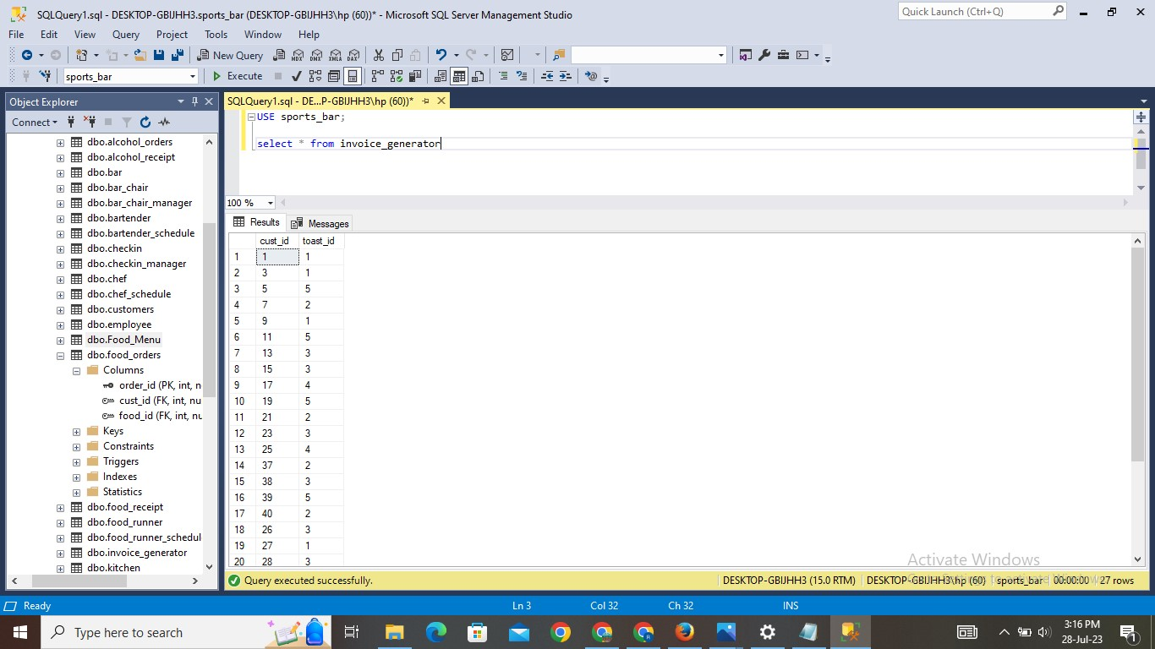

1. **Food Receipt Table:**

**Explanation:**

* The table is created with the name of invoice_generator. This table gives us information about food receipt id, customer id, table id and chair_id.
* Values are inserted into the table. And using SELECT statement can check the inserted values.

**Query:**

Create table food_receipt(food_receipt_id int primary key,

Cust_id int,

Table_id int,

Chair_id int,

Foreign key(cust_id) references customers(cust_id),

Foreign key(table_id) references tables_r(table_id),

Foreign key(chair_id) references bar_chair(chair_id))

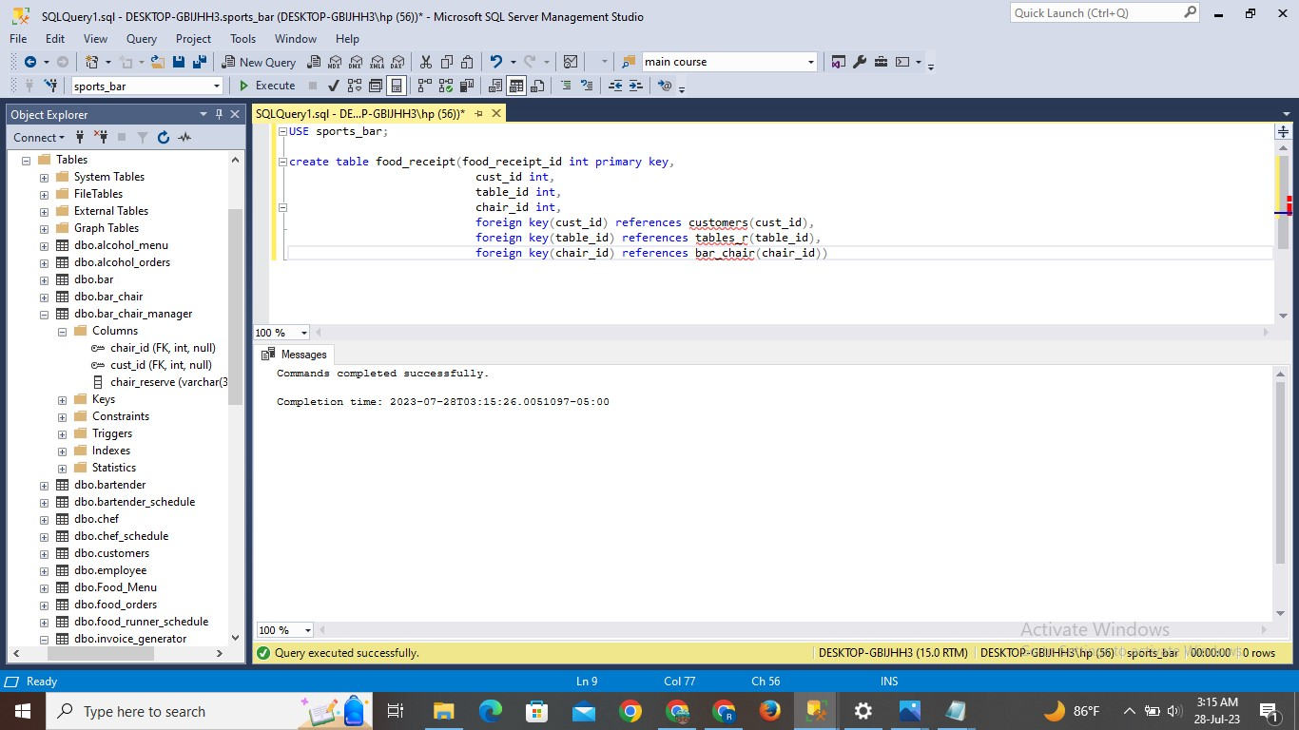

**INSERT STATEMENT:**

Insert into food_receipt values

    (1, 1, 1, 'NULL'),

    (2, 1, 1, 'NULL'),

    (3, 1, 1, 'NULL'),

    (4, 3, 2, 'NULL'),

    (5, 3, 2, 'NULL'),

    (6, 5, 3, 'NULL'),

    (7, 5, 3, 'NULL'),

    (8, 5, 3, 'NULL'),

    (9, 7, 4, 'NULL'),

    (10, 7, 4, 'NULL'),

    (11, 9, 5, 'NULL'),

    (12, 9, 5, 'NULL'),

    (13, 11, 6, 'NULL'),

    (14, 13, 7, 'NULL'),

    (15, 25, 13, 'NULL'),

    (16, 25, 13, 'NULL'),

    (17, 26, 'NULL', 1),

    (18, 26, 'NULL', 16),

    (19, 26, 'NULL', 1),

    (20, 26, 'NULL', 16),

    (21, 27, 'NULL', 2),

    (22, 27, 'NULL', 17),

    (23, 27, 'NULL', 2),

    (24, 27, 'NULL', 17),

    (25, 28, 'NULL', 3),

    (26, 28, 'NULL', 18),

    (27, 28, 'NULL', 3),

    (28, 28, 'NULL', 18),

    (29, 29, 'NULL', 4),

    (30, 29, 'NULL', 19),

    (31, 29, 'NULL', 4),

    (32, 29, 'NULL', 19),

    (33, 30, 'NULL', 5),

    (34, 30, 'NULL', 20),

    (35, 30, 'NULL', 5),

    (36, 30, 'NULL', 20),

    (37, 31, 'NULL', 6),

    (38, 31, 'NULL', 21),

    (39, 31, 'NULL', 6),

    (40, 31, 'NULL', 21),

    (41, 32, 'NULL', 7),

    (42, 32, 'NULL', 22),

    (43, 32, 'NULL', 7),

    (44, 32, 'NULL', 22),

    (45, 33, 'NULL', 8),

    (46, 33, 'NULL', 23),

    (47, 33, 'NULL', 8),

    (48, 33, 'NULL', 23),

    (49, 34, 'NULL', 9),

    (50, 34, 'NULL', 24),

    (51, 34, 'NULL', 9),

    (52, 34, 'NULL', 24),

    (53, 35, 'NULL', 10),

    (54, 35, 'NULL', 25),

    (55, 36, 'NULL', 11),

    (56, 36, 'NULL', 11),

    (57, 37, 'NULL', 12)

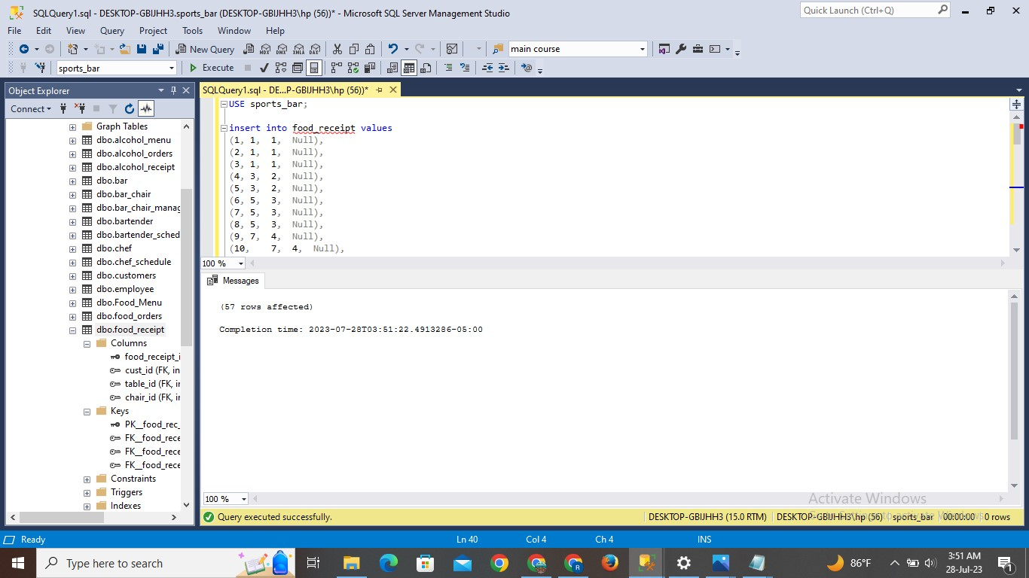

**Result:**

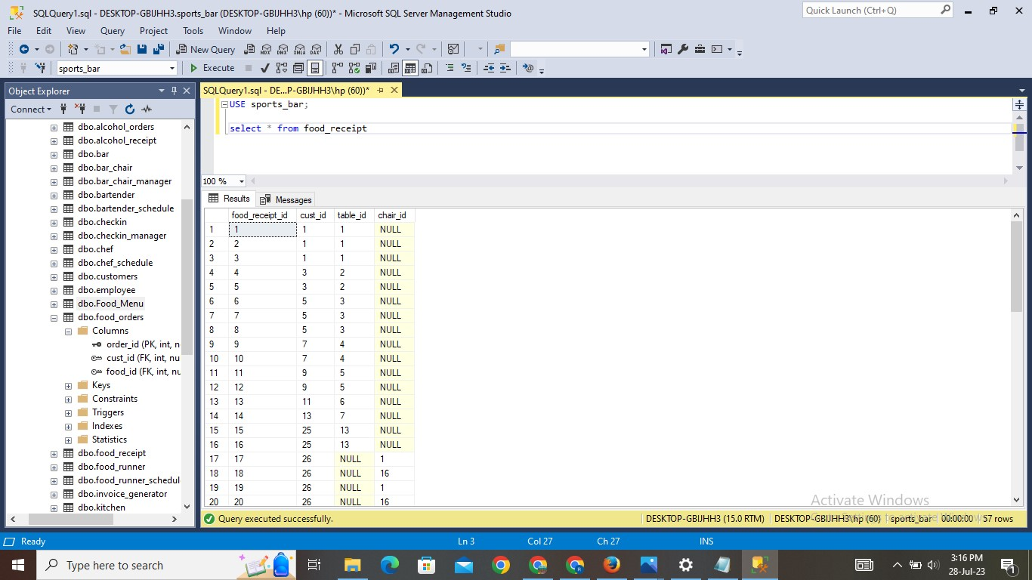

1. **Tables Manager Table:**

**Explanation:**

* The table is created with the name of kitchen. This table gives us information about food receipt id, table id, chair id, chef id.
* Values are inserted into the table. And using SELECT statement can check the inserted values.

**Query:**

Create table kitchen(food_receipt_id int,

Table_id int,

Chair_id int,

Chef_id int,

Foreign key(food_receipt_id) references food_receipt(food_receipt_id),

Foreign key(table_id) references tables_r(table_id),

Foreign key(chair_id) referencesbar_chair(chair_id),

Foreign key(chef_id) referenceschef_schedule(chef_id))

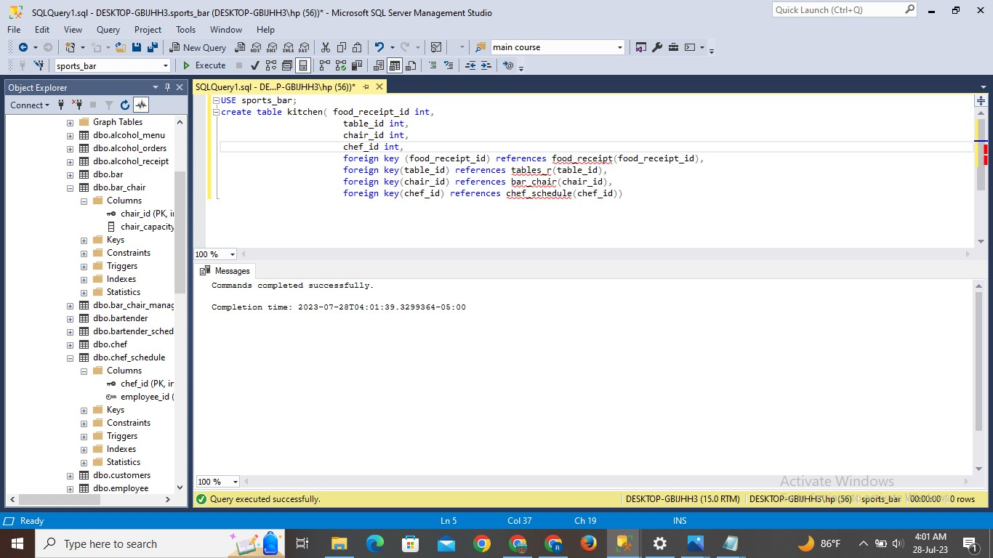

**INSERT STATEMENT:**

Insert into kitchen values

    (1, 1, 'NULL', 1),

    (2, 1, 'NULL', 2),

    (3, 1, 'NULL', 2),

    (4, 2, 'NULL', 2),

    (5, 2, 'NULL', 5),

    (6, 3, 'NULL', 5),

    (7, 3, 'NULL', 3),

    (8, 3, 'NULL', 1),

    (9, 4, 'NULL', 1),

    (10, 4, 'NULL', 1),

    (11, 5, 'NULL', 1),

    (12, 5, 'NULL', 1),

    (13, 6, 'NULL', 1),

    (14, 7, 'NULL', 2),

    (15, 13, 'NULL', 2),

    (16, 13, 'NULL', 4),

    (17, 'NULL', 1, 4),

    (18, 'NULL', 16, 4),

    (19, 'NULL', 1, 3),

    (20, 'NULL', 16, 3),

    (21, 'NULL', 2, 4),

    (22, 'NULL', 17, 5),

    (23, 'NULL', 2, 5),

    (24, 'NULL', 17, 5),

    (25, 'NULL', 3, 5),

    (26, 'NULL', 18, 5),

    (27, 'NULL', 3, 4),

    (28, 'NULL', 18, 2),

    (29, 'NULL', 4, 2),

    (30, 'NULL', 19, 1),

    (31, 'NULL', 4, 1),

    (32, 'NULL', 19, 1),

    (33, 'NULL', 5, 2),

    (34, 'NULL', 20, 2),

    (35, 'NULL', 5, 2),

    (36, 'NULL', 20, 4),

    (37, 'NULL', 6, 4),

    (38, 'NULL', 21, 4),

    (39, 'NULL', 6, 4),

    (40, 'NULL', 21, 5),

    (41, 'NULL', 7, 5),

    (42, 'NULL', 22, 5),

    (43, 'NULL', 7, 5),

    (44, 'NULL', 22, 5),

    (45, 'NULL', 8, 5),

    (46, 'NULL', 23, 2),

    (47, 'NULL', 8, 2),

    (48, 'NULL', 23, 2),

    (49, 'NULL', 9, 3),

    (50, 'NULL', 24, 2),

    (51, 'NULL', 9, 3),

    (52, 'NULL', 24, 3),

    (53, 'NULL', 10, 4),

    (54, 'NULL', 25, 5),

    (55, 'NULL', 11, 5),

    (56, 'NULL', 11, 3),

    (57, 'NULL', 12, 1)

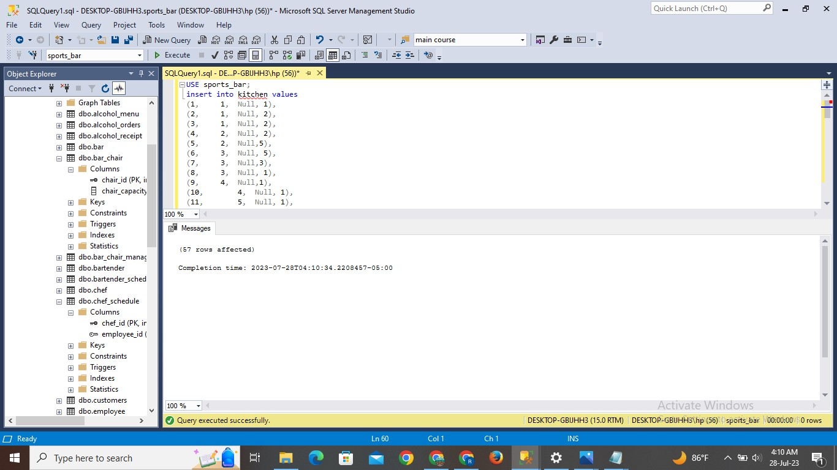

**Result:**

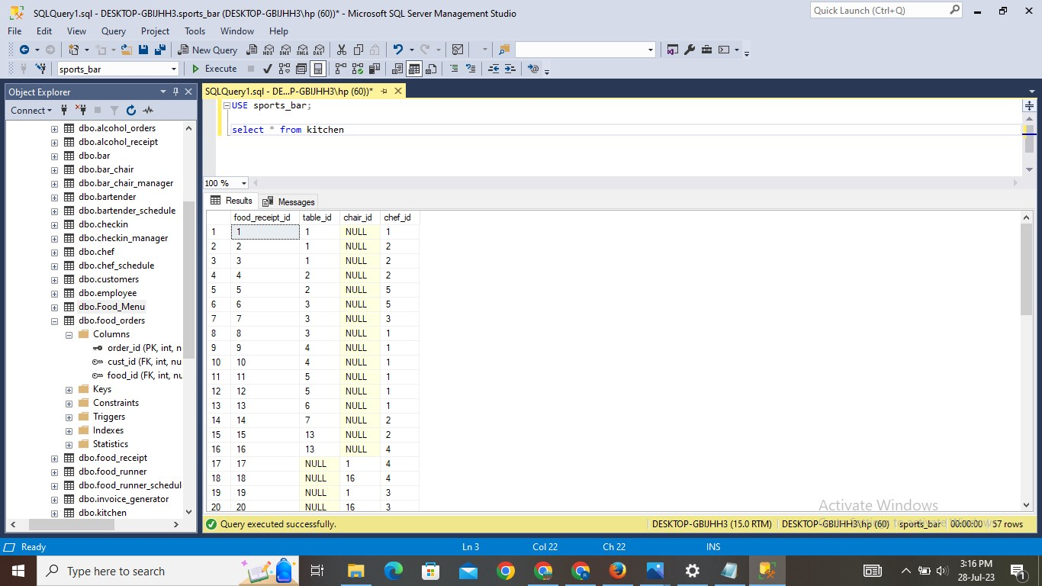

1. **Food Runner Table:**

**Explanation:**

* The table is created with the name of food_runner. This table gives us information about food runner, table id, chair id.
* Values are inserted into the table. And using SELECT statement can check the inserted values.

**Query:**

Create table food_runner(food_runner int,

Table_id int,

Chair_id int,

Foreign key(food_runner) references food_runner_schedule(food_runner_id);

Foreign key(table_id) references tables_r(table_id),

Foreign key(chair_id) references bar-chair(chair_id))

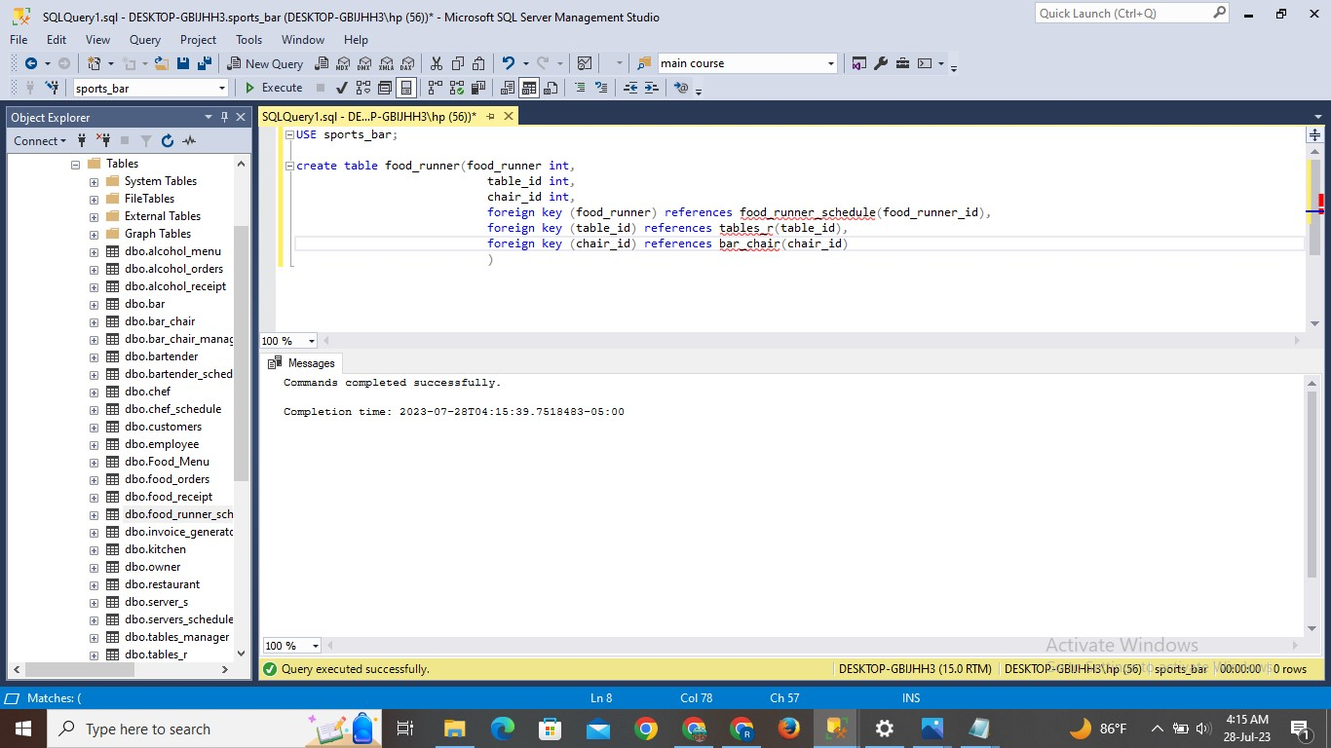

**INSERT STATEMENT:**

Insert into food_runner values

    (1, 1, 'NULL'),

    (2, 1, 'NULL'),

    (3, 1, 'NULL'),

    (4, 2, 'NULL'),

    (1, 2, 'NULL'),

    (2, 3, 'NULL'),

    (2, 3, 'NULL'),

    (3, 3, 'NULL'),

    (3, 4, 'NULL'),

    (4, 4, 'NULL'),

    (4, 5, 'NULL'),

    (3, 5, 'NULL'),

    (3, 6, 'NULL'),

    (4, 7, 'NULL'),

    (1, 13, 'NULL'),

    (1, 13, 'NULL'),

    (2, 'NULL', 1),

    (2, 'NULL', 16),

    (1, 'NULL', 1),

    (2, 'NULL', 16),

    (1, 'NULL', 2),

    (2, 'NULL', 17),

    (3, 'NULL', 2),

    (4, 'NULL', 17),

    (2, 'NULL', 3),

    (4, 'NULL', 18),

    (4, 'NULL', 3),

    (3, 'NULL', 18),

    (4, 'NULL', 4),

    (3, 'NULL', 19),

    (3, 'NULL', 4),

    (2, 'NULL', 19),

    (3, 'NULL', 5),

    (4, 'NULL', 20),

    (1, 'NULL', 5),

    (1, 'NULL', 20),

    (4, 'NULL', 6),

    (3, 'NULL', 21),

    (2, 'NULL', 6),

    (4, 'NULL', 21),

    (4, 'NULL', 7),

    (2, 'NULL', 22),

    (3, 'NULL', 7),

    (4, 'NULL', 22),

    (4, 'NULL', 8),

    (4, 'NULL', 23),

    (4, 'NULL', 8),

    (4, 'NULL', 23),

    (4, 'NULL', 9),

    (2, 'NULL', 24),

    (2, 'NULL', 9),

    (2, 'NULL', 24),

    (3, 'NULL', 10),

    (4, 'NULL', 25),

    (1, 'NULL', 11),

    (2, 'NULL', 11),

    (3, 'NULL', 12)

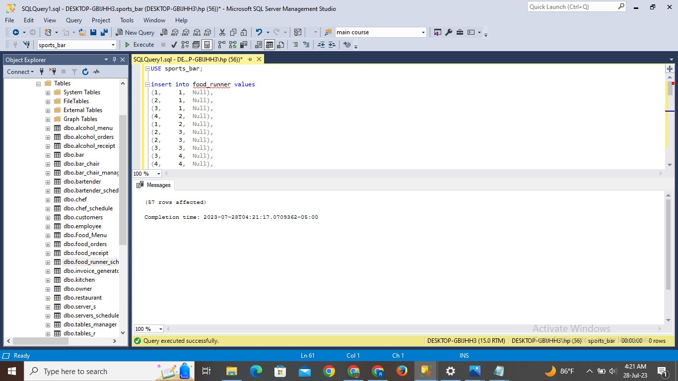

**Result:**

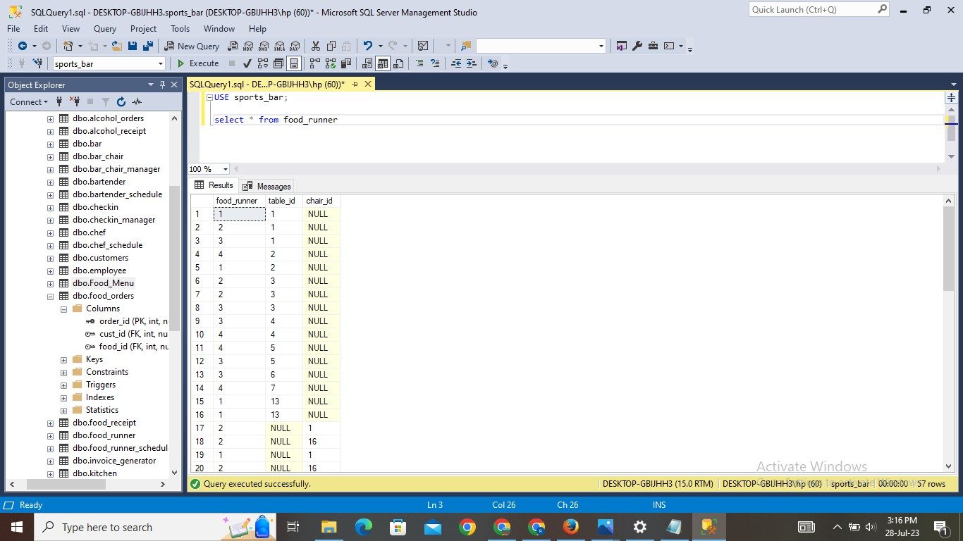

1. **Alcohol Receipt Table:**

**Explanation:**

* The table is created with the name of alcohol_receipt. This table gives us information about alcohol receipt id, customer id, table id, chair id.
* Values are inserted into the table. And using SELECT statement can check the inserted values.

**Query:**

Create table alcohol_receipt(alcohol_receipt_id int primary key,

Cust_id int,

Table_id int,

Chair_id int,

Foreign key(cust_id) references customers(cust_id),

Foreign key(table_id) references tables_r(table_id),

Foreign key(chair_id) references bar_chair(chair_id))

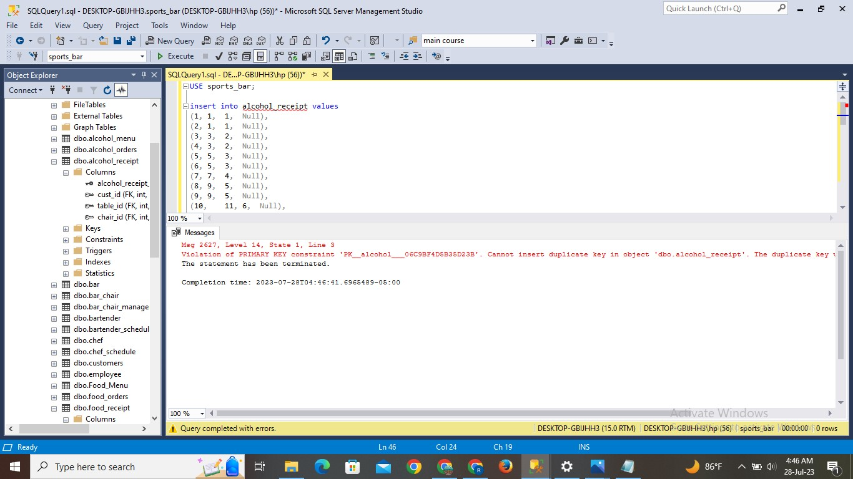

**INSERT STATEMENT:**

Insert into alcohol_receipt values

    (1, 1, 1, 'NULL'),

    (2, 1, 1, 'NULL'),

    (3, 3, 2, 'NULL'),

    (4, 3, 2, 'NULL'),

    (5, 5, 3, 'NULL'),

    (6, 5, 3, 'NULL'),

    (7, 7, 4, 'NULL'),

    (8, 9, 5, 'NULL'),

    (9, 9, 5, 'NULL'),

    (10, 11, 6, 'NULL'),

    (11, 13, 7, 'NULL'),

    (12, 15, 8, 'NULL'),

    (13, 17, 9, 'NULL'),

    (14, 19, 10, 'NULL'),

    (15, 25, 13, 'NULL'),

    (16, 25, 13, 'NULL'),

    (17, 1, 'NULL', 1),

    (18, 1, 'NULL', 1),

    (19, 2, 'NULL', 2),

    (20, 3, 'NULL', 3),

    (21, 3, 'NULL', 3),

    (22, 4, 'NULL', 4),

    (23, 5, 'NULL', 5),

    (24, 5, 'NULL', 5),

    (25, 6, 'NULL', 6),

    (26, 7, 'NULL', 7),

    (27, 8, 'NULL', 8),

    (28, 9, 'NULL', 9),

    (29, 9, 'NULL', 9),

    (30, 10, 'NULL', 10),

    (31, 11, 'NULL', 11),

    (32, 12, 'NULL', 12),

    (33, 13, 'NULL', 13),

    (34, 14, 'NULL', 14),

    (35, 15, 'NULL', 15),

    (36, 16, 'NULL', 16),

    (37, 16, 'NULL', 16),

    (38, 17, 'NULL', 17),

    (39, 18, 'NULL', 18),

    (40, 18, 'NULL', 18),

    (41, 19, 'NULL', 19),

    (42, 25, 'NULL', 25),

    (43, 25, 'NULL', 25)



**Result:**

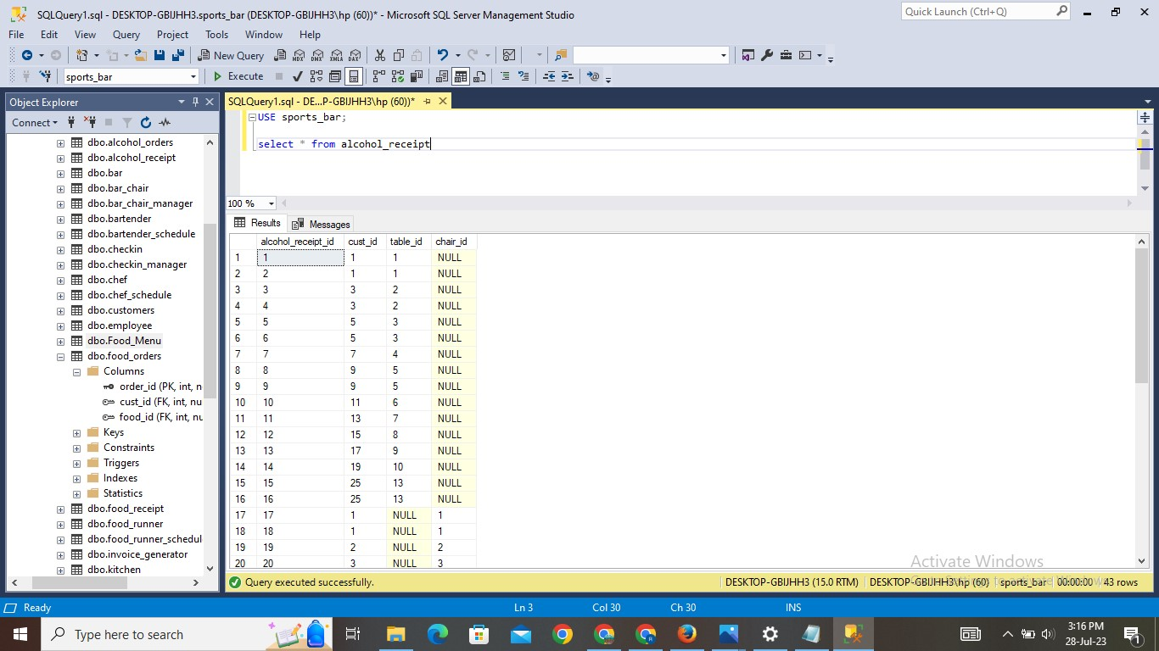

1. **Checkin Table:**

**Explanation:**

* The table is created with the name of checkin. This table gives us information about checkin time and checkout time.
* Values are inserted into the table. And using SELECT statement can check the inserted values.

**Query:**

Create table checkin(check_in int primary key,

Check_in_time datetime,

Check_out_time datetime)

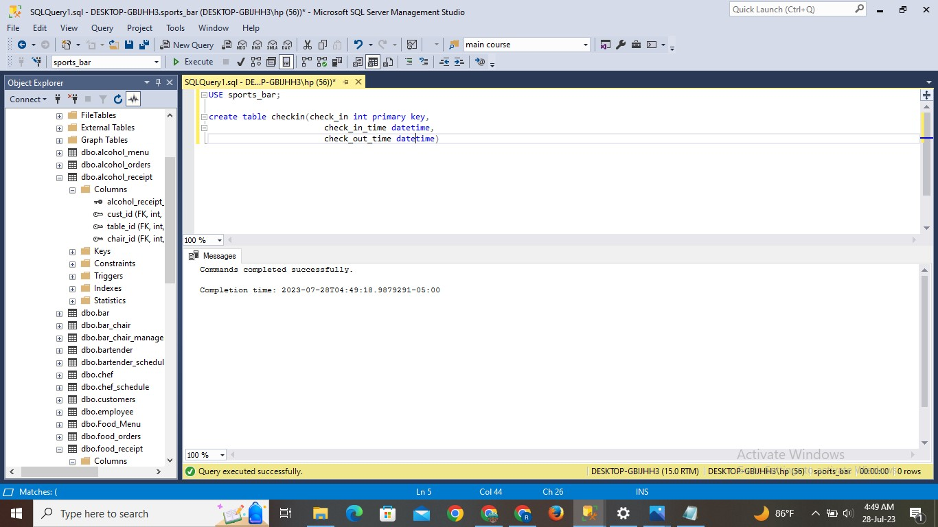

**INSERT STATEMENT:**

INSERT INTO checkin(check_in, check_in_time, check_out_time) VALUES

    (1000, '2023-07-27 10:00:00.000', '2023-07-27 12:30:00.000'),

    (1001, '2023-07-27 13:45:00.000', '2023-07-27 17:15:00.000'),

    (1002, '2023-07-27 09:30:00.000', '2023-07-27 11:00:00.000'),

    (1003, '2023-07-27 14:00:00.000', '2023-07-27 18:30:00.000'),

    (1004, '2023-07-27 11:45:00.000', '2023-07-27 14:30:00.000'),

    (1005, '2023-07-27 16:20:00.000', '2023-07-27 19:00:00.000'),

    (1006, '2023-07-27 08:00:00.000', '2023-07-27 11:30:00.000'),

    (1007, '2023-07-27 12:45:00.000', '2023-07-27 15:15:00.000'),

    (1008, '2023-07-27 10:30:00.000', '2023-07-27 13:00:00.000'),

    (1009, '2023-07-27 14:30:00.000', '2023-07-27 18:00:00.000'),

    (1010, '2023-07-28 09:00:00.000', '2023-07-28 12:30:00.000'),

    (1011, '2023-07-28 13:45:00.000', '2023-07-28 17:15:00.000'),

    (1012, '2023-07-28 09:30:00.000', '2023-07-28 11:00:00.000'),

    (1013, '2023-07-28 14:00:00.000', '2023-07-28 18:30:00.000'),

    (1014, '2023-07-28 11:45:00.000', '2023-07-28 14:30:00.000'),

    (1015, '2023-07-28 16:20:00.000', '2023-07-28 19:00:00.000'),

    (1016, '2023-07-28 08:00:00.000', '2023-07-28 11:30:00.000'),

    (1017, '2023-07-28 12:45:00.000', '2023-07-28 15:15:00.000'),

    (1018, '2023-07-28 10:30:00.000', '2023-07-28 13:00:00.000'),

    (1019, '2023-07-28 14:30:00.000', '2023-07-28 18:00:00.000'),

    (1020, '2023-07-29 10:00:00.000', '2023-07-29 12:30:00.000'),

    (1021, '2023-07-29 13:45:00.000', '2023-07-29 17:15:00.000'),

    (1022, '2023-07-29 09:30:00.000', '2023-07-29 11:00:00.000'),

    (1023, '2023-07-29 14:00:00.000', '2023-07-29 18:30:00.000'),

    (1024, '2023-07-29 11:45:00.000', '2023-07-29 14:30:00.000')

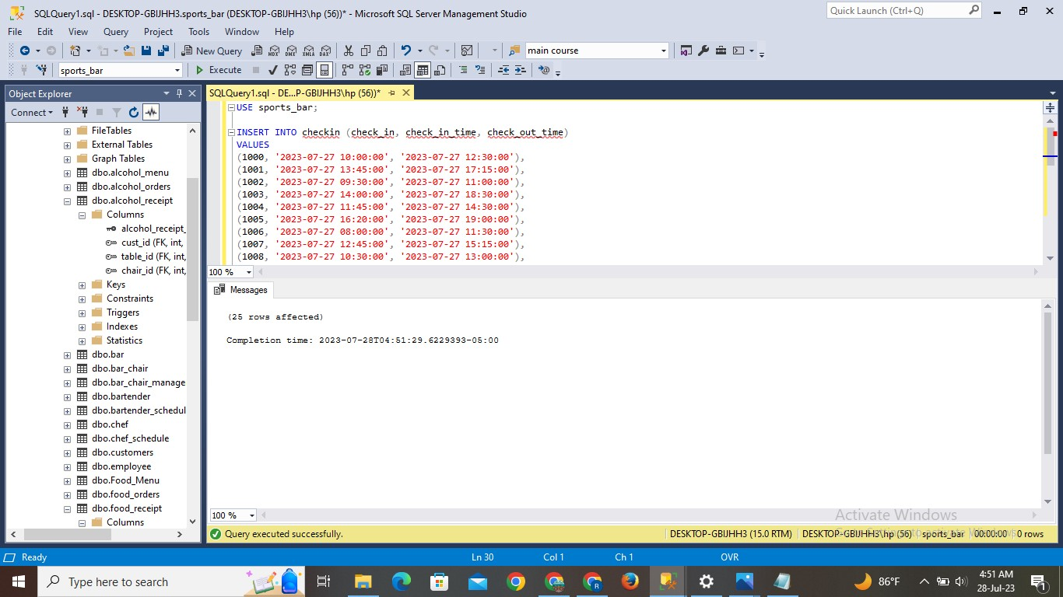

**Result:**

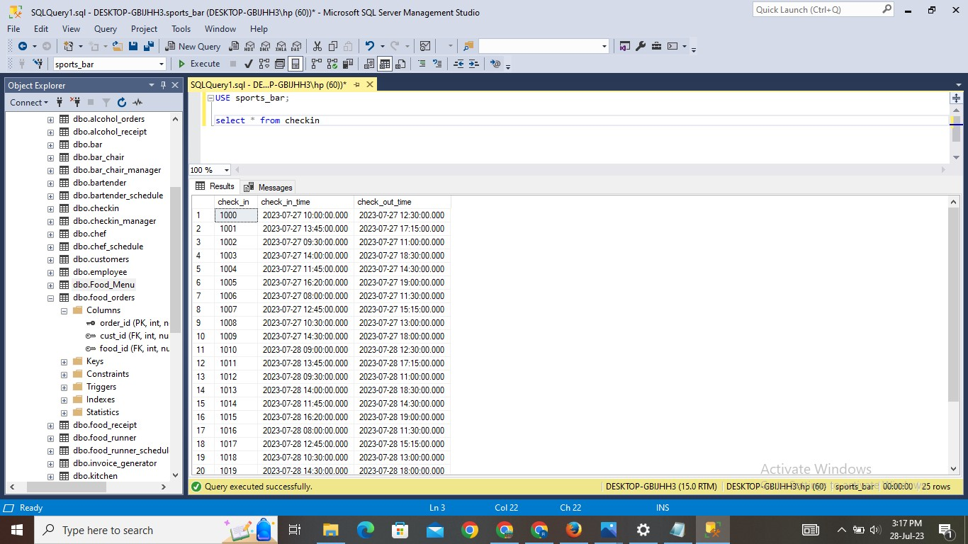

1. **Checkin Manager Table:**

**Explanation:**

* The table is created with the name of checkin_manager. This table gives us information about checkin id and employee id.
* Values are inserted into the table. And using SELECT statement can check the inserted values.

**Query:**

Create table checkin_manager(check_in int,

Employee_id int,

Foreign key(check_in) references checkin(check_in),

Foreign key(employee_id) references employee(employee_id))

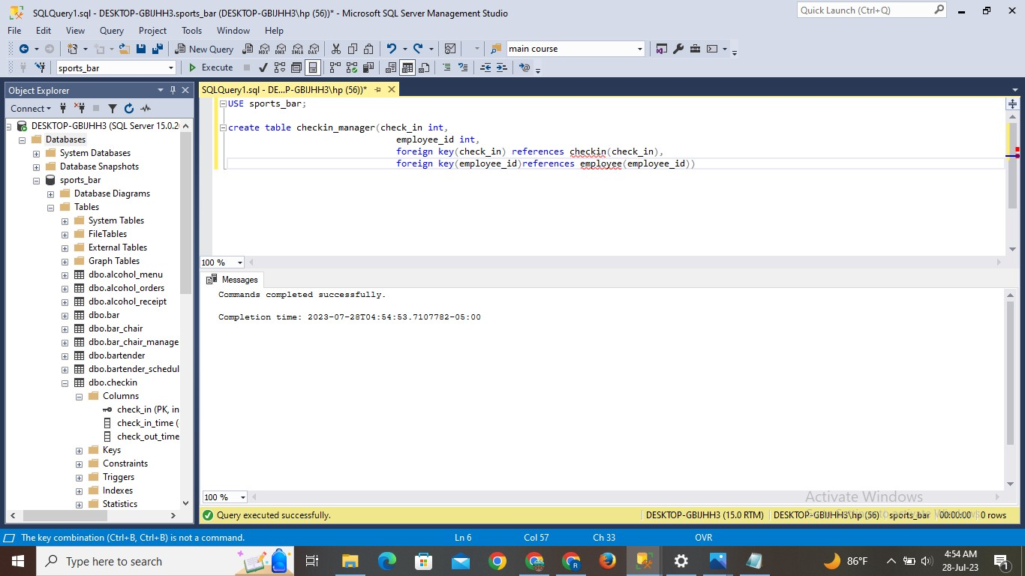

**INSERT STATEMENT:**

Insert into checkin manager values

    (1000, 1),

    (1001, 2),

    (1002, 3),

    (1003, 4),

    (1004, 5),

    (1005, 6),

    (1006, 7),

    (1007, 8),

    (1008, 9),

    (1009, 10),

    (1010, 11),

    (1011, 12),

    (1012, 13),

    (1013, 14),

    (1014, 15),

    (1015, 16),

    (1016, 17),

    (1017, 18),

    (1018, 19),

    (1019, 20),

    (1020, 21),

    (1021, 22),

    (1022, 23),

    (1023, 24),

    (1024, 25)

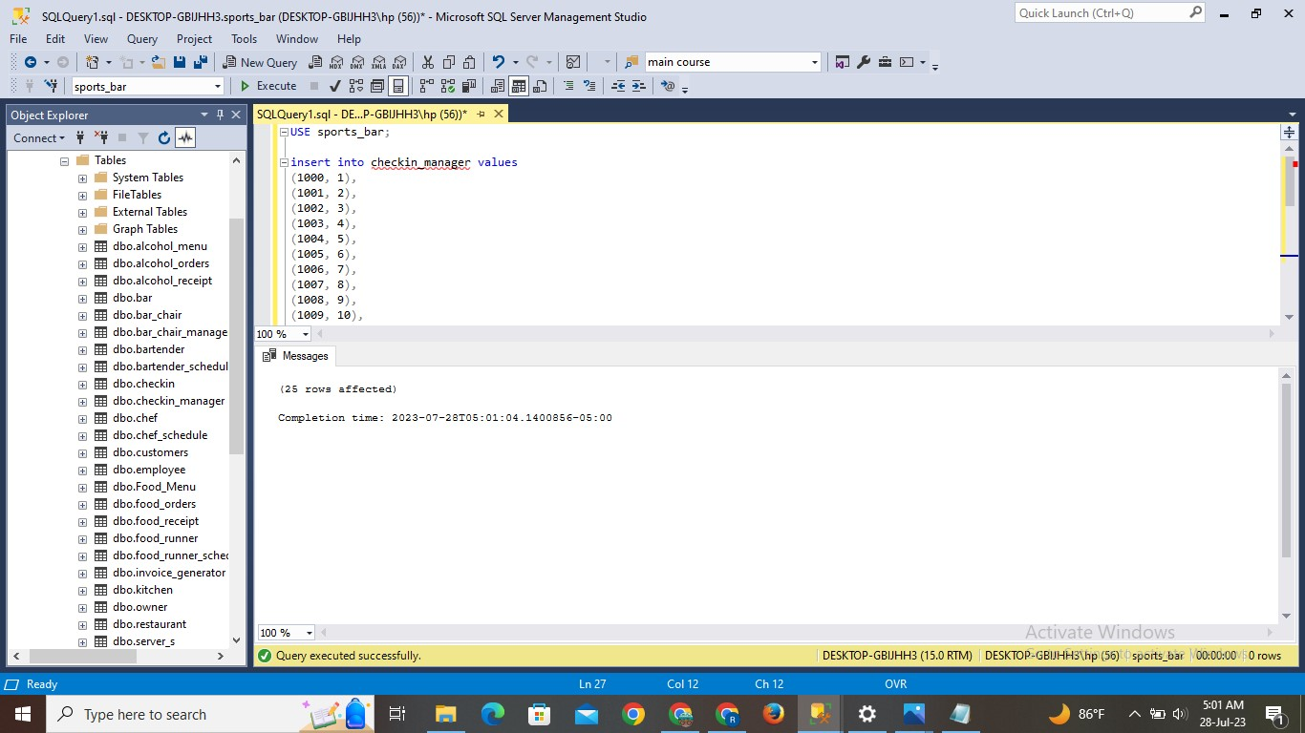

**Result:**

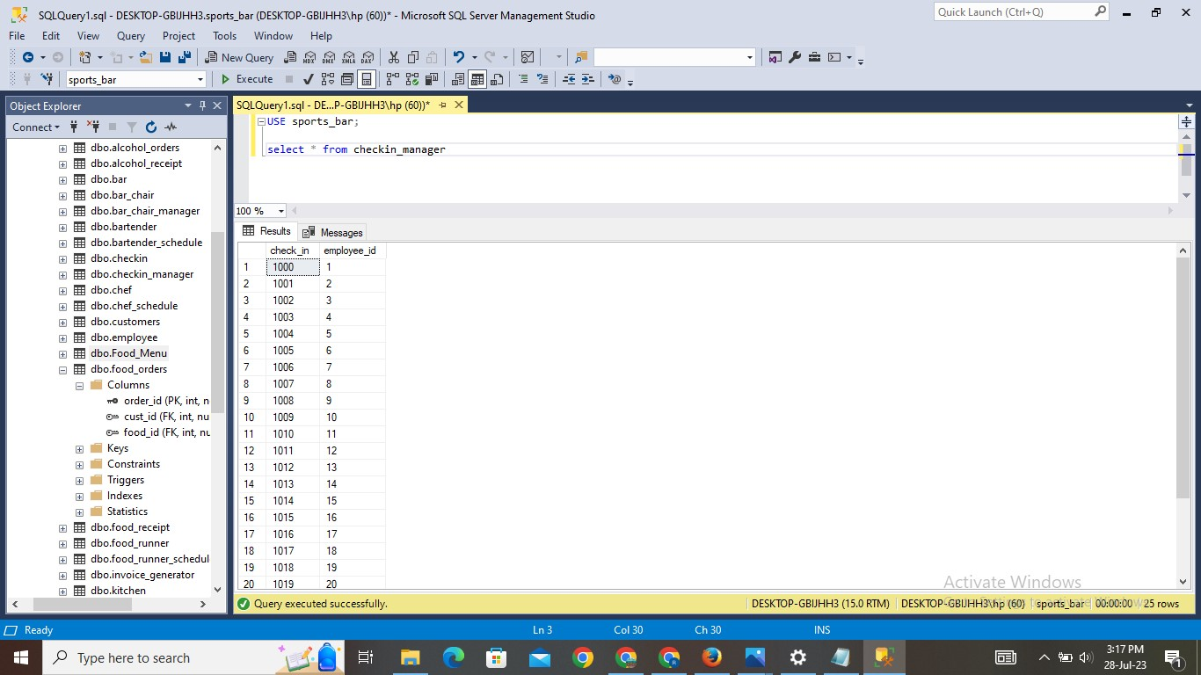

1. **TV Position Table:**

**Explanation:**

* The table is created with the name of tv_position. This table gives us information about tv id and tv position.
* Values are inserted into the table. And using SELECT statement can check the inserted values.

**Query:**

Create table tv_position(tv_id int primary key,

Tv_position varchar(30))

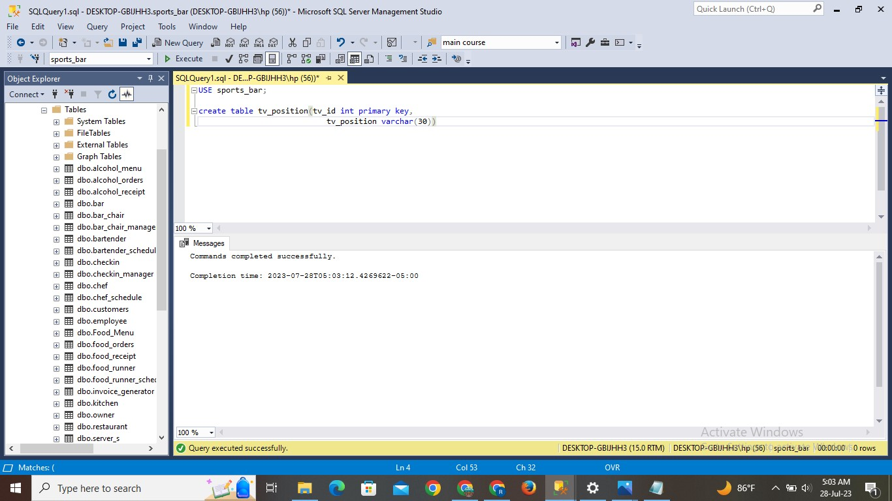

**INSERT STATEMENT:**

INSERT INTO tv_position(tv_id, tv_position) VALUES

    (1, "Wall-Mounted - Behind the Bar"),

    (2, "Wall-Mounted - Above Seating Area 1"),

    (3, "Wall-Mounted - Above Seating Area 2"),

    (4, "Wall-Mounted - Above Seating Area 3"),

    (5, "Tabletop - Near Pool Tables"),

    (6, "Tabletop - VIP Section 1"),

    (7, "Tabletop - VIP Section 2"),

    (8, "Ceiling-Mounted - Center of the Room"),

    (9, "Ceiling-Mounted - Near Entrance"),

    (10, "Wall-Mounted - Near Dart Boards"),

    (11, "Wall-Mounted - Above Billiards Area"),

    (12, "Wall-Mounted - Above Bar Area"),

    (13, "Ceiling-Mounted - Above Dance Floor"),

    (14, "Tabletop - Near Shuffleboard Area"),

    (15, "Ceiling-Mounted - Near Stage"),

    (16, "Wall-Mounted - Above Booth 1"),

    (17, "Wall-Mounted - Above Booth 2"),

    (18, "Tabletop - Outdoor Patio 1"),

    (19, "Tabletop - Outdoor Patio 2"),

    (20, "Ceiling-Mounted - Outdoor Patio"),

    (21, "Wall-Mounted - Above Poker Tables"),

    (22, "Ceiling-Mounted - Game Zone Area"),

    (23, "Tabletop - Near Foosball Area"),

    (24, "Wall-Mounted - Above Lounge Area"),

    (25, "Tabletop - Near Bar Counter")

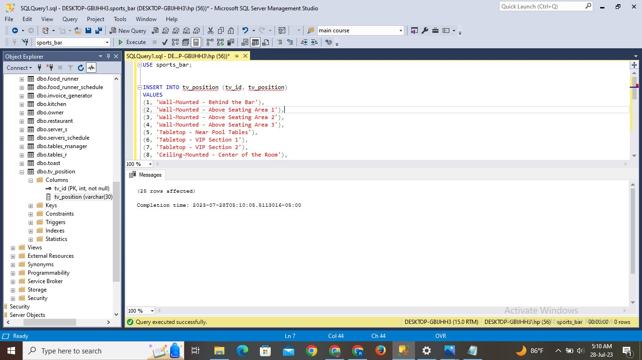

**Result:**

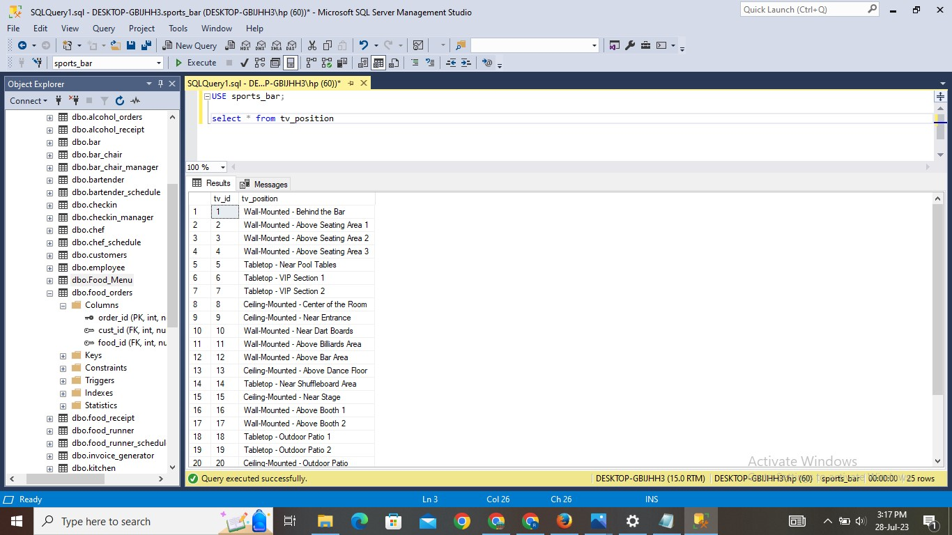

1. **TV Channel Table:**

**Explanation:**

* The table is created with the name of tv_channel. This table gives us information about tv id, show time and channel number.
* Values are inserted into the table. And using SELECT statement can check the inserted values.

**Query:**

Create table tv_channel(tv_id int primary key,

Show_time datetime,

Channel_no int)

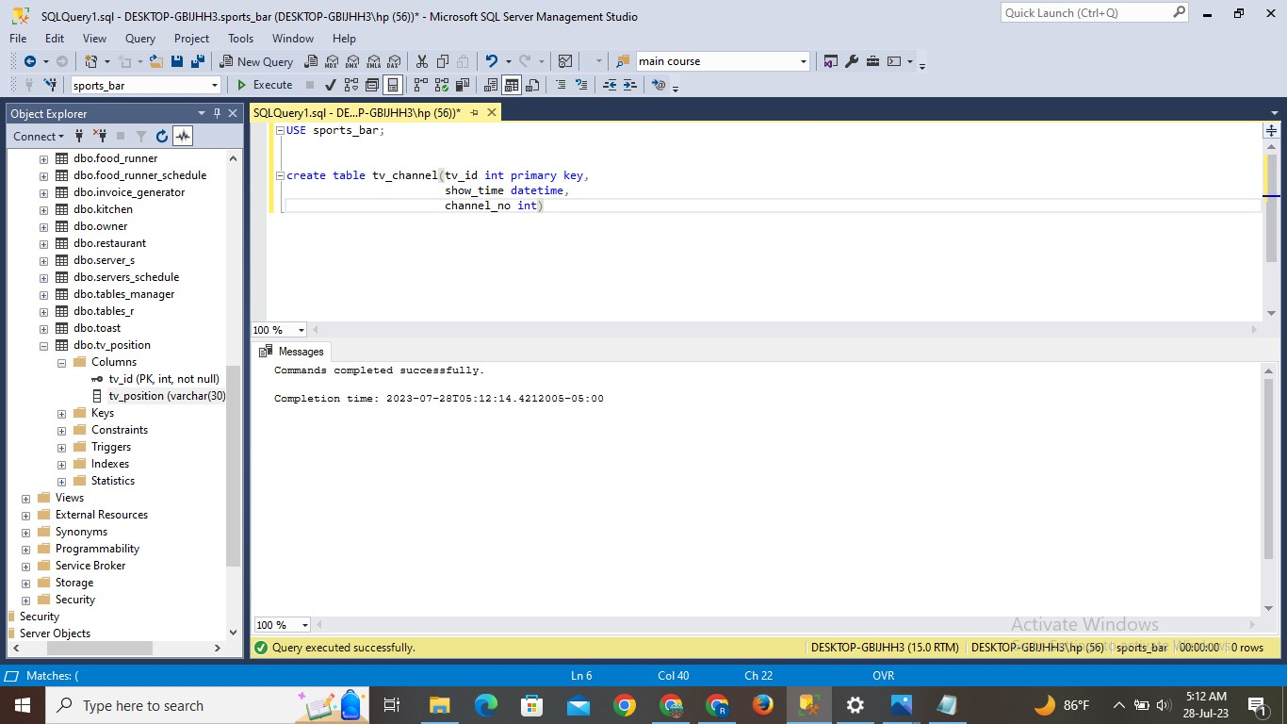

**INSERT STATEMENT:**

INSERT INTO tv_channel(tv_id, show_time, channel_no)

    (1, "2023-07-27 10:00:00.000", 101),

    (2, "2023-07-27 11:30:00.000", 102),

    (3, "2023-07-27 13:00:00.000", 103),

    (4, "2023-07-27 14:30:00.000", 104),

    (5, "2023-07-27 16:00:00.000", 105),

    (6, "2023-07-27 17:30:00.000", 106),

    (7, "2023-07-27 19:00:00.000", 107),

    (8, "2023-07-27 20:30:00.000", 108),

    (9, "2023-07-27 22:00:00.000", 109),

    (10, "2023-07-28 10:30:00.000", 110),

    (11, "2023-07-28 12:00:00.000", 111),

    (12, "2023-07-28 13:30:00.000", 112),

    (13, "2023-07-28 15:00:00.000", 113),

    (14, "2023-07-28 16:30:00.000", 114),

    (15, "2023-07-28 18:00:00.000", 115),

    (16, "2023-07-28 19:30:00.000", 116),

    (17, "2023-07-28 21:00:00.000", 117),

    (18, "2023-07-28 22:30:00.000", 118),

    (19, "2023-07-29 11:00:00.000", 119),

    (20, "2023-07-29 12:30:00.000", 120),

    (21, "2023-07-29 14:00:00.000", 121),

    (22, "2023-07-29 15:30:00.000", 122),

    (23, "2023-07-29 17:00:00.000", 123),

    (24, "2023-07-29 18:30:00.000", 124),

    (25, "2023-07-29 20:00:00.000", 125)

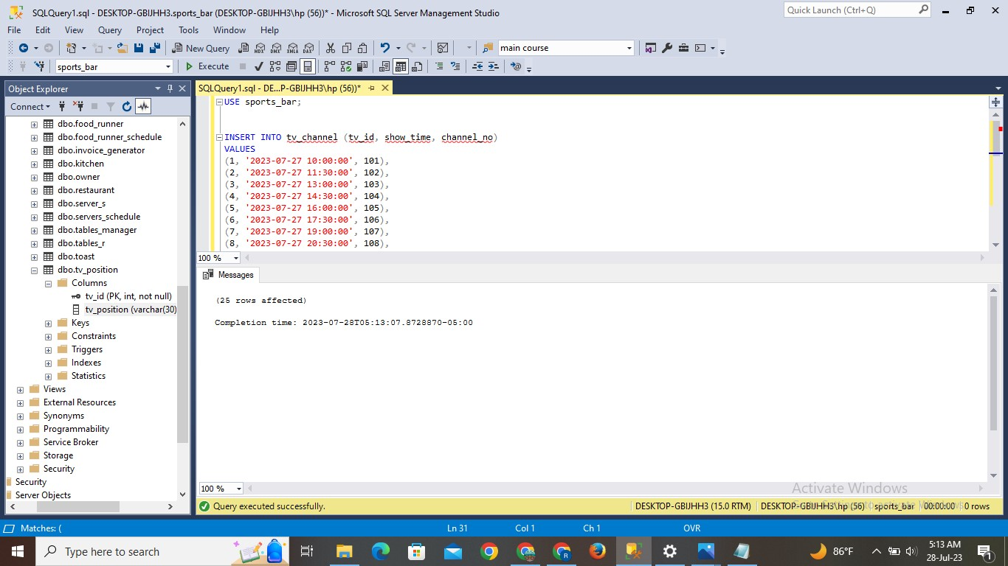

**Result:**

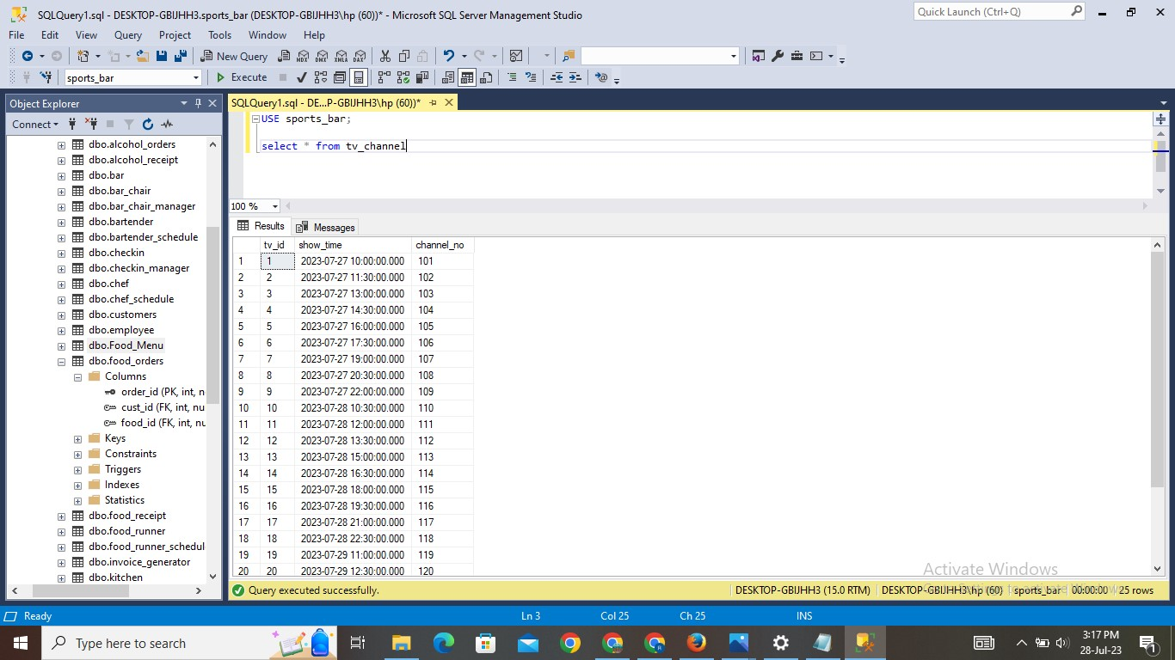

**Data Retrieval and Simple Reports:**

1. What are all the food items ordered by customer id ‘2’?

**Explanation:** To get all the records containing the names of food items ordered by the customer whose id is ‘2’

**Query:**

use sports_bar;

select food_name

FROM food_menu JOIN food_orders on food_menu.food_id = food_orders.food_id

WHERE cust_id = 2

**RESULT:**

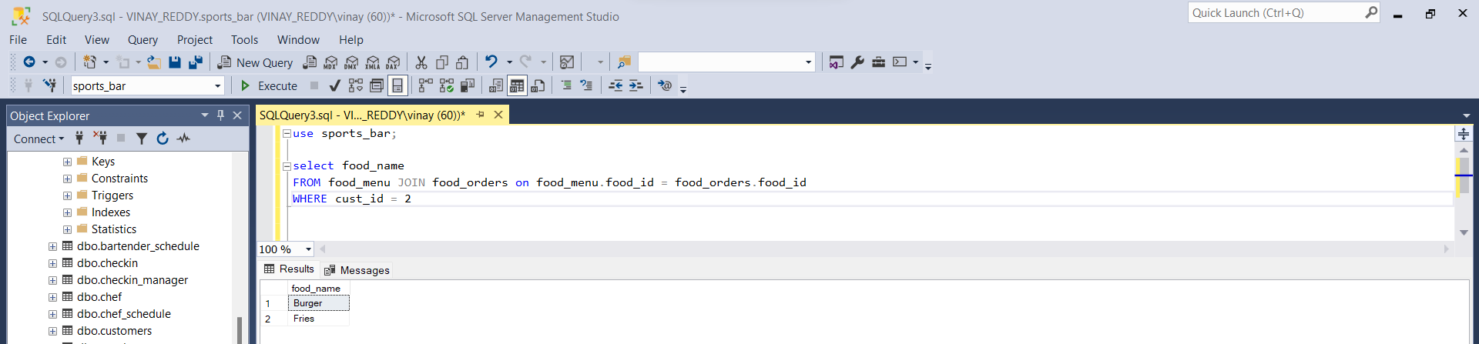

1. What are all the alcohol orders placed by customer id ‘1’?

**Explanation:** To get all the records containing the names of alcohol items ordered by the customer whose id is ‘1’

**Query:**

select alcohol_name from (SELECT cust_id, alcohol_name

FROM alcohol_orders Ao JOIN alcohol_menu Am ON Ao.alcohol_id = Am.alcohol_id

GROUP BY cust_id, alcohol_name) as hp where hp.cust_id = 1

**Result:**

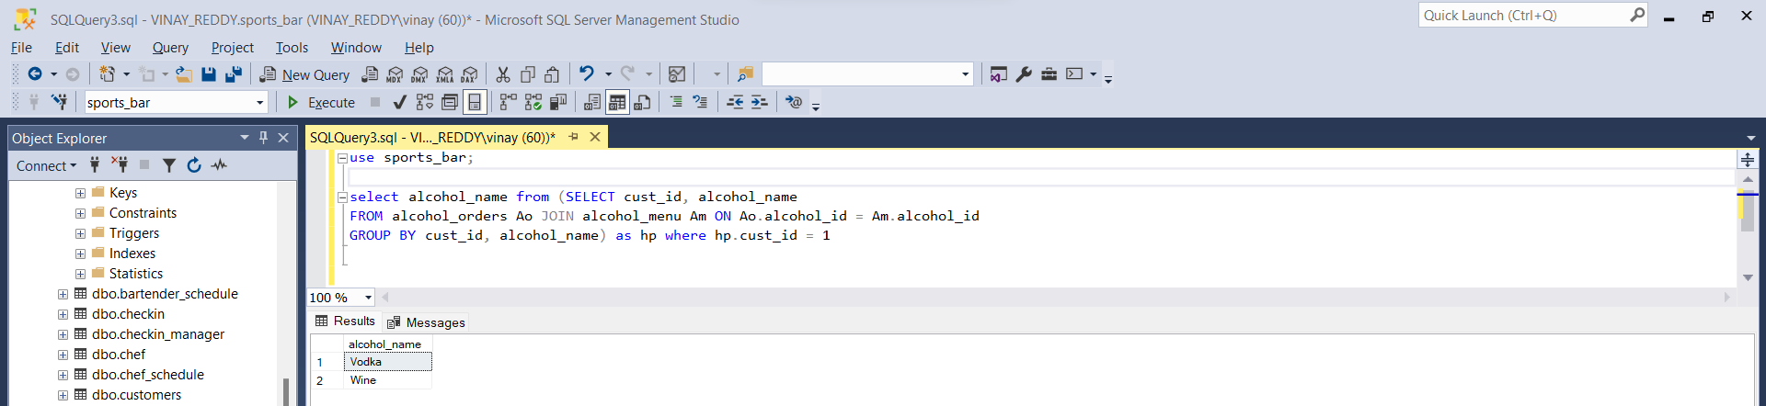

1. Who are all the employees that served customer bearing id ‘1’?

**Explanation:** To show all the records of employees who served customer id ‘1’

**Query:**

use sports_bar;

select employee_name

from server_s as s join servers_schedule as ss on s.server_id = ss.server_id join employee e on e.employee_id = ss.employee_id

where cust_id = 1

**Result:**

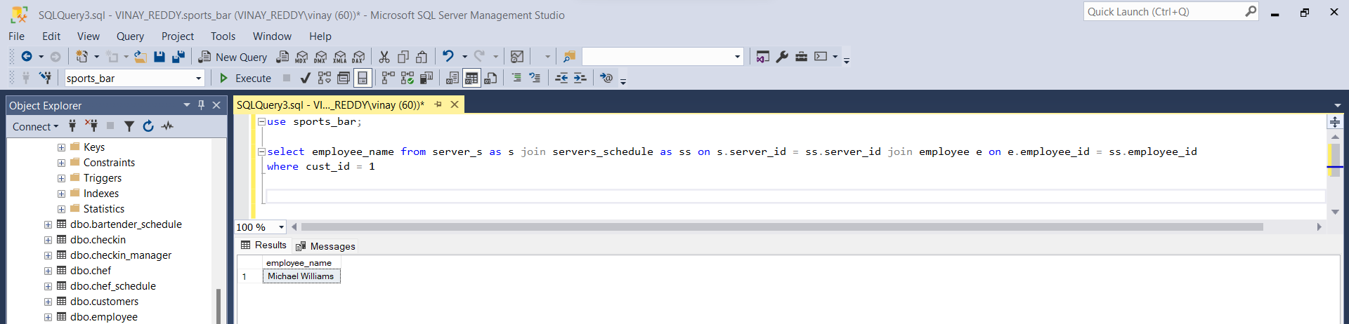

1. How many times each food item is sold?

**Explanation:** To display all the items sold and their count

**Query:**

use sports_bar;

select food_name, count(*) as frequency

from food_orders fo join food_menu fm on fo.food_id = fm.food_id

group by food_name

**Result:**

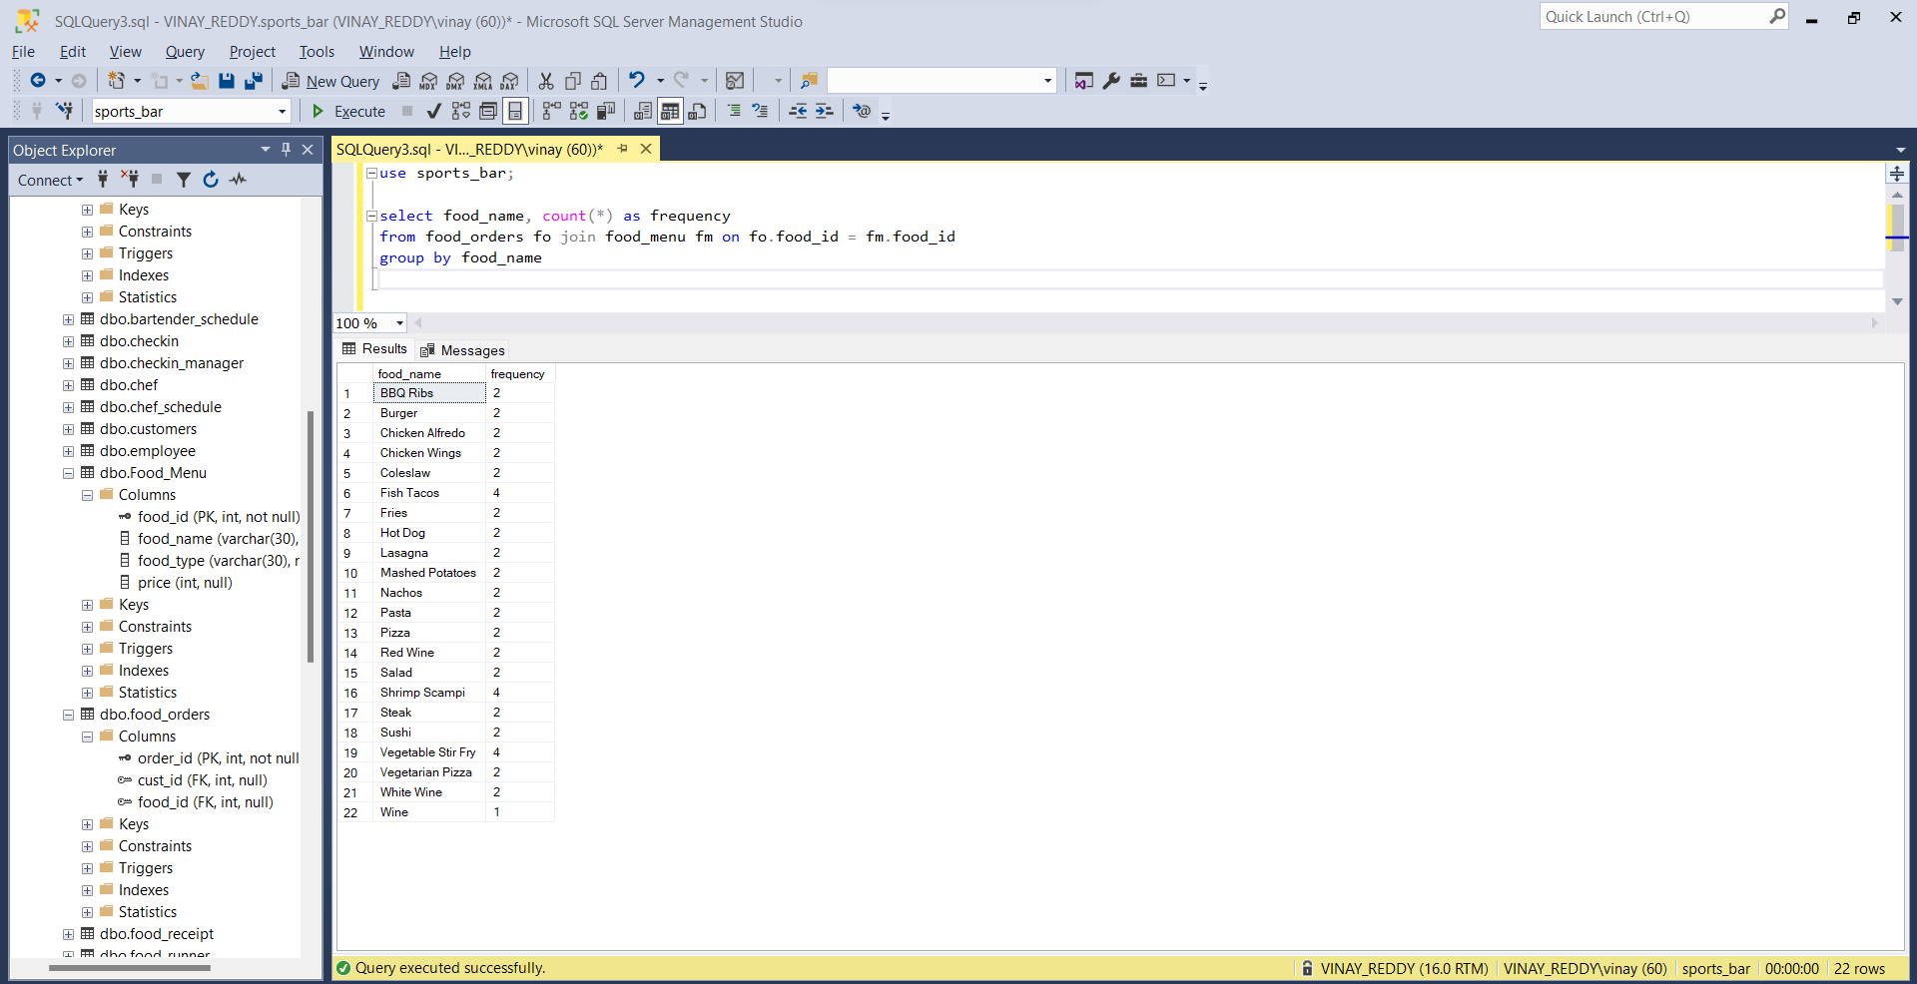

1. How many times is each alcohol ordered, display the count.

**Explanation:** To understand how many times a type of alcohol is ordered.

**Query:**

use sports_bar;

select alcohol_name, count(*) as frequency

from alcohol_orders fo join alcohol_menu fm on fo.alcohol_id = fm.alcohol_id

group by alcohol_name

**Result:**

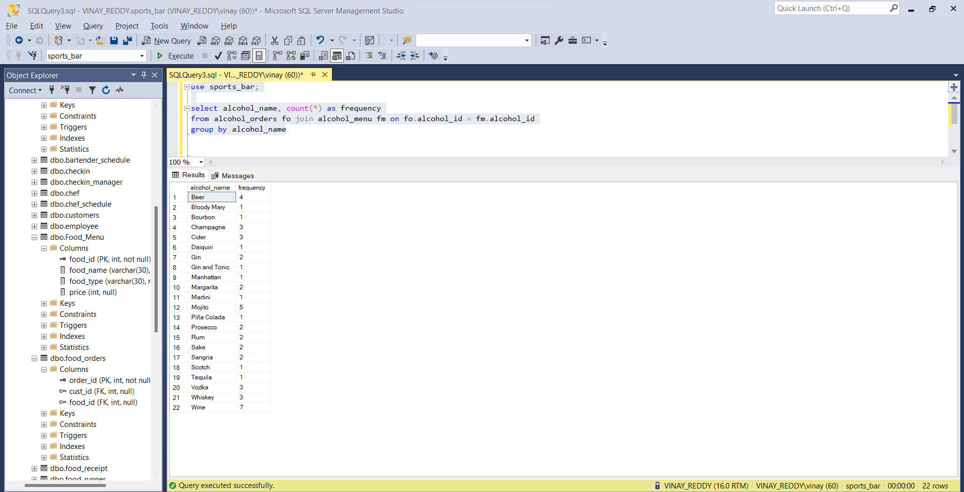

1. Display all the table id where it is reserved in advance.

**Explanation:** To show all the tables which are reserved by customers.

**Query:**

select table_id

from tables_manager

where reserver = 'yes'

**Result:**

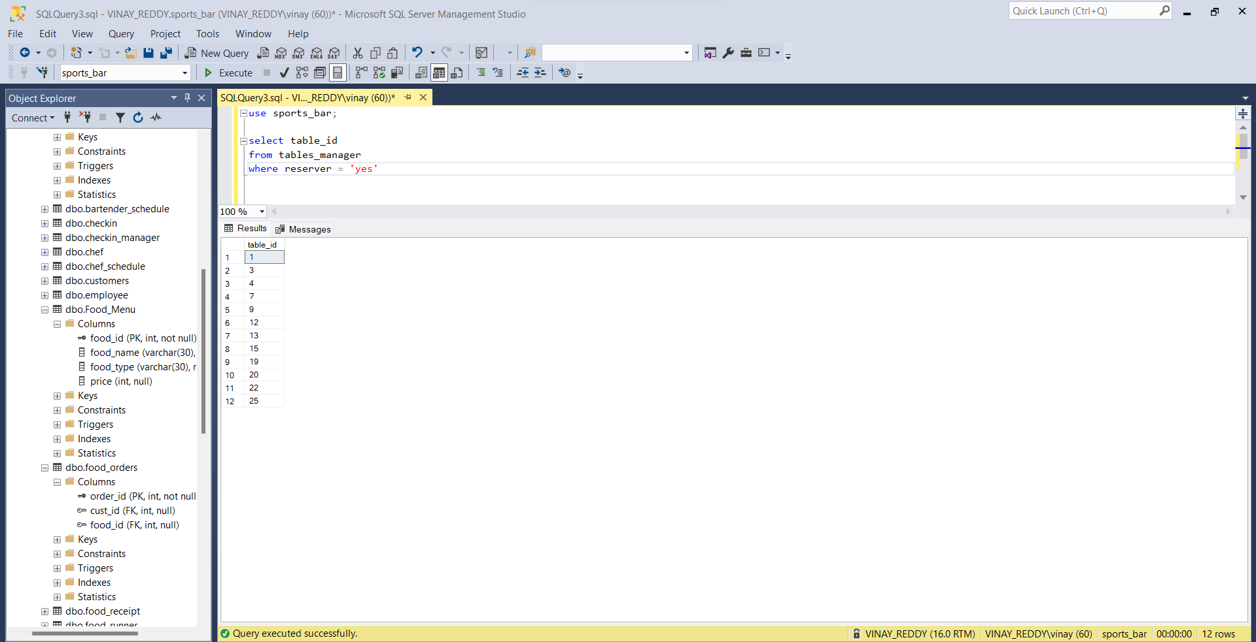

1. At what time is channel 105 playing and its location?

**Explanation:** I would like to know the location of the TV in which channel 105 is playing and also the timings of it.

**Query:**

select show_time, tv_position

from tv_channel tc join tv_position tp on tc.tv_id = tp.tv_id

where channel_no = 105

**Result:**

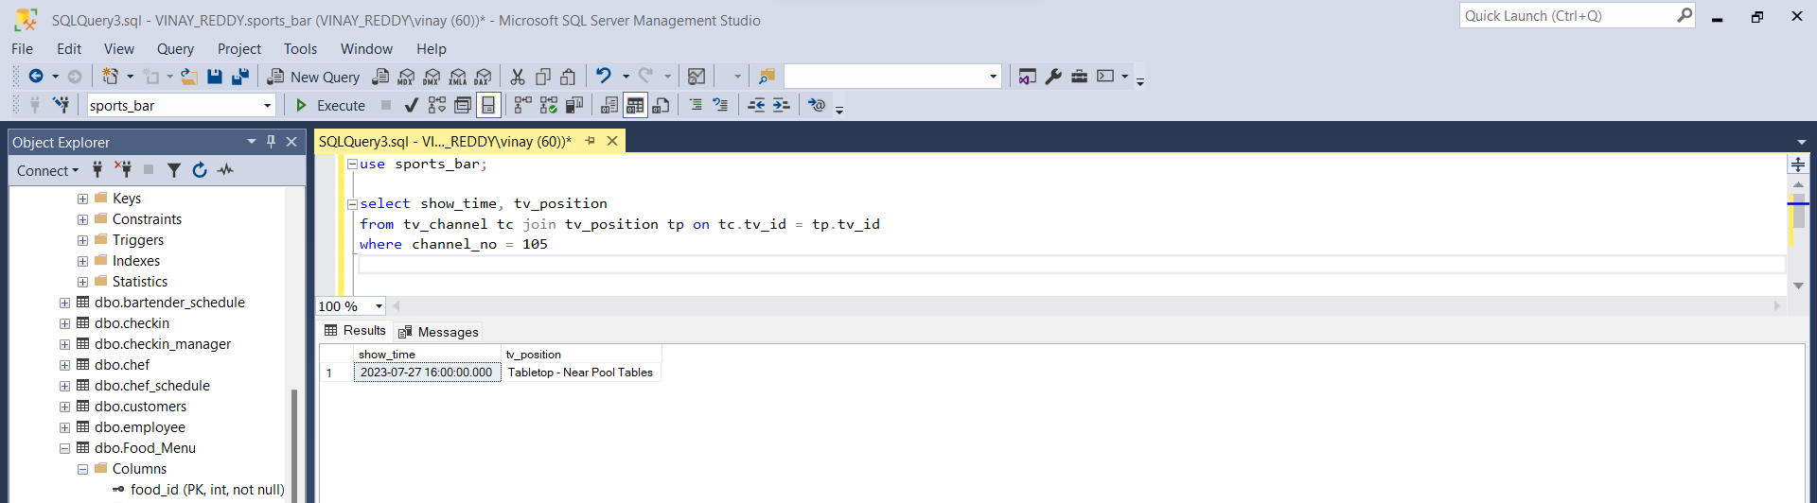

1. List the details of customers who order online.

**Explanation:** To know the details of customers who prefer online booking.

**Query:**

select *

from customers

where cust_type = 'online';

**Result:**

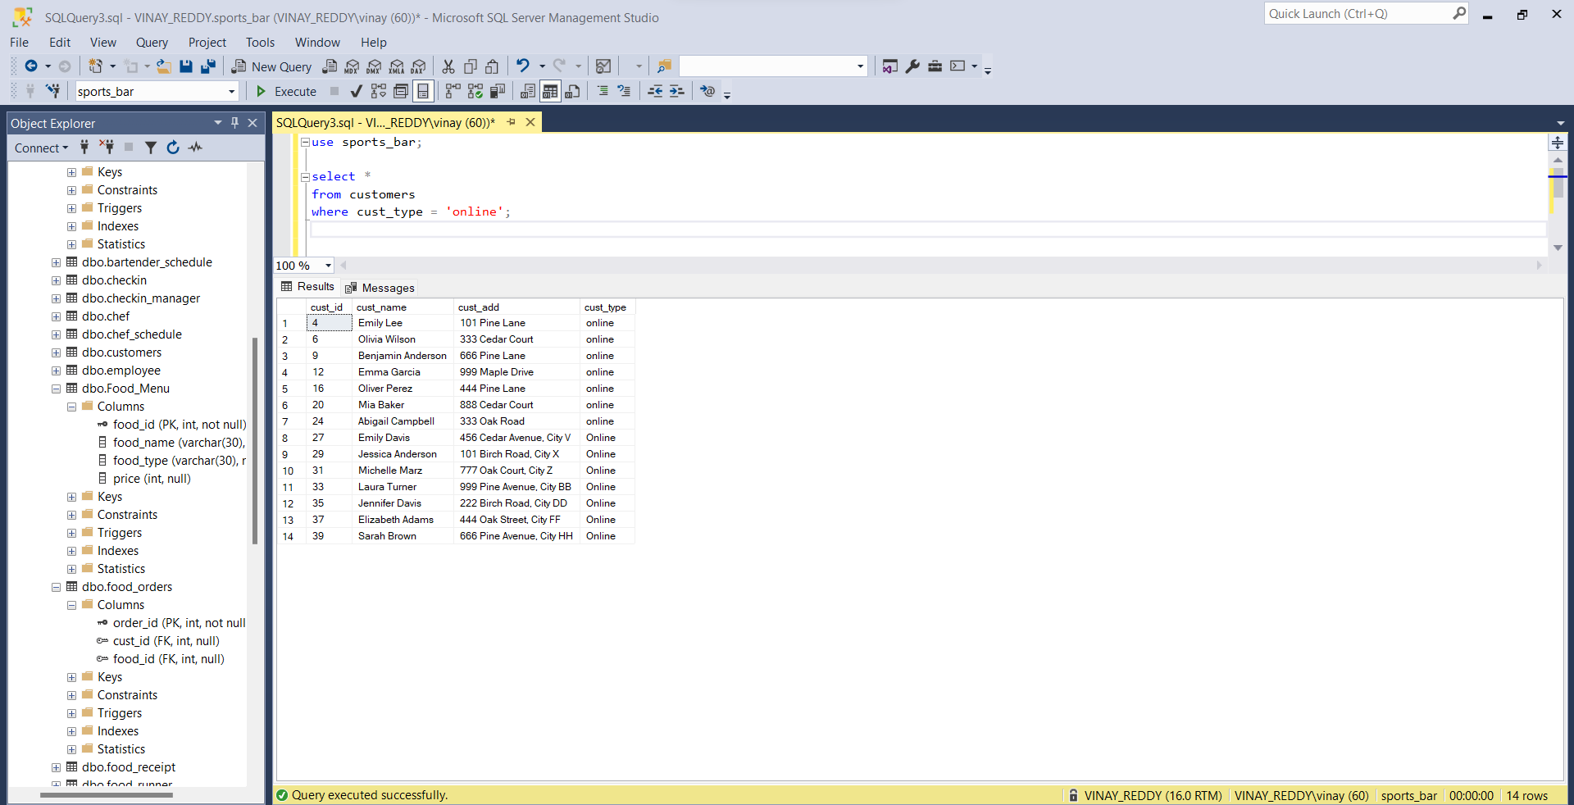

1. List the details of employees who are bartenders.

**Explanation:** To display all the details of employees who work in bars as bartenders.

**Query:**

select *

from employee

where employee_type = 'bartender'

**Result:**

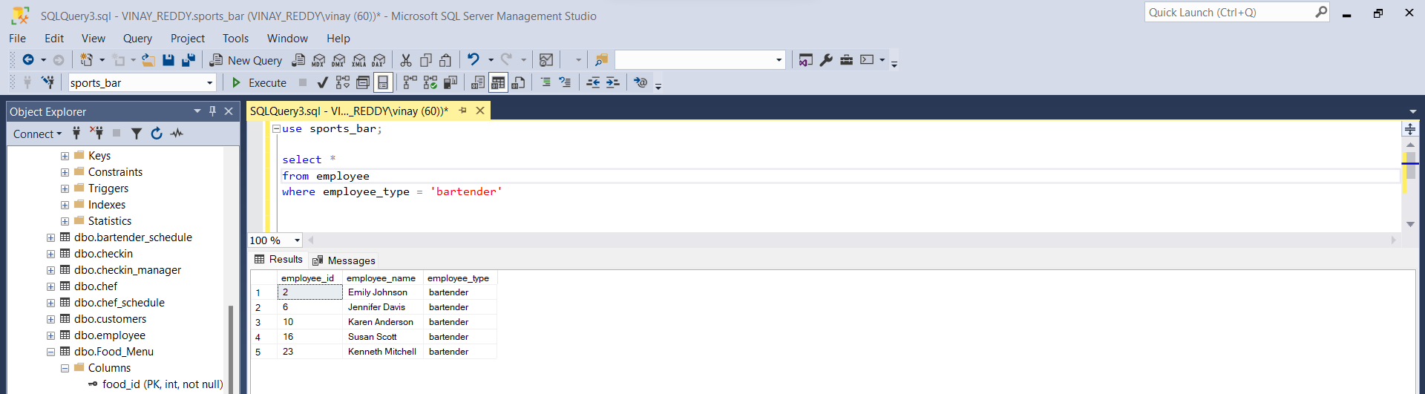

1. Create a list of employees (chef) who has made pizza for orders.

**Explanation:** In this question, I am looking for chefs who prepared pizza for customers.

**Query:**

select distinct employee_name, employee_type, chef_type

from kitchen k join chef c on c.chef_id = k.chef_id join food_receipt fr on fr.table_id = k.table_id join food_orders fo on fo.cust_id = fr.cust_id join food_menu fm on fo.food_id = fm.food_id join chef_schedule cs on cs.chef_id = k.chef_id join employee e on e.employee_id = cs.employee_id

where food_name = 'Pizza';

**Result:**

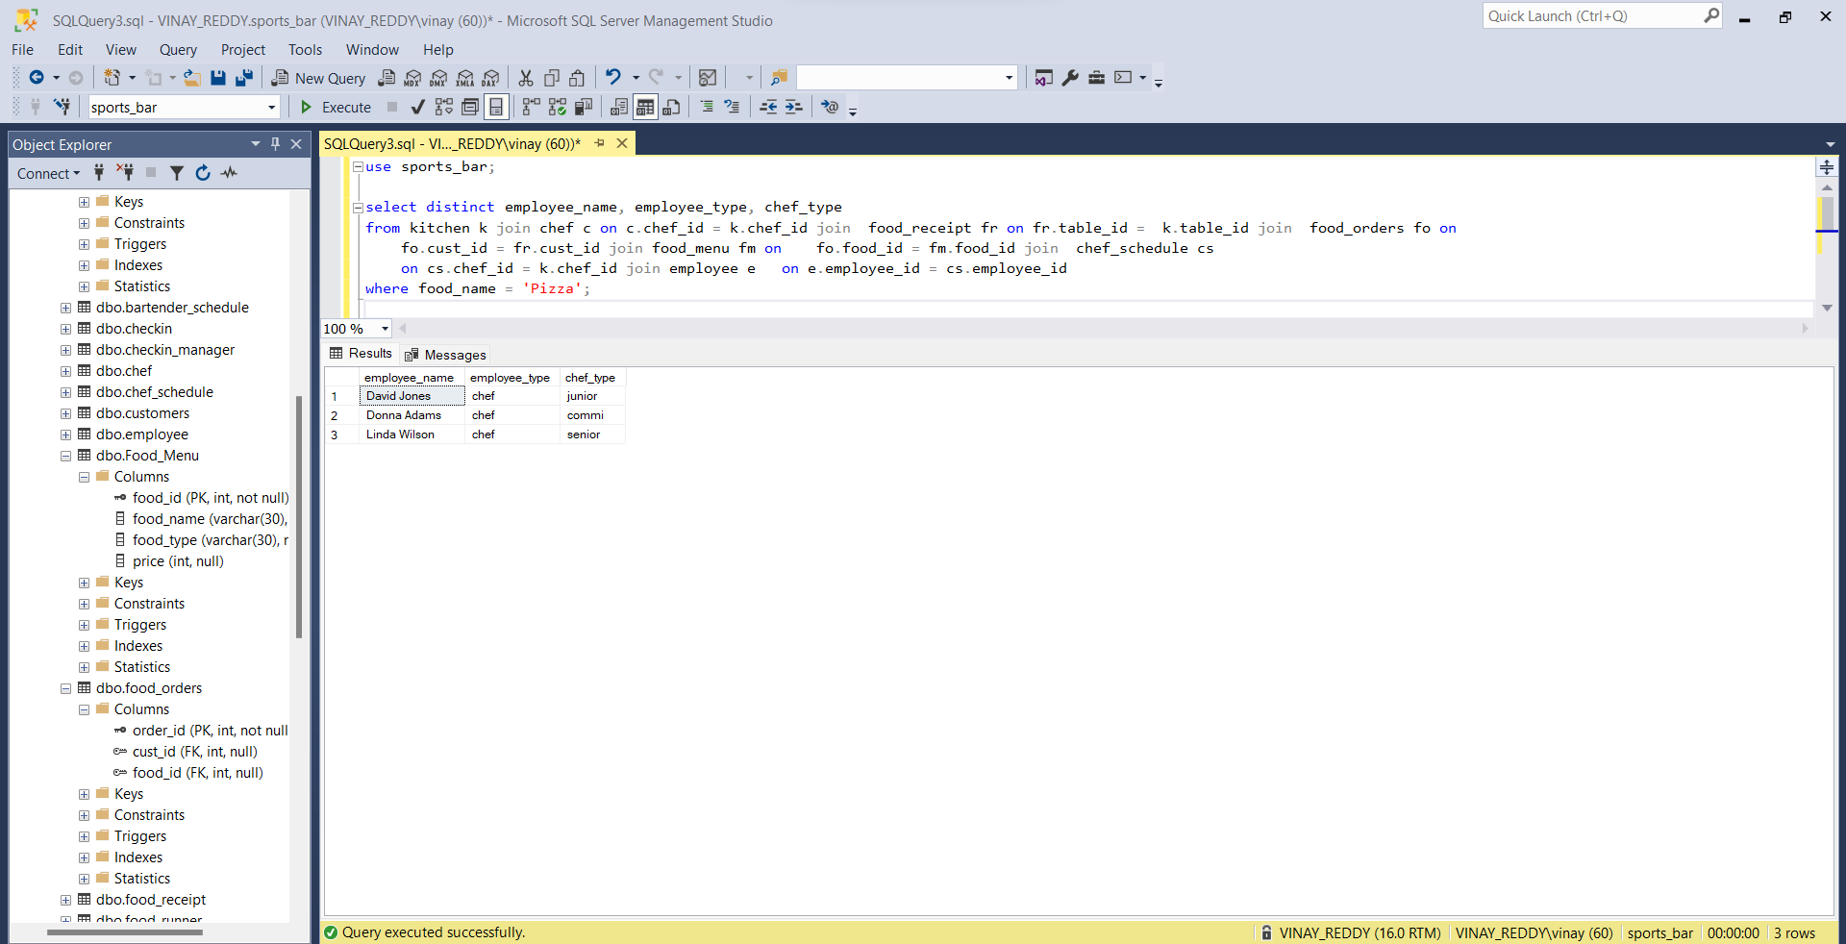

**Database Backup File Link:**

[**https://drive.google.com/file/d/1-twxZof7hNunrdldmGR0NHPX1Bo4YAvs/view?usp=sharing**](https://drive.google.com/file/d/1-twxZof7hNunrdldmGR0NHPX1Bo4YAvs/view?usp=sharing)

* Download the file.
* Upload in Microsoft SQL System Management Studio (SSMS)
* Right click and select restore option to load the database in SSMS.
* Now you can see the tables and create the queries.

**Conclusion:**

Hence, with all the created tables and paths laid between tables, I am able to provide unique ids to employees and log their work timings accurately. With the kiosk being updated with menu and invoice details, it became easy for employees to serve, generate bills and deal with payments. It also helped to achieve better customer service as the server knows where to serve exactly with zero error. Thus, achieved most of the goals by implementing database for sports bar organization.